INFOLINK UNIVERSITY COLLEGE
HAWASSA CAMPUS

AUTOMATIC LICENSE PLATE RECOGNITION BASED SMART TRAFFIC MANAGEMENT SYSTEM HAWASSA CITY

Group Members and ID Numbers

Dinkinesh Adugna ………………………………….. IHEBM-307875-16
Befikadu Yakob ……………………………………… IHRCS-357639-15
Betelhem Melaku ……………………………………. IHRCS-940754-16
Mihretab Nigatu ………………………………………… IHRCS-9599-16

Advisor: Mr. Hailemariam Wolde

Documentation (Proposal) of Course Software Engineering
Submitted to the Department of Computer Science, Faculty of Engineering, Infolink University College, in Partial Fulfillment of the Requirement for the Degree of Bachelor of Science in Computer Science

Hawassa, Ethiopia
January 21, 2026

Table of Content
List of Tables VIII
List of Figures IX
Definitions, Acronyms, and Abbreviations X
ABSTRACT XI
Problem – Solution – Impact XIV
CHAPTER ONE - 1 -
INTRODUCTION - 1 -
1.1 Overview - 1 -
1.2 Background of the Organization - 1 -
1.3 Background of the Project - 2 -
1.4 Team Composition - 2 -
1.5 Statement of the Problem - 3 -
1.6 Objectives of the Project - 4 -
1.6.1 General Objective - 4 -
1.6.2 Specific Objectives - 4 -
1.7 Feasibility Analysis - 4 -
1.7.1 Operational Feasibility - 5 -
1.7.2 Technical Feasibility - 5 -
1.7.3 Economic Feasibility - 5 -
1.7.4 Behavioral / Political Feasibility - 6 -
1.7.5 Schedule Feasibility - 6 -
1.8 Cost–Benefit Analysis - 8 -
1.8.1 Cost of the Project - 8 -
1.8.2 Consolidated Total Cost - 13 -
1.8.3 Estimated Cost Reductions - 13 -
1.9 Scope and Significance of the Project - 13 -
1.9.1 Scope of the Project - 13 -
1.9.2 Significance of the Project - 13 -
1.10 Target Beneficiaries of the System - 14 -
1.11 Methodology for the Project - 14 -
1.11.1 Data Source - 14 -
1.11.2 Fact-Finding Techniques - 15 -
1.11.3 System Analysis and Design Approach - 15 -
1.11.4 Overview of Project Development Phases - 16 -
1.11.5 Testing Procedures - 18 -
1.11.6 Real World Implementation Strategy - 19 -
1.11.7 Required Resources and Cost Analysis - 19 -
1.11.8 Risk Analysis, Assumptions, and Constraints - 20 -
1.11.9 Limitation of the Project - 20 -
1.11.10 Ethical, Legal, and Privacy Considerations - 20 -
CHAPTER TWO - 22 -
DESCRIPTION OF THE EXISTING SYSTEM - 22 -
2.1 Introduction to the Existing System - 22 -
2.2 Stakeholders and Players in the Existing System - 22 -
2.3 Major Functions and Activities of the Existing System - 24 -
2.4 Business Rules Governing the Existing System - 25 -
2.5 Reports Generated in the Existing System - 26 -
2.5.1 Types of Reports - 26 -
2.5.2 Limitations of Existing Reports - 26 -
2.6 Documentation and Forms Used in the Existing System - 26 -
2.6.1 Common Forms Used - 26 -
2.6.2 Issues with Manual Documentation - 27 -
2.7 Bottlenecks of the Existing System (PIECES Framework) - 27 -
2.7.1 Performance - 27 -
2.7.2 Information (Input and Output Issues) - 27 -
2.7.3 Security and Control - 27 -
2.7.4 Efficiency - 28 -
2.7.5 Service - 28 -
2.8 Practices to Be Preserved - 28 -
2.8.1 Legal and Administrative Compliance - 28 -
2.8.2 Subcity-Based Administrative Structure - 28 -
2.8.3 Manual Verification Authority - 28 -
2.8.4 Existing Communication Culture - 28 -
2.9 Proposed Solution for the New System - 28 -
2.9.1 Overview of the Proposed System - 29 -
2.9.2 Key Features of the Proposed System - 29 -
2.9.3 Alignment with Existing Practices - 30 -
2.10 Functional Requirements - 30 -
2.10.1 Performance Requirements - 30 -
2.10.2 Process Requirements - 31 -
2.10.3 Input-Related Requirements - 32 -
2.10.4 Output-Related Requirements - 32 -
2.10.5 Storage-Related Requirements - 32 -
2.11 Non-Functional Requirements - 33 -
2.11.1 Performance Requirements - 33 -
2.11.2 User Interface Requirements - 33 -
2.11.3 Security and Access Permissions - 33 -
2.11.4 Backup and Recovery Requirements - 33 -
2.11.5 Scalability and Maintainability - 33 -
2.11.6 Comparative Analysis of Existing and Proposed Systems - 34 -
CHAPTER THREE - 35 -
SYSTEM ANALYSIS - 35 -
3.1 Introduction - 35 -
3.2 System Requirements Specification (SRS) - 35 -
3.3 System Overview - 36 -
3.3.1 Key Characteristics of the System - 36 -
3.3.2 Core Functional Capabilities - 36 -
3.4 Stakeholders and System Actors - 37 -
3.4.1 Primary Stakeholders - 37 -
3.4.2 System Actors (Authorized Users and External Systems) - 37 -
3.4.3 Explicit Exclusion of Driver as a System Actor - 39 -
3.5 System Boundary Definition - 40 -
3.5.1 In-Scope System Responsibilities - 40 -
3.5.2 Out-of-Scope System Responsibilities - 40 -
3.6 System Constraints and Assumptions - 40 -
3.7 Operating Environment - 42 -
3.7.1 Deployment Environment - 42 -
3.7.2 Client Environment - 42 -
3.7.3 Integration Environment - 42 -
3.8 Future Expansion Considerations - 43 -
3.8.1 Functional Expansion - 43 -
3.8.2 Intelligence and Analytics Expansion - 43 -
3.8.3 Integration Expansion - 43 -
3.9 Use Case Diagram - 43 -
3.9.1 Identified Main Use Cases - 43 -
3.10 System Business Rules & Logic (Supplementary Detail) - 44 -
3.11 Use Case Documentation - 45 -
3.12 Analysis-Level Class Diagram (Comprehensive Description and Rationale) - 49 -
3.12.1 Purpose of the Analysis-Level Class Diagram - 49 -
3.12.2 High-Level System Grouping and Structural Domains - 49 -
3.12.3 Design Principles Applied - 50 -
3.12.4 Security & User Management Domain - 51 -
3.12.5 Vehicle & Registration Domain - 52 -
3.12.6 Violation & Enforcement Domain (Core) - 53 -
3.12.7 Surveillance & Evidence Domain - 54 -
3.12.8 Intelligence & Coordination Domain - 55 -
3.12.9 Complaint & Oversight Domain - 56 -
3.12.10 Payment Domain (External Interaction Only) - 57 -
3.12.11 Shared Value Objects - 57 -
3.12.12 Conclusion - 57 -
3.13 SEQUENCE DIAGRAMS – DETAILED OPERATIONAL INTERACTION MODEL - 58 -
3.13.1 Purpose and Government Context - 58 -
3.13.2 Detailed Sequence Flow Descriptions - 59 -
3.14 Activity Diagram – Detailed Functional Documentation - 70 -
3.14.1 Introduction - 70 -
3.14.2 Scope and Coverage - 70 -
3.14.3 Authentication and Role Assignment Phase - 71 -
3.14.4 Violation Detection Phase (Parallel Activities) - 71 -
3.14.5 Violation Registration and Evidence Capture - 72 -
3.14.6 Alert Broadcasting and Coordination Phase - 72 -
3.14.7 Vehicle Interception and Driver Interaction - 73 -
3.14.8 Immediate Admission Path (No Complaint) - 73 -
3.14.9 Complaint Handling Path (Office-Based Only) - 73 -
3.14.10 Payment Processing Phase (OTP-Based) - 74 -
3.14.11 Case Closure and Archival - 75 -
3.14.12 Summary of Activity Diagram Strengths - 75 -
3.15 User Interface Prototyping - 76 -
3.15.1 Introduction - 76 -
3.15.2 User Interface Design Principles - 77 -
3.15.3 UI Prototypes by User Role - 77 -
3.15.4 UI Navigation Structure - 82 -
3.15.5 Non-Functional UI Requirements - 82 -
3.15.6 User Experience (UX) Justification for Examiners - 82 -
3.16 Supplementary Specifications - 86 -
3.16.1 Scope and Purpose - 86 -
3.16.2 Security Requirements - 86 -
3.16.3 Legal and Regulatory Constraints - 87 -
3.16.4 Performance Requirements - 87 -
3.16.5 Reliability and Availability - 87 -
3.16.6 Data Integrity and Consistency - 87 -
3.16.7 External Interface and Dependency Constraints - 88 -
3.16.8 Usability and Human Factors - 88 -
3.16.9 Maintainability and Scalability - 88 -
3.16.10 Assumptions and Dependencies - 88 -
3.17 Change Management Process - 88 -
CHAPTER FOUR - 90 -
SYSTEM DESIGN - 90 -
4.1 Introduction - 90 -
4.1.1 Design Objectives - 90 -
4.1.2 Design Scope - 91 -
4.1.3 Architectural Philosophy - 91 -
4.1.4 Compliance and Standards Alignment - 92 -
4.1.5 Design Readiness Statement - 92 -
4.1.6 Chapter Organization - 92 -
4.1.7 System Architecture Design - 93 -
4.2 Class Type Architecture - 93 -
4.2.1 Overview - 93 -
4.2.2 Presentation Layer (User Interaction Layer) - 94 -
4.2.3 Controller / Process Layer - 95 -
4.2.4 Domain & Intelligence (Business/Domain) Layer - 96 -
4.2.5 Data Management (Persistence) Layer - 96 -
4.2.6 Infrastructure & Integration (System) Layer - 97 -
4.2.7 Architectural Security Principles - 98 -
4.2.8 Architectural Quality Attributes - 99 -
4.2.9 Architecture Validation Statement - 99 -
4.3 Class Modeling - 99 -
4.3.1 Purpose of Class Modeling - 99 -
4.3.2 Class Modeling Scope - 99 -
4.3.3 User Class Hierarchy - 100 -
4.3.4 Core Domain Classes - 100 -
4.3.5 Relationship Design Principles - 102 -
4.3.6 Compliance and Design Quality Considerations - 102 -
4.4 State Chart Modeling - 102 -
4.4.1 Introduction - 102 -
4.4.2 Scope of State Modeling - 102 -
4.4.3 Violation State Chart – Conceptual Overview - 103 -
4.4.4 Complaint State Behavior (Embedded) - 105 -
4.4.5 Design & Compliance Considerations - 106 -
4.5 Collaboration Modeling - 106 -
4.5.1 Introduction - 106 -
4.5.2 Collaboration Modeling Scope - 106 -
4.5.3 Key Collaboration Participants - 107 -
4.5.4 Collaboration Scenario 1: Violation Detection & Reporting - 107 -
4.5.5 Collaboration Scenario 2: Alert Broadcasting & Inter-Subcity Coordination - 108 -
4.5.6 Collaboration Scenario 3: CCTV-Assisted Evidence Validation - 109 -
4.5.7 Collaboration Scenario 4: Complaint Handling & Legal Decision - 110 -
4.5.8 Collaboration Scenario 5: Penalty Payment & Case Closure - 111 -
4.5.9 Collaboration Integrity & Governance Controls - 112 -
4.6 Component Modeling - 112 -
4.6.1 Introduction - 112 -
4.6.2 Component Modeling Objectives - 113 -
4.6.3 High-Level Component Architecture - 113 -
4.6.4 Presentation Components - 113 -
4.6.5 Control & Orchestration Components - 114 -
4.6.6 Core Domain Components - 114 -
4.6.7 Surveillance & Intelligence Components - 115 -
4.6.8 Financial & External Integration Components - 115 -
4.6.9 Governance & Audit Components - 116 -
4.6.10 Component Dependency Rules - 117 -
4.6.11 Government-Grade Design Assurance - 117 -
4.6.12 Transition to Next Section - 117 -
4.7 Deployment Modeling - 117 -
4.7.1 Introduction - 117 -
4.7.2 Deployment Design Principles - 118 -
4.7.3 Deployment Environments - 118 -
4.7.4 Physical Deployment Nodes - 119 -
4.7.5 Scalability & Future Deployment Considerations - 122 -
4.7.6 Government Compliance Assurance - 122 -
4.8 Persistence Modeling - 122 -
4.8.1 Introduction - 122 -
4.8.2 Persistence Design Objectives - 122 -
4.8.3 Data Categories and Classification - 123 -
4.8.4 Database Architecture - 124 -
4.8.5 Core Persistent Entities - 125 -
4.8.6 Data Lifecycle Management - 127 -
4.8.7 Data Security Controls - 127 -
4.8.8 Backup and Disaster Recovery - 127 -
4.8.9 Compliance and Governance Assurance - 128 -
4.9 User Interface design - 128 -
4.9.1 Introduction - 128 -
4.9.2 UI Design Objectives - 128 -
4.9.3 UI Architectural Pattern - 129 -
4.9.4 Common UI Components - 129 -
4.9.5 Role-Specific UI Designs - 130 -
4.9.6 UI Validation and Error Handling - 132 -
4.9.7 Accessibility and Government Standards Compliance - 132 -
4.9.8 UI Security Considerations - 132 -
4.9.9 UI Evolution and Future Readiness - 133 -
4.9.10 UI Design Summary - 133 -
4.10 System Transition and Deployment Strategy - 133 -
4.10.1 Introduction - 133 -
4.10.2 Transition Objectives - 133 -
4.10.3 Transition Scope - 134 -
4.10.4 Phased Transition Strategy - 134 -
4.10.6 Training and Capacity Building - 136 -
4.10.7 Data Migration and Initialization - 136 -
4.10.8 Compliance, Governance, and Audit Readiness - 137 -
4.10.9 Transition Completion Criteria - 137 -
CONCLUSION A
RECOMMENDATIONS C
APPENDIX E
Appendix A: Actors Summary E
Appendix B: Legal Basis E
Appendix C: Assumptions and Limitations E
Appendix D: Detailed Project Task and Schedule E
REFERENCES I

List of Tables

Table Page No

Table 1.1 Team Composition and Role ______________________________________ 3
Table 1.2 Traffic Officer End-User Devices __________________________________ 9
Table 1.3 Data Center Server Infrastructure __________________________________ 10
Table 1.4 Supporting Infrastructure ________________________________________ 10
Table 1.5 Connectivity & Electricity (Annual Operational Cost) __________________10
Table 1.6 Training Cost (All Phases) ________________________________________10
Table1.7Phase one cost table ______________________________________________11
Table1.8 Phase two cost table _____________________________________________ 11
Table1.9 Phase three cost table ____________________________________________ 12
Table1.10 Phase four cost table ____________________________________________12
Table1.11 Total cost breakdown table _______________________________________13
Table 1.12 Cost reduction ________________________________________________ 12
Table 1.13 Tools and Technologies Used ____________________________________ 18
Table 2.1 Proposed System Addresses Existing Problems _______________________ 30
Table 2.2 Comparison of Existing and Proposed Systems _______________________ 34

Table 3.1 Stakeholders and System Interaction _______________________________ 39
Table 3.2 Alignment with Use Cases _______________________________________ 58
Table 3.3 Legend and Modeling Conventions _________________________________59
Table 3.4 Role and UX Design Rationale ____________________________________ 83

Table 4.1 Relationship Between Analysis Artifacts and Design Artifacts ____________92
Table 4.2 Actor to Layer Mapping __________________________________________ 98
Table 4.3 Architectural Support for Phased Deployment _________________________99
Table 4.4 Architectural Benefits Summary ____________________________________99
Table 4.5 Specialized User Classes _________________________________________ 100
Table 4.6 Network & Security Boundaries ____________________________________121
Table 4.7 Retention and Archival Policy _____________________________________128
Table 4.8 User Roles and UI Access Scope ___________________________________ 129
Table 4.9 Risk Management and Mitigation ___________________________________137
Table A.1 Summary of Project Tasks, Duration, and Focus ______________________ 145

List of Figures

Figure Page No
Fig 3.1 Use case UML Diagram of ALPR STMS, Hawassa _______________________ 45
Fig 3.2 Class UML Diagram ALPR STMS, Hawassa ____________________________ 58
Fig 3.3 Security Login Sequence UML Diagram ALPR STMS, Hawassa ____________ 61
Fig 3.4 Manual Violation Reporting UML Diagram ALPR STMS, Hawassa __________ 62
Fig 3.5 CCTV-Assisted Violation Sequence UML Diagram ALPR STMS, Hawassa ____ 65
Fig 3.6 Inter-Subcity Coordination Sequence UML Diagram ALPR STMS, Hawassa ____66
Fig 3.7 Complain Resolution Sequence UML Diagram ALPR STMS, Hawassa ________ 67
Fig 3.8 OTP based Payment Sequence UML Diagram ALPR STMS, Hawassa _________ 68
Fig 3.9 System Closure Sequence UML Diagram ALPR STMS, Hawassa _____________ 69
Fig 3.10 Full-System Sequence UML Diagram ALPR STMS, Hawassa _______________ 70
Fig 3.11 Full-System Activity UML Diagram ALPR STMS, Hawassa ________________ 76

Fig 4.1: Class-type layered architectural Diagram UML Diagram ALPR STMS, Hawassa _ 89
Fig 4.2: Violation State Chart Diagram ________________________________________ 103
Fig 4.3: Collaboration Diagram – Violation Detection and Reporting ________________ 108
Fig 4.4: Collaboration Diagram – Alert & Coordination __________________________ 109
Fig 4.5: Collaboration Diagram – CCTV Validation _____________________________ 110
Fig 4.6: Collaboration Diagram – Complaint Handling ___________________________ 111
Fig 4.7: Collaboration Diagram – Payment _____________________________________ 112
Fig 4.8: Component Interaction Diagram ______________________________________ 116
Fig 4.9: Deployment Diagram _______________________________________________ 121
Fig 4.10: Persistence Architecture Diagram ____________________________________ 127
Figure A.1: Detailed Project Tasks and Schedule – ALPR STMS, Hawassa ___________ 143

Definitions, Acronyms, and Abbreviations
Term / Acronym | Description
ALPR | Automatic License Plate Recognition
SRS | Software Requirements Specification
CCTV | Closed-Circuit Television
STMS | Smart Traffic Management System
HCATRDD | Hawassa City Administration Transport and Road Development Department
Subcity | Administrative traffic enforcement zone within Hawassa City
Wanted Vehicle | A vehicle flagged for violations, crimes, or investigations
FR | Functional Requirement
NFR-P0 | Non-Functional Requirements of Performance
NFR-UI | Non-Functional Requirements of User Interface
NFR-S | Non-Functional Requirements of Security and Access Permissions
NFR-BR | Non-Functional Requirements of Backup and Recovery
NFR-SM | Non-Functional Requirements of Scalability and Maintainability
UC | Use Case
OTP | One-Time Password
UML | Unified Modeling Language
RBAC | Role-Based Access Control
RPO | Recovery Point Objective
RTO | Recovery Time Objective

ABSTRACT
Urban traffic management in rapidly growing in Ethiopia in such cities like Hawassa; has become increasingly complex due to rising vehicle volumes, limited enforcement capacity, and heavy reliance on manual traffic control mechanisms. Existing traffic enforcement practices are largely dependent on human observation, walkie-talkie communication, and fragmented paper-based records, resulting in delayed response to violations, weak inter-subcity coordination, limited traceability of enforcement actions, and inadequate use of digital evidence. These constraints hinder effective traffic regulation, transparency, and long-term planning.
This project presents the design and specification of a Smart Traffic Management System based on Automatic License Plate Detection and Recognition (ALPR), developed to modernize traffic law enforcement in Hawassa City in alignment with national transport regulations and smart city initiatives. The proposed system integrates computer vision, deep learning, location intelligence, and structured software engineering methodologies to enhance detection, reporting, coordination, and resolution of traffic violations while preserving legal authority and human decision-making.
The system supports both manual violation reporting by traffic officers and automated CCTV-assisted detection, enabling a hybrid enforcement model that reflects real-world operational conditions. Detected or reported violations are digitally recorded, enriched with time-stamped location data, visual evidence, and vehicle information, and broadcast to relevant officers and subcity units through a centralized coordination mechanism. Advanced services such as route prediction and location-based alerting are incorporated to improve interception efficiency and proactive enforcement without replacing institutional oversight.
A key design principle of the system is strict role separation and legal compliance. All human operators—including traffic officers, subcity officers, CCTV operators, complaint officers, and system administrators—access the system through secure authentication and role-based authorization, while drivers interact with the system exclusively through OTP-based payment channels after official enforcement decisions. Complaint handling is conducted entirely through traffic offices, where assigned officers review evidence, consult CCTV records or reporting officers, and formally confirm, revoke, or uphold violations before any payment is authorized.
The system architecture follows a layered, service-oriented design, incorporating violation management, ALPR processing, penalty calculation, complaint resolution, payment integration, audit logging, and reporting services. All critical actions are recorded in immutable audit logs to ensure accountability, transparency, and evidentiary integrity. The solution is designed for incremental deployment, allowing Hawassa City to transition gradually from manual digital reporting to semi-automated and predictive enforcement without disrupting existing operations.
The proposed system complies with ISO/IEC software quality and usability standards, public-sector IT governance principles, and the Road Transport Traffic Control COM Regulation 557-2024, ensuring regulatory alignment, legal admissibility, and long-term sustainability. By improving enforcement accuracy, operational coordination, and institutional
accountability, this project provides a scalable and legally grounded foundation for intelligent traffic management and contributes meaningfully to Hawassa City’s smart city transformation.

Problem – Solution – Impact

Problem
Urban traffic enforcement in Hawassa City is constrained by operational, technological, and institutional limitations. Current practices rely heavily on manual observation, verbal radio communication, and paper-based documentation, which leads to fragmented enforcement records, delayed response to violations, and weak coordination across subcity boundaries. The absence of an integrated digital system makes it difficult to reliably track violations, preserve admissible evidence, or monitor the movement of suspect vehicles across different locations.
Furthermore, existing traffic control mechanisms lack real-time intelligence, automated detection capabilities, and predictive support, limiting proactive enforcement. Complaint handling is time-consuming and inconsistently documented, while payment processes are disconnected from enforcement decisions, raising concerns related to transparency, accountability, and legal defensibility. These challenges collectively undermine effective implementation of traffic regulations, including those mandated under Road Transport Traffic Control COM Regulation 557-2024, and restrict the city’s ability to scale toward smart mobility governance.

Solution
To address these challenges, this project proposes an ALPR-Based Smart Traffic Management System designed according to modern software engineering principles, public-sector IT governance standards, and applicable transport regulations. The system introduces a hybrid enforcement model that combines manual reporting by traffic officers with automated CCTV-assisted detection using computer vision and deep learning techniques.
The solution provides a centralized platform for violation management, digital evidence handling, location-aware alert broadcasting, and route prediction, enabling coordinated enforcement across subcities. Role-based authentication ensures that all authorized personnel—traffic officers, subcity officers, CCTV operators, complaint officers, and administrators—interact with the system according to their legal mandates, while drivers engage solely through OTP-based payment mechanisms after formal validation.
Complaint resolution is fully office-based and evidence-driven, preserving due process and institutional authority. Integrated audit logging, reporting, and data retention mechanisms ensure traceability, compliance, and long-term analytical value. The system is designed for incremental deployment, allowing seamless integration with existing CCTV infrastructure without disrupting current security operations.

Impact
The proposed system significantly enhances enforcement accuracy, operational efficiency, and institutional accountability in Hawassa City’s traffic management framework. By digitizing violation detection, documentation, and coordination, the system reduces response time, minimizes human error, and strengthens evidence-based decision-making.
From a governance perspective, the solution supports regulatory compliance, legal admissibility of digital evidence, and transparent enforcement aligned with national traffic regulations. Predictive analytics and real-time alerts improve interception success rates, while structured reporting enables informed policy formulation and urban mobility planning.
In the long term, the system contributes to Hawassa City’s smart city objectives, providing a scalable, secure, and sustainable foundation for intelligent traffic enforcement. It also serves as a replicable model for other Ethiopian cities seeking to modernize traffic control systems while maintaining legal rigor, human oversight, and public trust.

CHAPTER ONE

INTRODUCTION

1.1 Overview
Rapid urbanization, population growth, and increasing motorization have significantly transformed transportation systems in Ethiopian cities. Hawassa City, the capital of the Sidama National Regional State, has experienced sustained growth in vehicle ownership, traffic density, and urban mobility demands. While this growth supports economic and social development, it also introduces complex challenges related to traffic congestion, law enforcement, road safety, and inter-agency coordination.
Traditional traffic management approaches—largely dependent on human observation, manual reporting, and analog communication—are increasingly inadequate to address the scale, speed, and complexity of modern urban traffic. These limitations highlight the need for intelligent, technology-driven solutions capable of improving traffic law enforcement, operational efficiency, and public safety.
This document presents the Automatic License Plate Detection and Recognition (ALPR)–Based Smart Traffic Management System proposed for Hawassa City Administration Transport and Road Development Department. The system is designed to modernize traffic enforcement operations by introducing automated vehicle identification, digital evidence management, real-time inter-sub-city coordination, and data-driven decision support.
This chapter provides background information on the responsible organization, the project context, team composition, the problem statement, and the objectives of the proposed system.

1.2 Background of the Organization
The Hawassa City Administration Transport and Road Development Department, operating under the Sidama National Regional State, is the primary government authority responsible for planning, regulating, and managing transportation and road infrastructure within Hawassa City.
The department’s key mandates include:
- Traffic regulation and enforcement
- Road safety management and accident prevention
- Vehicle monitoring and control
- Coordination with traffic police, city security units, and sub-city administrations
- Development and maintenance of urban transport systems
Within the department, the Traffic and Vehicle Management Sector is responsible for day-to-day traffic operations. This sector oversees traffic police deployment across sub-cities, major intersections, and entry/exit checkpoints. Officers monitor traffic flow, enforce traffic laws, respond to violations, and coordinate incident handling.
Currently, operational coordination relies heavily on:
- Manual observation by traffic police officers
- Verbal and radio-based communication using walkie-talkie
- Paper-based or fragmented digital record-keeping
Although closed-circuit television (CCTV) cameras exist in some locations for general security purposes, they are not integrated into a centralized, intelligent traffic management or vehicle identification system. Consequently, the department lacks a unified digital platform for automated vehicle tracking, violation management, and historical data analysis.

1.3 Background of the Project
Traffic control and law enforcement in Hawassa City remain predominantly human-centered and reactive. When a traffic violation, accident, or vehicle-related offense occurs, the process typically involves:
- Manual identification of the vehicle by a traffic police officer
- Verbal reporting of the incident to the nearest sub-city station
- Broadcasting of vehicle details to other sub-cities or exit checkpoints using walkie-talkie
- Reliance on officer memory and experience to predict vehicle movement
This approach presents several operational limitations:
- Lack of digital records and traceability
- No centralized database of vehicles and violations
- Difficulty in real-time tracking of wanted or suspect vehicles
- Absence of automated evidence (images or video) to support enforcement decisions
- Inefficient coordination across sub-cities and checkpoints
The proposed ALPR-Based Smart Traffic Management System addresses these limitations by introducing an intelligent, integrated, and scalable digital platform. Using computer vision and deep learning technologies, the system automatically detects and recognizes vehicle license plates, records violations with supporting evidence, and distributes real-time alerts to relevant traffic officers and subcity stations based on geographic location, severity, and operational priority.
The system is designed to align with Hawassa City’s current operational structure while laying the foundation for future smart city initiatives, including fully automated CCTV-based enforcement and predictive traffic analytics.

1.4 Team Composition
The project is developed by a team of Computer Science students from Infolink College, Hawassa Campus, as part of the Software Engineering course requirement.
The team collaboratively undertakes:
- System analysis and requirement elicitation
- Software Requirements Specification (SRS) development
- System design and architecture modeling
Automatic license plate detection & recognition using deep learning | Automatic License Plate Recognition Based Smart Traffic Management System (ALPR STMS) for Hawassa City
Prepared By | S.no | Name | ID.no | Email/Mobile | Responsibility
Group Six | 1 | Dinkinesh Adugna | IHEBM-307875-16 | 0910798181 | System Annalist and Requirement Engineer
 | 2 | Befikadu Yakob | IHRCS-357639-15 | 0941962991 | System Annalist and Requirement Engineer
 | 3 | Betelhem Melaku | IHRCS-940754-16 | 0935428245 | System Annalist and Requirement Engineer
 | 4 | Mihretab Nigatu | IHRCS-9599-16 | mnay.mtab@gmail.com | System Annalist and Requirement Engineer
Date | January 21, 2026
Advisor | Mr. Hailemariam Wolde

Table 1.1 Team Composition and Role

The project follows established software engineering methodologies and best practices to ensure the development of a reliable, maintainable, and well-documented system suitable for real-world deployment and future enhancement.

1.5 Statement of the Problem
Despite ongoing efforts by the Hawassa City Administration Transport and Road Development Department, the existing traffic management and enforcement framework faces significant operational and technical challenges, including:
- Traffic violations are recorded manually, increasing the likelihood of errors, inconsistencies, and data loss
- Communication between traffic officers and subcity stations relies on walkie-talkies, which provide no digital logging, audit trails, or prioritization
- There is no automated mechanism for vehicle identification using license plate recognition
- Tracking wanted or suspect vehicles across subcities in real time is inefficient and unreliable
- Existing CCTV infrastructure is not integrated into traffic enforcement or vehicle monitoring workflows
- Lack of digital evidence (images or video) complicates dispute resolution and complaint handling
- Penalty calculation, violation history management, and reporting are time-consuming and fragmented
These challenges reduce enforcement effectiveness, delay response times, limit accountability, and hinder proactive traffic management, ultimately affecting road safety and public trust.

1.6 Objectives of the Project

1.6.1 General Objective
The general objective of this project is to design and develop an Automatic License Plate Detection and Recognition (ALPR)–Based Smart Traffic Management System that enhances the operational capacity of the Hawassa City Administration Transport and Road Development Department by:
- Automating vehicle identification
- Improving inter-subcity coordination and communication
- Supporting evidence-based traffic law enforcement
- Enabling real-time monitoring and intelligent decision-making
The system aims to transform the current manual and radio-based traffic enforcement process into a digitally integrated, intelligent, and scalable platform, capable of supporting present operational needs while enabling future expansion toward comprehensive smart city traffic management.

1.6.2 Specific Objectives
The specific objectives of the project are to:
- Design and implement a system capable of automatically detecting and recognizing vehicle license plates using deep learning and computer vision techniques
- Digitally store recognized license plate numbers along with comprehensive vehicle profiles and violation histories
- Provide traffic police officers with a user-friendly application for reporting and managing traffic violations
- Generate and broadcast real-time alerts to relevant subcity stations and nearby traffic officers based on geographic location, urgency, and operational priority
- Support map-based visualization and manual path prediction of suspect or wanted vehicles by reporting officers
- Assist traffic police in tracking wanted vehicles across multiple subcities in near real time
- Capture and store digital evidence, including images and video frames, to support traffic violation enforcement and dispute resolution
- Establish a scalable foundation for future system phases, including full CCTV-based automated detection, predictive vehicle tracking, and advanced traffic analytics.

1.7 Feasibility Analysis
Feasibility analysis evaluates whether the proposed ALPR-Based Smart Traffic Management System can be successfully developed, implemented, and sustained within the operational, technical, economic, political, and time constraints of Hawassa City Administration. This analysis ensures that the project is practical, realistic, and aligned with organizational capacity and strategic goals.

1.7.1 Operational Feasibility
Operational feasibility assesses how well the proposed system fits within existing organizational structures, workflows, and operational practices of the Hawassa City Administration Transport and Road Development Department.
The proposed system is operationally feasible for the following reasons:
- The system is designed to support and enhance existing traffic police workflows, not replace them.
- Traffic officers will continue performing enforcement duties, but with digital tools for reporting, evidence capture, and communication.
- Subcity stations will benefit from centralized dashboards and alert systems, improving coordination without altering command hierarchies.
- The system aligns with current enforcement responsibilities such as violation tracking, vehicle monitoring, and inter-subcity communication.
- Minimal organizational restructuring is required, as the system integrates with existing traffic police roles.
Proper training and phased deployment will further ensure smooth adoption and operational acceptance by traffic officers and administrators.

1.7.2 Technical Feasibility
Technical feasibility evaluates whether the required technology, infrastructure, and expertise are available or attainable to develop and operate the system.
The system is technically feasible due to the following factors:
- ALPR technology using computer vision and deep learning is mature and widely used globally.
- Open-source frameworks (e.g., OpenCV, TensorFlow, PyTorch) support license plate detection and recognition.
- The system can be deployed using standard server infrastructure, with optional cloud or hybrid deployment models.
- Existing CCTV infrastructure can be integrated incrementally in future phases.
- Mobile and web-based applications can be developed using well-established technologies.
- The development team possesses foundational skills in software engineering, databases, and system design, with supervision and learning aligned to academic standards.
The system architecture is modular and scalable, allowing gradual enhancement as technical capacity grows.

1.7.3 Economic Feasibility
Economic feasibility examines whether the benefits of the system justify the costs associated with development, deployment, and operation.
The project is economically feasible because:
- It leverages existing infrastructure such as traffic police personnel and partial CCTV installations.
- Open-source technologies reduce licensing costs.
- Improved enforcement efficiency can increase traffic fine collection accuracy.
- Reduced manual work lowers administrative overhead.
- Long-term benefits outweigh initial investment through improved road safety, reduced violations, and better data-driven planning.
Cost–Benefit Analysis
Benefits:
- Reduced operational inefficiencies
- Improved violation detection and enforcement
- Enhanced public trust through transparency and evidence-based decisions
- Better traffic planning through historical data analysis
- Reduced accident rates and enforcement costs over time
Costs:
- Initial system development
- Hardware and infrastructure setup
- Training and maintenance
Overall, the tangible and intangible benefits significantly outweigh the projected costs.

1.7.4 Behavioral / Political Feasibility
Behavioral and political feasibility assesses user acceptance, institutional support, and policy alignment.
The system is behaviorally and politically feasible because:
- It strengthens the authority and effectiveness of traffic police rather than diminishing it.
- Digital evidence reduces conflict between officers and drivers.
- Transparency supports fair enforcement, improving public perception.
- The project aligns with government digital transformation and smart city initiatives.
- No legal or policy barriers exist to prevent system implementation.
Resistance to change may occur initially; however, training, awareness programs, and leadership support will mitigate this risk.

1.7.5 Schedule Feasibility
The proposed project schedule has been carefully evaluated to ensure realism, achievability, and alignment with academic and institutional constraints.
- The feasibility of the schedule is justified based on the following factors:
a) Phased Development Strategy
The system is structured into four incremental phases, with the current development cycle focusing exclusively on Phase One (Manual Digital Traffic Reporting System).
This controlled scope significantly reduces complexity and ensures deliverability within the allocated time frame.
A detailed task-level schedule, including weekly breakdowns, milestones, and phase alignment, is provided in Appendix D.
b) Academic Calendar Alignment
The schedule explicitly accounts for:
- University holiday periods
- Final examination breaks
- Reduced productivity windows
- No critical development tasks are scheduled during these periods, ensuring realistic workload distribution.
c) Institutional Authorization Considerations
Adequate time is allocated for:
- Document collection
- Legal and administrative approvals
- Stakeholder coordination
- These activities are known to require extended durations in government environments and have been appropriately planned.
d) Progressive Deliverables
Key milestones, particularly the Software Requirements Specification (SRS) submission, are positioned early to:
- Enable formal validation
- Reduce rework risk
- Support subsequent design and implementation stages
e) Reusability Across Future Phases
Artifacts produced during this schedule (requirements, UML models, architecture) are designed for reuse in Phases Two through Four, improving long-term efficiency without extending the current timeline.

1.8 Cost–Benefit Analysis
Although the project requires initial development and deployment investment, the long-term benefits significantly outweigh the costs.
Tangible Benefits
- Reduced time to intercept wanted vehicles
- Improved violation detection accuracy
- Reduced manpower requirements
- Faster penalty processing
- Reliable Data store
Intangible Benefits
- Improved public safety
- Increased transparency and accountability
- Enhanced public trust in traffic enforcement
- Foundation for future smart city initiatives
Overall, the system represents a high return on investment for the city administration.

1.8.1 Cost of the Project

1.8.1.1 Introduction
The ALPR-Based Smart Traffic Management System (STMS) is a multi-phase government initiative aimed at digitizing traffic violation reporting, integrating CCTV monitoring, predictive path tracking, and advanced automation for smart enforcement. The following cost analysis presents a detailed breakdown of all resources, infrastructure, devices, connectivity, electricity, development, testing, training, and operational expenses for all four phases.
This analysis ensures transparency, audit readiness, and budget planning for the Finance Department and other regulatory bodies.
The total cost of the project is minimized by using existing infrastructure and open-source technologies. Costs are categorized as follows:
One-Time Costs
- System development and customization
- Initial training programs
- System integration and configuration
- Data center build-up
Recurrent Costs
- System maintenance
- Model retraining and updates
- Server maintenance
- User support and administration
- Network access

1.8.1.2 Assumptions
- Prices reflect market averages including taxes, installation, and logistics.
- Imported products are calculated in ETB; local price equivalents used where possible.
- Quantities are planning estimates: e.g., 500 traffic officers, 100 CCTV cameras (distributed over phases).
- System implementation is incremental:
- Phase 1: Digital traffic reporting (manual reporting, GPS, OTP payments)
- Phase 2: CCTV integration (video capture and storage)
- Phase 3: Route prediction with partial CCTV expansion
- Phase 4: Smart CCTV automation (full city-scale video monitoring & rule-based detection)
- Training costs apply across all phases.
- Tablets provided for officers; personal devices are not used.
- Annual operational costs (connectivity & electricity) are recurring per phase allocation.

1.8.1.3 Core Infrastructure
Item | Description | Quantity | Unit Cost (ETB) | Total Cost (ETB)
Android Tablets | Enterprise, GPS + LTE, 6–8GB RAM | 500 | 24,750 | 12,375,000
Rugged Covers & Mounts | Shock-resistant | 500 | 2,750 | 1,375,000
Subtotal – Officer Devices |  |  |  | 13,750,000
These devices are mandatory from Phase One and remain valid for subsequent phases.
Table 1.2 Traffic Officer End-User Devices

Server Role | Model | CPU | RAM | Storage (Initial → Phase 4) | Primary Function | Avg. Cost (ETB)
Application Server | Dell PowerEdge R750 | Dual Intel Xeon | 128GB | 2TB NVMe → 4TB | APIs, services, dashboards | 900,000
Database Server | HPE DL380 Gen10 | Dual Xeon | 256GB | 4TB SSD → 8TB RAID | Violation, payment, logs | 890,000
Analytics Server | Lenovo SR665 V3 | Dual AMD EPYC | 256GB | 4TB SSD → 8TB | Prediction & analytics | 1,150,000
GPU Processing Server | GPU Optimized Server | Multi-core + GPU | 256GB | 6TB NVMe → 12TB | ALPR, video processing | 3,000,000
Storage Server | Synology RS4021xs+ | Multi-core | 64GB | 80TB → 200TB | Video & evidence storage | 1,700,000
Subtotal - Servers |  |  |  |  |  | 7,640,000
Table 1.3 Data Center Server Infrastructure

Item | Description | Cost (ETB)
Network Switches (Core & Access) | Managed, enterprise-grade | 450,000
Structured Cabling & Fiber | Server room + CCTV backbone | 1,100,000
Server Racks | Lockable, ventilated | 280,000
UPS & Power Conditioning | Redundant protection | 420,000
Cooling & Ventilation | Standard server room | 350,000
Subtotal – Supporting Infrastructure |  | 2,600,000
Table 1.4 Supporting Infrastructure

Item | Description | Annual Cost (ETB)
Mobile Internet (Traffic Officers) | 500 × 14,000 ETB yearly (Unlimited) | 7,000,000
Fixed Broadband (Data Center) | Fixed BB 50Mbps for 5255 ETB monthly | 63,060
Electricity (Servers & Cooling) | Based on EEU tariff | 180,000
Subtotal – Connectivity & Electricity |  | 7,243,060
Table 1.5 Connectivity & Electricity (Annual Operational Cost)

Training Type | Description | Cost (ETB)
Traffic Officer Training | System usage, reporting, OTP payment | 200,000
Administrative Training | System administration, monitoring | 200,000
Manuals & Materials | Guides, cheat sheets | 100,000
Refresher & Updates | Phase updates & optimization | 150,000
Total Training Cost |  | 650,000
Table 1.6 Training Cost (All Phases)

1.8.1.4 Phase-Wise Cost Breakdown
Phase One – Digital Traffic Reporting System
Scope:
Manual traffic violation reporting, GPS capture, subcity alerts, OTP-based payments. No CCTV integration yet.
Cost Component | Description | Cost (ETB)
Officer Devices | Tablets & covers (500 units) | 13,750,000
Application Server | Core backend services | 900,000
Database Server | Violation & payment records | 890,000
Supporting Infrastructure | Network switches, racks, UPS | 2,600,000
Connectivity & Electricity (Annual) | Mobile internet, fixed broadband, power | 7,243,060
System Design & Architecture | Requirements & models | 700,000
System Development | Core system build | 1,800,000
Testing & Quality Assurance | Functional & security | 600,000
Training | Included from section 1.8.2.E | 650,000
Phase One Total |  | 28,133,060
Table1.7 Phase one cost table

Phase Two – CCTV Integration
Scope:
Introduction of CCTV feeds and storage server. Storage server now used. Cameras initially installed (10–20 units). System integration software, design, testing, and load validation included.
Cost Component | Description | Cost (ETB)
GPU Server | Video ingestion | 3,000,000
Storage Server | NAS for CCTV data | 1,700,000
CCTV Integration Software | Video streaming ingestion | 1,800,000
Development & Testing | Integration & QA | 1,600,000
Supporting Infrastructure | Additional cabling & racks | 600,000
Connectivity & Electricity | Annual allocation | 7,243,060
Training | Included from section 1.8.2.E | 650,000
Phase Two Total |  | 16,593,060
Table1.8 Phase two cost table

Phase Three – Route Prediction & Partial CCTV Expansion
Scope:
- 40 additional CCTV cameras installed
- Predictive path algorithms designed, trained, and validated
- Storage expansion for new video feeds
Cost Component | Description | Cost (ETB)
Additional CCTV Cameras | 40 units, enterprise-grade | 1,680,000
Predictive Model | Algorithm design & training | 2,400,000
Storage Expansion | Additional NAS capacity | 1,400,000
Development & Testing | Model validation & integration | 800,000
Connectivity & Electricity | Annual allocation | 7,243,060
Training | Included from section 1.8.2.E | 650,000
Phase Three Total |  | 14,173,060
Table1.9 Phase three cost table

Phase Four – Smart CCTV Automation
Scope:
- Additional 60 CCTV cameras
- Full GPU server utilization for ALPR and real-time processing
- Rule-based detection system fully operational
- Stress testing, load balancing, optimization, and city-scale monitoring
Cost Component | Description | Cost (ETB)
CCTV Cameras | 60 units, high-end | 2,700,000
GPU Server Expansion | High-volume real-time processing | 2,800,000
Automation Software | Rule-based detection & alerting | 2,100,000
Storage Expansion | High-resolution video storage | 1,400,000
Development, Testing & Optimization | Load & system validation | 1,100,000
Connectivity & Electricity | Annual allocation | 7,243,060
Training | Included from section 1.8.2.E | 650,000
Phase Four Total |  | 17,993,060
Table1.10 Phase four cost table

1.8.2 Consolidated Total Cost
Phase | Cost (ETB)
Phase One | 28,133,060
Phase Two | 16,593,060
Phase Three | 14,173,060
Phase Four | 17,993,060
Grand Total | 76,892,240
Table1.11 Total cost breakdown table

1.8.3 Estimated Cost Reductions
Cost Area | Annual Savings (ETB)
Elimination of Traffic Charge Pads | 1,200,000
Reduced Fuel Consumption | 2,800,000
Reduced Manual Coordination | 1,500,000
Faster Complaint Resolution | 1,700,000
Total Estimated Annual Savings | 7,200,000
Table 1.12 Cost reduction

1.9 Scope and Significance of the Project

1.9.1 Scope of the Project
The scope of the ALPR-Based Smart Traffic Management System includes:
- Automated and manual license plate recognition
- Digital traffic violation reporting and management
- Centralized vehicle and violation database
- Real-time alerts and inter-subcity coordination
- Digital evidence storage (images and video frames)
- Map-based visualization and tracking support
Out of scope for the initial phase:
- Fully autonomous enforcement without human intervention
- National-level vehicle registration integration
- Advanced AI-based behavior prediction (future phase)

1.9.2 Significance of the Project
The project is significant because it:
- Modernizes traffic enforcement operations in Hawassa City
- Improves road safety and compliance with traffic laws
- Enhances transparency, accountability, and public trust
- Supports data-driven traffic planning and policy decisions
- Lays the foundation for smart city traffic management systems

1.10 Target Beneficiaries of the System
The primary and secondary beneficiaries of the system include:
Primary Beneficiaries
- Hawassa City Administration Transport and Road Development Department
- Traffic police officers and subcity stations
- City traffic management authorities
Secondary Beneficiaries
- Road users and vehicle owners
- City residents and pedestrians
- Law enforcement and security agencies
- Urban planners and policy makers
Long-Term Beneficiaries
- Hawassa City Administration
- Sidama National Regional State
- Future smart city initiatives

1.11 Methodology for the Project
The methodology defines the systematic and disciplined approach followed in the planning, analysis, design, development, testing, and implementation of the Automatic License Plate Detection and Recognition (ALPR) Based Smart Traffic Management System. Given the safety-critical nature of traffic systems and the involvement of multiple operational stakeholders, a clearly defined methodology is essential to ensure correctness, reliability, scalability, and sustainability.
The proposed methodology integrates software engineering best practices, incremental development, and reuse-oriented design, allowing the system to evolve gradually from a manual digital support tool into a fully automated intelligent traffic management platform. This approach minimizes operational disruption, reduces risk, and ensures continuous validation with real-world traffic operations in Hawassa City.

1.11.1 Data Source
The project uses both primary and secondary data sources to ensure that the developed system accurately reflects real traffic management practices, legal requirements, and technical constraints.
Primary data is collected directly from the Hawassa City Administration Transport and Road Development Department, particularly from traffic police officers, subcity coordinators, and supervisory officials. These stakeholders provide practical insights into daily enforcement activities, reporting procedures, communication flows, and coordination challenges among subcities.
Secondary data sources include Ethiopian road traffic regulations, penalty and violation documents, administrative directives, academic research papers on ALPR and intelligent transportation systems, and software engineering reference materials. These sources ensure that the system design complies with legal frameworks and aligns with established technical standards.

1.11.2 Fact-Finding Techniques
To obtain complete, accurate, and verifiable system requirements, multiple fact-finding techniques are applied.
Interview
Structured and semi-structured interviews are conducted with traffic police officers, subcity station heads, and administrative personnel. The interviews focus on understanding how violations are currently identified, how information is shared, how wanted vehicles are tracked, and what challenges officers face during real enforcement operations. Interview results are used to define functional requirements, user roles, and system constraints.
Practical Observation
Practical observation is carried out at selected intersections, checkpoints, and subcity stations. By observing traffic control activities directly, the development team gains insight into response times, communication delays, coordination gaps, and operational limitations that are not always expressed verbally. This ensures the system addresses actual operational realities.
Document Analysis
Existing documents such as violation forms, penalty records, traffic rules, and reporting templates are analyzed. This helps identify mandatory data fields, penalty structures, evidence requirements, and compliance obligations that the system must support.

1.11.3 System Analysis and Design Approach
The project follows a structured system analysis approach combined with object-oriented analysis and design (OOAD). During analysis, system requirements are identified, categorized, validated, and documented to ensure clarity and completeness.
During the design phase, Unified Modeling Language (UML) is used to model system behavior and structure. UML diagrams provide a visual representation of user interactions, data flow, and system components. These models serve as a blueprint for development and ensure a shared understanding among stakeholders.
To manage complexity and support future expansion, the system adopts a hybrid Incremental and Reuse-Oriented Development Model. Existing libraries, frameworks, and proven algorithms are reused where appropriate to reduce development time and improve reliability.

1.11.4 Overview of Project Development Phases
The system is developed in four clearly defined and logically progressive phases. Each phase builds upon the previous one, allowing gradual improvement of intelligence, automation, and system capability.
Phase One: Digital Manual Reporting and Intelligent Alert Broadcasting
Phase One focuses on replacing the existing walkie-talkie-based communication system with a digital, location-aware reporting and alert platform. In this phase, traffic police officers manually enter traffic violation information into the system using a mobile or desktop interface.
Once a violation is reported, the system automatically records:
- License plate number
- Violation type
- Time and date
- Geographic location of the reporting officer
The system then broadcasts alerts digitally to:
- The relevant subcity station
- Nearby traffic officers
- All other subcities (with different priority levels)
Officers can also draw an estimated escape path on a digital map. Officers located within the defined radius or along the drawn path receive high-priority alerts, while others receive general notifications. This phase establishes the digital foundation of the system while remaining fully compatible with existing enforcement practices.
Phase Two: CCTV-Assisted Vehicle Detection and Location Updates
Phase Two introduces CCTV-assisted intelligence without disrupting the existing city security surveillance system. CCTV feeds are routed to a central control environment where the ALPR system analyzes video frames for license plates marked as wanted.
When a wanted vehicle is detected:
- The system extracts the license plate
- Confirms it against the database
- Records the camera location and timestamp
- Broadcasts a new alert to nearby officers
A circular alert radius is generated around the detection point, prioritizing officers most likely to intercept the vehicle. This phase significantly improves tracking efficiency and reduces dependence on human observation alone.
Phase Three: Predictive Route Intelligence and Proactive Enforcement
Phase Three adds predictive intelligence to the system. Using historical movement data, road network structure, traffic patterns, and officer input, the system predicts possible routes a wanted vehicle may take.
Based on these predictions:
- Officers positioned along likely routes receive priority alerts
- Long-range alerts are issued ahead of the vehicle’s potential movement
- Response coordination becomes proactive rather than reactive
This phase enables smarter deployment of enforcement resources and increases the probability of successful interception.
Phase Four: Fully Automated Smart Traffic Enforcement
Phase Four represents the highest level of system intelligence. In this phase, the system automatically detects traffic violations using smart cameras without manual reporting.
Violations such as red-light crossing, wrong turn, or restricted-lane usage are:
- Detected automatically
- Documented with image/video evidence
- Linked to vehicle and owner information
- Processed for penalty calculation
Officers intervene only for confirmation, enforcement, and dispute handling. This phase significantly reduces manual workload and supports scalable smart city traffic management.
Activity / Function | Tools, Frameworks, and Technologies
User Interface Development | HTML5, CSS3, JavaScript (Responsive Web Design Standards)
Mobile Application Development | Flutter (Cross-Platform: Android & iOS)
Backend Application Development | Python (FastAPI or Flask – RESTful API Architecture)
Computer Vision Processing | OpenCV (Image Processing and Video Stream Handling)
Deep Learning & AI Models | YOLO (Object Detection), Convolutional Neural Networks (CNN)
Development Database Environment | Firebase (Authentication, Realtime Database, Prototyping)
Production / Deployment Database | City Data Center Servers (PostgreSQL or MySQL – Relational DBMS)
Mapping & Location Services | OpenStreetMap / Google Maps API (GPS Tracking and Route Visualization)
Notification & Alert System | Firebase Cloud Messaging (FCM), SMS Gateway (OTP & Alerts)
Operating Platforms | Linux (Primary), Windows, macOS
Integrated Development Environments (IDEs) | Visual Studio Code, PyCharm
Documentation & Reporting Tools | Microsoft Word, Microsoft Excel
User Training & Capacity Building Tools | Microsoft PowerPoint, Recorded Video Tutorials
Table 1.13 Tools and Technologies Used
These tools are selected for reliability, scalability, and compatibility with intelligent transportation systems.

1.11.5 Testing Procedures
Testing is a critical activity in the development of the ALPR-Based Smart Traffic Management System because the system directly supports law enforcement decisions, public safety, and legal accountability. Any malfunction, incorrect detection, or delayed alert could lead to operational failure or public mistrust. Therefore, a multi-layered and continuous testing strategy is adopted throughout all development phases.
Unit Testing
Unit testing is conducted at the component level to verify the correctness of individual modules. Each functional unit—such as license plate detection, plate number recognition, violation record creation, alert broadcasting, route prediction, and penalty calculation—is tested independently using controlled inputs. This ensures that each module produces accurate and expected outputs before integration.
Integration Testing
Integration testing ensures that individual modules interact correctly when combined. For example, the integration between the CCTV feed processing module and the alert broadcasting module is tested to confirm that a detected vehicle automatically triggers location-based notifications. This phase verifies data consistency, communication reliability, and error handling between system components.
System Testing
System testing evaluates the complete system as a unified whole under realistic operational conditions. Simulated traffic scenarios, multiple concurrent violation reports, and high alert volumes are used to test system performance, response time, scalability, and fault tolerance. This ensures the system can handle real-world traffic conditions without degradation.
User Acceptance Testing (UAT)
User Acceptance Testing is conducted with selected traffic police officers, subcity coordinators, and system operators. Their feedback is used to validate usability, clarity of alerts, accuracy of predictions, and ease of reporting. UAT ensures the system aligns with operational workflows and does not introduce unnecessary complexity.
Validation and Evidence Accuracy Testing
Special attention is given to validating image and video evidence used for violations. This includes testing image clarity, timestamp accuracy, location tagging, and plate recognition confidence scores. Manual override and verification options are tested to ensure human judgment can correct system errors.

1.11.6 Real World Implementation Strategy
The implementation of the system follows a phased, controlled, and risk-aware deployment strategy designed to minimize disruption to existing traffic operations and ensure smooth adoption by enforcement personnel.
Incremental Deployment Approach
Rather than deploying the entire system at once, the system is implemented incrementally. Each phase is deployed only after successful testing and validation of the previous phase. This allows early detection of issues, gradual training of users, and progressive improvement of system reliability.
Parallel Operation with Existing System
During the initial deployment stages, the system operates in parallel with the existing walkie-talkie communication system. This ensures continuity of enforcement operations and provides a fallback mechanism in case of technical failure. Over time, reliance on manual communication is reduced as system confidence increases.
Pilot Area Implementation
The system is first deployed in selected subcities and high-traffic areas. Performance metrics such as response time, interception success rate, and officer satisfaction are evaluated before city-wide rollout.
Training and Change Management
Structured training sessions are provided to traffic officers, CCTV operators, and administrators. Training includes system usage, interpretation of alerts, handling false positives, and escalation procedures. This ensures effective adoption and reduces resistance to change.

1.11.7 Required Resources and Cost Analysis
The successful implementation of the project requires a combination of technical, human, and organizational resources. The project prioritizes cost efficiency by leveraging existing infrastructure wherever possible.
Human Resources
- Software developers (backend, frontend, UI UX, AI)
- System analysts and designers
- Traffic enforcement domain experts
- CCTV operators and supervisors
- System administrators
Hardware Resources
- CCTV cameras (Excisting plus new additionals)
- Central servers (city data center)
- Workstations for control centers
- Mobile devices for traffic officers
- Network infrastructure
Software Resources
Most software components are open-source or freely available, reducing licensing costs. Firebase is used for development, while deployment relies on government-owned servers.

1.11.8 Risk Analysis, Assumptions, and Constraints
Risks
- Poor image quality from some CCTV cameras
- Network connectivity issues
- False positives in automated detection
- Resistance to technology adoption
Assumptions
- Cooperation from traffic and security departments
- Availability of legal approvals
- Access to CCTV feeds
Constraints
- Limited camera coverage
- Budgetary limitations
- Legal and privacy regulations
Risk mitigation strategies include manual verification, phased deployment, and policy compliance.

1.11.9 Limitation of the Project
Despite its advanced capabilities, the system has limitations. Full automation depends on camera quality, coverage, and lighting conditions. Certain violations still require human judgment. However, the system is designed to evolve and improve over time through updates and infrastructure expansion.

1.11.10 Ethical, Legal, and Privacy Considerations
The system strictly follows Ethiopian traffic laws and data protection principles. Access control, role-based permissions, encrypted data storage, and audit logs ensure privacy and prevent misuse. Public awareness and transparency are emphasized to maintain trust.

CHAPTER TWO

DESCRIPTION OF THE EXISTING SYSTEM

2.1 Introduction to the Existing System
The existing traffic management and law enforcement system in Hawassa City is predominantly manual, reactive, and communication-driven, relying heavily on human observation, physical presence, and verbal information exchange. Traffic enforcement activities are carried out by traffic police officers stationed at major roads, intersections, roundabouts, and checkpoints throughout the city.
Traffic police officers are responsible for observing traffic flow, identifying violations, stopping offending vehicles where possible, and reporting incidents to their respective subcity traffic stations. These activities are largely dependent on individual judgment, visibility conditions, and the immediate physical reach of officers.
Although Hawassa City has deployed closed-circuit television (CCTV) cameras at selected strategic locations, the primary purpose of these cameras is general city security and crime monitoring, not traffic law enforcement. CCTV feeds are managed by the city police security unit and are not integrated into a dedicated traffic management or intelligent transportation system. Consequently, traffic enforcement operations do not benefit from real-time automated surveillance support.
Furthermore, the existing system lacks a centralized digital platform for storing and managing traffic violations, vehicle information, enforcement history, or penalty records. Most operational data is communicated verbally and recorded manually, significantly limiting the system’s efficiency, accuracy, consistency, scalability, and auditability.

2.2 Stakeholders and Players in the Existing System
The existing traffic management system involves multiple stakeholders who interact through loosely coordinated and predominantly manual processes.

2.2.1 Traffic Police Officers
Traffic police officers serve as the frontline enforcers of traffic laws in Hawassa City. Their primary responsibilities include:
- Monitoring traffic behavior
- Identifying traffic violations such as speeding, illegal parking, reckless driving, and failure to obey traffic signals
- Taking immediate enforcement action when possible
When a violation occurs, officers attempt to physically stop the offending vehicle. If the vehicle escapes, the officer communicates incident details—such as the license plate number, vehicle description, and location—via walkie-talkie to the relevant subcity traffic station.
Officers rely entirely on:
- Personal judgment
- Physical visibility
- Manual memory and verbal descriptions
There is no automated support for license plate identification, route prediction, structured alert dissemination, or evidence capture.

2.2.2 Subcity Traffic Stations
Hawassa City is administratively divided into several subcities, each operating its own traffic control station. Subcity traffic stations function as local coordination centers responsible for:
- Receiving violation reports from traffic officers within their jurisdiction
- Relaying information to other subcity stations when a vehicle crosses administrative boundaries
- Managing local enforcement records
Communication between subcity stations is conducted verbally through radio communication. This process:
- Lacks standardized reporting formats
- Is dependent on officer availability
- Does not provide digital traceability or prioritization
Despite these limitations, subcity stations play a critical role in maintaining jurisdictional order and basic coordination.

2.2.3 City Traffic and Transport Administration
At the city level, the Hawassa City Administration Transport and Road Development Department provides strategic oversight, policy direction, and administrative supervision of traffic enforcement activities.
The department is responsible for:
- Implementing traffic regulations
- Managing penalty structures
- Supervising subcity traffic operations
- Ensuring regulatory compliance
However, due to the absence of centralized digital systems, the department has limited real-time visibility into field operations, enforcement efficiency, and violation trends.

2.2.4 CCTV Surveillance Unit
The CCTV surveillance infrastructure in Hawassa City is managed by the city police security department. Camera operators monitor live feeds primarily for:
- Crime prevention
- Public safety monitoring
- General security incidents
Traffic monitoring is not a primary responsibility of the CCTV unit, and there is no automated traffic violation detection or license plate recognition mechanism in place.
Traffic police may request CCTV footage after an incident, but this process is:
- Manual
- Time-consuming
- Reactive rather than proactive

2.2.5 Drivers and Vehicle Owners
Drivers and vehicle owners interact with the existing system only when:
- Physically stopped by traffic police
- Summoned to traffic offices for violations
- Submitting complaints or appeals
They do not receive:
- Real-time alerts
- Digital penalty notifications
- Automated enforcement updates
All interactions related to penalties, payments, complaints, and appeals are conducted manually at traffic offices.

2.3 Major Functions and Activities of the Existing System
The existing traffic management system operates through a sequence of manual inputs, processes, and outputs.

2.3.1 Inputs
The primary inputs to the system include:
- Visual observation of traffic violations by officers
- Verbal communication of license plate numbers and incident details
- Physical driver documents (driver’s license, vehicle registration)
- Handwritten notes and paper-based reports
These inputs are often:
- Incomplete
- Inconsistent
- Prone to human error
- Affected by environmental conditions such as weather and visibility

2.3.2 Processes
Key operational processes include:
- Manual identification of traffic violations
- Physical attempts to stop offending vehicles
- Verbal reporting via walkie-talkie
- Subcity-level coordination
- Manual determination of penalties
- Temporary physical confiscation of driver licenses
These processes are sequential, slow, and highly dependent on human coordination, making them difficult to scale and standardize.

2.3.3 Output
The primary outputs of the existing system include:
- Verbal alerts communicated to other officers
- Paper-based violation records
- Physical penalty notices
- Manual payment receipts
There is no centralized digital repository or searchable system for outputs, limiting historical analysis and reporting.

2.4 Business Rules Governing the Existing System
Traffic enforcement in Hawassa City operates under Ethiopian federal and regional traffic laws, including regulations issued by the Federal Transport Authority and implemented at the city level.
Key business rules include:
- Traffic violations are categorized based on type and severity
- Certain violations result in monetary penalties, while others include penalty points
- Repeat offenses lead to increased penalties
- Traffic police officers have the authority to temporarily confiscate driver licenses
- Drivers have the right to submit complaints and appeals
- Enforcement jurisdiction is divided among subcities, requiring inter-subcity cooperation
Although these rules are legally well-defined, their enforcement under the existing system is:
- Manual
- Inconsistent
- Difficult to audit
- Largely undocumented digitally
There is no automated rule validation, digital penalty calculation, or real-time monitoring of repeat offenders.

2.5 Reports Generated in the Existing System
Reporting within the existing traffic management system is manual, fragmented, and decentralized, with most reports maintained in physical form.

2.5.1 Types of Reports
The main reports generated include
- Daily Traffic Violation Reports: Prepared by individual officers or subcity stations, summarizing daily violations by type and frequency.

- Incident and Escape Reports: Generated when a vehicle commits a serious violation and escapes. These reports contain manually recorded details such as license plate number, vehicle description, location, and time.

- Penalty and Payment Reports: Document penalties imposed and payments collected. Records are maintained using physical receipts and manual logs.

- License Confiscation Reports: Prepared when driver licenses are temporarily confiscated due to severe violations.

- Complaint and Appeal Reports: Created when drivers submit complaints or appeals against penalties. These records are stored and processed manually.

2.5.2 Limitations of Existing Reports
The current reporting mechanism suffers from several limitations:
- Reports are not available in real time
- No centralized database exists for historical analysis
- Repeat offenders are difficult to identify
- Reports cannot be easily shared across subcities
- High risk of data loss, duplication, and inconsistency
These limitations significantly reduce enforcement effectiveness and make data-driven traffic management and planning nearly impossible.

2.6 Documentation and Forms Used in the Existing System
Documentation in the existing traffic management system of Hawassa City is entirely manual, relying on paper-based forms that are physically completed, stored, and retrieved at subcity or city traffic offices.

2.6.1 Common Forms Used
The most frequently used forms in the existing system include:
- Traffic Violation Ticket Forms – used to record details of traffic offenses
- Vehicle and Driver Information Forms – used to capture driver identity and vehicle registration details
- License Confiscation Slips – issued when licenses are temporarily confiscated
- Payment Receipts – issued for penalty payments
- Complaint and Appeal Forms – used by drivers to challenge penalties
All forms are filled manually and archived in physical filing systems, with no digital backup or centralized repository.

2.6.2 Issues with Manual Documentation
Manual documentation introduces several critical challenges:
- Handwritten forms are prone to errors and illegibility
- Physical storage consumes significant office space
- Retrieval of historical records is time-consuming and inefficient
- Documents are vulnerable to damage, loss, or misplacement
- Lack of standardized formats across subcities leads to inconsistency
The absence of digitized documentation prevents automation, data integration, and real-time information sharing across enforcement units.

2.7 Bottlenecks of the Existing System (PIECES Framework)
To systematically analyze weaknesses in the existing system, the PIECES Framework—covering Performance, Information, Economy, Control, Efficiency, and Service—is applied.

2.7.1 Performance
- Slow response to traffic violations
- Delayed communication between subcities
- Absence of real-time alerting mechanisms
- Inability to track escaped vehicles promptly

2.7.2 Information (Input and Output Issues)
- Inaccurate or incomplete license plate recordings
- Missing or inconsistent violation details
- Redundant data entry across multiple offices
- No standardized reporting formats or validation

2.7.3 Security and Control
- Unauthorized access to paper-based records
- Absence of role-based access control
- No audit trails or activity logs
- High risk of record manipulation or tampering

2.7.4 Efficiency
- High manpower requirements for routine tasks
- Excessive time spent searching and verifying records
- Manual coordination across offices
- Reduced productivity during peak traffic hours

2.7.5 Service
- Poor service delivery to drivers
- Long waiting times for complaints and appeals
- Limited transparency in penalty handling
- No digital notifications or confirmations

2.8 Practices to Be Preserved
Despite its limitations, the existing system contains essential practices that must be preserved to ensure legal validity, administrative continuity, and user acceptance.

2.8.1 Legal and Administrative Compliance
- Enforcement based on federal and regional traffic laws
- Official authority of traffic police officers
- Established penalty structures and violation classifications

2.8.2 Subcity-Based Administrative Structure
- Jurisdictional enforcement by subcities
- Existing communication hierarchy
- Clear responsibility allocation

2.8.3 Manual Verification Authority
- Human judgment in violation confirmation
- Supervisor approval mechanisms
- Driver rights to complaint and appeal

2.8.4 Existing Communication Culture
- Alert broadcasting during critical incidents
- Inter-subcity collaboration and coordination
These practices ensure fairness, legality, and administrative acceptance and are integrated into the proposed system rather than replaced.

2.9 Proposed Solution for the New System
To overcome the limitations of the existing system, this project proposes an Automatic License Plate Detection and Recognition–Based Smart Traffic Management System (ALPR-STMS) tailored for the Hawassa City Administration Transport and Road Development Department.
The proposed system digitizes, automates, and enhances current practices while preserving the existing legal, administrative, and operational framework.

2.9.1 Overview of the Proposed System
The proposed system introduces a centralized digital platform integrating:
- Traffic police officers
- Subcity traffic offices
- CCTV surveillance systems
- Central control center administrators
- Drivers and payment gateways
The system supports manual, semi-automated, and fully automated enforcement, enabling incremental deployment based on infrastructure readiness.

2.9.2 Key Features of the Proposed System
1. Digital Violation Reporting
- Officers submit violations via mobile or web applications
- Plate numbers, violation types, and locations are digitally recorded
- Image and CCTV evidence are attached where available
2. Centralized Vehicle and License Plate Database
- Digital storage of vehicle and owner records
- License plate numbers serve as unique identifiers
- Instant retrieval of violation history
3. Smart Alert Broadcasting
- Automatic alerts to nearby officers and subcities
- Priority alerts based on radius and predicted routes
- Border alerts for vehicles exiting city limits
4. CCTV-Assisted Detection (Phases 2 and 3)
- Automated analysis of CCTV feeds
- License plate detection and verification
- Manual validation and override by operators
5. Predictive Path Tracking
- Officers define estimated escape routes on maps
- System generates radius-based and route-based alerts
- Predictive intelligence improves interception success
6. Automated Penalty Processing (Phase 4)
- Automatic calculation of penalties and points
- Direct linkage to traffic regulations
- Digital notification and payment requests
7. Complaint and Appeal Management
- Digital submission of complaints
- Evidence-based review process
- Penalties may be confirmed, modified, or dismissed
Existing Problem | Proposed Solution
Manual reporting | Digital reporting via mobile/web
Delayed communication | Real-time alert broadcasting
No vehicle tracking | ALPR with predictive routing
Data inconsistency | Centralized digital database
Weak evidence | Image and video-based proof
Poor transparency | Digital logs and audit trails
Table 2.1 Proposed System Addresses Existing Problems

2.9.3 Alignment with Existing Practices
The proposed system:
- Preserves subcity jurisdictional authority
- Maintains human decision-making and verification
- Provides manual fallback during technical failures
- Fully complies with federal and city traffic regulations

2.10 Functional Requirements
Functional requirements define what the system must do to support traffic law enforcement, coordination, and administrative control. These requirements are derived from stakeholder needs, operational workflows, and system objectives of the ALPR-Based Smart Traffic Management System.

2.10.1 Performance Requirements
These requirements define how the system must perform in terms of responsiveness, processing, and operational behavior.
- FR-07 ~ The system shall broadcast violation alerts to nearby traffic officers based on geographic proximity.
- FR-08 ~ The system shall notify relevant subcity traffic offices when violations require escalation.
- FR-09 ~ The system shall support priority-based alerting for high-risk or escaped vehicles.
- FR-11 ~ The system shall prioritize alerts for officers located along predicted escape paths.
- FR-13 ~ The system shall automatically extract license plate numbers from camera feeds when available.
- FR-14 ~ The system shall compare detected plates against active violation and wanted vehicle records.
- FR-17 ~ The system shall calculate penalty fees based on violation type and predefined traffic rules.

2.10.2 Process Requirements
These requirements define the business workflows and operational procedures supported by the system.
Authentication & Access Control
- FR-01 ~ The system shall require all users to authenticate before accessing any functionality.
- FR-02 ~ The system shall enforce role-based access control (RBAC) based on user roles such as Traffic Police Officer, Subcity Officer, CCTV Operator, and System Administrator.
Violation Reporting & Coordination
- FR-03 ~ The system shall allow traffic police officers to manually report traffic violations using a digital interface.
- FR-10 ~ The system shall allow officers to draw estimated escape routes on a map interface.
- FR-12 ~ The system shall integrate with CCTV feeds to support license plate detection.
- FR-15 ~ The system shall allow CCTV operators to validate, confirm, or dismiss detected events.
- FR-19 ~ The system shall prevent penalty finalization until reviewed by authorized officers.
Complaint Handling (Internal Process)
- FR-20 ~ The system shall allow subcity officers to retrieve violation records using violation record IDs.
- FR-21 ~ The system shall allow authorized officers to review attached evidence, including images and video.
- FR-22 ~ The system shall support requesting CCTV footage from surveillance units.
- FR-23 ~ The system shall allow officers to revoke, modify, or confirm violations based on review outcomes.
Payment Processing Workflow
- FR-24 ~ The system shall initiate OTP-based payment requests only after official penalty confirmation.
- FR-25 ~ The system shall integrate with an external payment gateway for transaction processing.
- FR-27 ~ The system shall not expose payment interfaces directly to drivers.
Administrative Processes
- FR-28 ~ The system shall allow administrators to manage users and assign roles.
- FR-29 ~ The system shall allow configuration of traffic rules, penalties, and system parameters.

2.10.3 Input-Related Requirements
These requirements define all data that must be entered, captured, or received by the system.
- FR-04 ~ The system shall automatically capture the date, time, and geographic location of each reported violation.
- FR-05 ~ The system shall associate each violation with a unique violation record ID.
- FR-06 ~ The system shall retrieve vehicle details using the provided license plate number.
- FR-10 ~ The system shall allow officers to draw estimated escape routes on a map interface.
- FR-16 ~ The system shall record detection confidence levels and validation outcomes.

2.10.4 Output-Related Requirements
These requirements define the information and results produced by the system.
- FR-07 ~ The system shall broadcast violation alerts to nearby traffic officers.
- FR-08 ~ The system shall notify relevant subcity traffic offices when violations require escalation.
- FR-09 ~ The system shall support priority-based alerting for high-risk or escaped vehicles.
- FR-11 ~ The system shall prioritize alerts for officers located along predicted escape paths.
- FR-18 ~ The system shall optionally assign penalty points according to regulation.
- FR-26 ~ The system shall record payment confirmation status for each violation.

2.10.5 Storage-Related Requirements
These requirements define how data must be stored, retained, and audited.
- FR-05 ~ The system shall associate each violation with a unique violation record ID.
- FR-14 ~ The system shall compare detected plates against active violation and wanted vehicle records.
- FR-16 ~ The system shall record detection confidence levels and validation outcomes.
- FR-21 ~ The system shall allow authorized officers to review attached evidence, including images and video.
- FR-26 ~ The system shall record payment confirmation status for each violation.
- FR-30 ~ The system shall maintain detailed audit logs of all system actions.

2.11 Non-Functional Requirements
Non-functional requirements specify how the system performs its functions and define the quality attributes, constraints, and operational standards under which the ALPR-Based Smart Traffic Management System operates. These requirements ensure that the system is secure, reliable, usable, and suitable for government-level deployment.

2.11.1 Performance Requirements
These requirements define the system’s responsiveness, processing speed, and operational efficiency.
- NFR-P01 ~ The system shall process violation reports in real time.
- NFR-P02 ~ Alerts shall be delivered within seconds of reporting or detection.
- NFR-P03 ~ CCTV-based detection shall operate with minimal processing latency.

2.11.2 User Interface Requirements
These requirements define usability, accessibility, and interaction quality for system users.
- NFR-UI01 ~ User interfaces shall be simple and intuitive to minimize operational errors.
- NFR-UI02 ~ Mobile access shall be supported for field traffic police officers.
- NFR-UI03 ~ Minimal training shall be required for basic system operation.

2.11.3 Security and Access Permissions
These requirements define how the system protects data, controls access, and ensures accountability.
- NFR-S01 ~ All system access shall be authenticated and authorized.
- NFR-S02 ~ Role-based access control shall restrict functionality based on assigned user roles.
- NFR-S03 ~ Sensitive data shall be encrypted both in storage and during transmission.
- NFR-S04 ~ CCTV data access shall be restricted to authorized roles only.
- NFR-S05 ~ All system actions shall be logged for audit purposes.

2.11.4 Backup and Recovery Requirements
These requirements ensure data durability, continuity of operations, and fault tolerance.
- NFR-BR01 ~ The system shall be available during official traffic operation hours.
- NFR-BR02 ~ Automatic backups shall prevent data loss.
- NFR-BR03 ~ System failures shall not affect historical data integrity.

2.11.5 Scalability and Maintainability
Although not explicitly listed in the guideline outline, these requirements are essential for a phased, government-scale system and are therefore included as supporting attributes.
- NFR-SM01 ~ The system shall support the addition of new cameras and subcities without major redesign.
- NFR-SM02 ~ A modular architecture shall support phased upgrades (Phase 1 to Phase 4).
- NFR-SM03 ~ System components shall be maintainable without full system downtime.

2.11.6 Comparative Analysis of Existing and Proposed Systems
To further justify the non-functional improvements introduced by the proposed system, a comparative analysis is provided below.
Feature | Existing System | Proposed System
Report | Manual | Digital
Communication | Walkie-talkie | Real-time alerts
Tracking | None | ALPR-based
Data Storage | Paper | Centralized Database
Evidence | Limited | CCTV-based
Table 2.2 Comparison of Existing and Proposed Systems

CHAPTER THREE

SYSTEM ANALYSIS

3.1 Introduction
System analysis is a critical phase of the Software Development Life Cycle (SDLC) that focuses on understanding organizational processes, identifying stakeholder needs, defining system requirements, and modeling system interactions before system design and implementation. A well-executed system analysis ensures that the proposed solution addresses real operational challenges, aligns with institutional policies, and remains technically and legally viable.
This chapter presents a detailed system analysis of the Automatic License Plate Detection and Recognition–Based Smart Traffic Management System (ALPR-STMS) proposed for the Hawassa City Administration Transport and Road Development Department. The analysis is grounded in requirement engineering best practices, structured stakeholder engagement, and UML-based system modeling.
Currently, traffic enforcement operations in Hawassa City rely on manual observation, walkie-talkie communication, and fragmented documentation. Vehicle tracking, inter-subcity coordination, violation evidence handling, and penalty enforcement depend heavily on human judgment and verbal reporting. These practices lead to delayed response times, weak traceability, data inconsistency, and limited enforcement efficiency.
The proposed ALPR-STMS introduces a centralized digital platform that supports traffic officers, subcity coordination units, and CCTV surveillance teams through digital reporting, real-time alert broadcasting, CCTV-assisted detection, and phased intelligent automation. Importantly, the system is designed to support and enhance existing legal and administrative workflows, not replace them.
This chapter focuses on:
- Identifying system stakeholders and actors
- Defining the system scope and boundaries
- Establishing a clear understanding of system responsibilities
- Preparing the foundation for functional modeling and system design

3.2 System Requirements Specification (SRS)
The System Requirements Specification (SRS) formally defines the functional and non-functional requirements of the ALPR-STMS in a precise, verifiable, and implementation-independent manner. It serves as a reference document for developers, system owners, evaluators, and future maintainers.
The SRS for the ALPR-STMS is derived from:
- Structured interviews with traffic police officers, subcity officers, and administrative personnel
- Observation of real traffic enforcement and coordination activities
- Review of Ethiopian federal and regional traffic regulations
- Analysis of limitations in the existing traffic management system
- Consideration of future system expansion through phased implementation
The system is intentionally designed as a phased solution, starting with digital support for manual enforcement and evolving toward semi-automated and fully automated traffic intelligence. Therefore, the SRS addresses both current operational realities and future smart city objectives.

3.3 System Overview
The Automatic License Plate Detection and Recognition–Based Smart Traffic Management System (ALPR-STMS) is a centralized information system designed to support traffic law enforcement, vehicle tracking, and inter-subcity coordination within Hawassa City.
- The system provides digital tools and intelligence to:
- Traffic police officers operating in the field
- Subcity traffic coordination offices
- CCTV surveillance operators and systems
- City-level traffic administration

3.3.1 Key Characteristics of the System
- The system does not directly serve drivers as system users.
- All enforcement actions, decisions, and communications occur within authorized traffic and administrative units.
- Drivers interact with the enforcement process physically through officers and subcity offices.
- Electronic payment (OTP-based) is supported only after official confirmation by authorized personnel.

3.3.2 Core Functional Capabilities
The ALPR-STMS integrates:
- Manual digital reporting of traffic violations by officers
- Automatic capture of location and timestamp data
- Real-time alert broadcasting across subcities
- CCTV-assisted license plate detection and tracking
- Digital storage of violations, penalties, and evidence
- Internal coordination for complaint handling and verification
- Secure audit logging and administrative control
The system acts as a decision-support and coordination platform, enhancing speed, accuracy, accountability, and evidence availability while preserving human authority in enforcement decisions.

3.4 Stakeholders and System Actors
This section identifies stakeholders (entities with interest or authority over the system) and system actors (entities that directly interact with the system).
In alignment with the revised architecture, drivers are explicitly excluded as system actors.

3.4.1 Primary Stakeholders
Hawassa City Administration Transport and Road Development Department
The principal system owner responsible for policy oversight, regulatory compliance, and administrative governance. The department ensures that the system aligns with traffic laws, operational mandates, and city-level objectives.
Traffic Police Department
Responsible for day-to-day traffic law enforcement. Traffic police officers are the primary users of the system for reporting violations, receiving alerts, and coordinating enforcement actions.
Subcity Traffic Coordination Offices
Subcity offices act as operational coordination hubs. They oversee enforcement activities within their jurisdiction, manage escalations across subcities, handle complaints, and authorize penalties or revocations.
CCTV Surveillance Units
Responsible for monitoring camera feeds, validating system detections, and providing video evidence when required. They support both proactive tracking and post-incident verification.

3.4.2 System Actors (Authorized Users and External Systems)
The system involves multiple authorized human actors and external systems, each with clearly defined responsibilities and access boundaries. This separation of roles ensures accountability, security, and compliance with institutional traffic enforcement procedures.
Traffic Police Officer (System Actor)
A frontline law enforcement officer responsible for on-road traffic control and violation reporting. The Traffic Police Officer:
- Logs into the system using secure credentials
- Reports traffic violations digitally
- Automatically captures time and geographic location of violations
- Receives real-time alerts related to reported or detected violations
- Draws estimated escape routes using the map interface
- Acts on system-generated intelligence during vehicle interception
Sub-city Officer (System Actor)
An authorized supervisory officer responsible for administrative coordination and decision-making at the subcity level. The Subcity Officer:
- Coordinates inter-subcity enforcement activities
- Handles escalation of violations beyond local jurisdictions
- Reviews detailed violation records and attached evidence
- Oversees complaint resolution outcomes
- Authorizes penalty confirmation or violation revocation
Complaint Officer (System Actor)
An authorized office-based official responsible for handling formal complaints submitted by drivers. The Complaint Officer operates strictly within office environments and does not interact with drivers digitally. The Complaint Officer:
- Logs into the system with restricted administrative credentials
- Retrieves violation records using a unique violation record ID
- Reviews digital evidence, including images and CCTV footage
- Requests additional CCTV video evidence from CCTV operators when required
- Communicates internally with reporting Traffic Police Officers for clarification
- Decides whether a violation should be confirmed, modified, or revoked
- Ensures all complaint decisions are documented and auditable
CCTV Operator (System Actor)
An authorized operator responsible for managing surveillance and video evidence. The CCTV Operator:
- Monitors live CCTV camera feeds
- Validates system-detected license plate recognition events
- Confirms or dismisses detected violations based on visual evidence
- Provides video or image evidence upon official request
CCTV System (External System Actor)
An automated surveillance subsystem integrated with the traffic management platform. The CCTV System:
- Supplies live video feeds
- Performs license plate detection using computer vision techniques
- Generates detection events for system evaluation and validation
Payment Gateway (External System Actor)
An external financial system responsible solely for payment processing. The Payment Gateway:
- Processes OTP-based traffic penalty payments
- Confirms transaction success or failure
- Does not store or manage violation or enforcement data
System Administrator (System Actor)
A technical authority responsible for system governance and configuration. The System Administrator:
- Manages system users and assigns roles
- Configures traffic rules, penalties, and system parameters
- Maintains audit logs and system integrity
- Oversees system availability and security controls
Driver (External Human Actor)
A vehicle operator indirectly interacting with the system. The Driver:
- Receives OTP payment requests after official penalty confirmation
- Completes penalty payment via the payment gateway
- Submits complaints in person at subcity offices
- Does not log into or directly interact with the system
Stakeholder | Primary Interaction
Traffic Police Officer | Report violations & intercept vehicles
Subcity Officer | Coordinate enforcement & authorize decisions
Complaint Officer | Review complaints & decide outcomes
CCTV Operator | Validate detections & provide evidence
CCTV System | Detection and recognition
Payment Gateway | Facilitate penalty payment
System Administrator | Manage system configuration
Driver | Pay penalties & submit complaints
Table 3.1 Stakeholders and System Interaction

3.4.3 Explicit Exclusion of Driver as a System Actor
Drivers and vehicle owners are not system users and do not directly interact with the ALPR-STMS.
Driver interaction occurs through:
- Physical engagement with traffic police officers
- Complaint submission at subcity traffic offices using a violation record ID
- Manual review and decision by authorized officials
- OTP-based payment facilitated by officers or subcity offices after confirmation
This design:
- Preserves legal and administrative authority
- Prevents unauthorized access to enforcement systems
- Aligns with existing operational practices
- Ensures accountability and controlled decision-making

3.5 System Boundary Definition
Defining the system boundary is essential to clearly distinguish what responsibilities belong to the ALPR-STMS and what activities remain outside the scope of the system. This separation prevents ambiguity, scope creep, and unrealistic expectations during development and deployment.

3.5.1 In-Scope System Responsibilities
The ALPR-STMS is responsible for the following within its boundary:
- Digital reporting of traffic violations by authorized officers
- Automatic capture of violation metadata (time, location, officer ID)
- Centralized storage of vehicle, violation, and penalty records
- CCTV-assisted license plate detection and tracking
- Real-time alert broadcasting to officers and subcity offices
- Inter-subcity coordination and escalation management
- Penalty calculation based on predefined traffic rules
- Internal complaint review support through evidence retrieval
- OTP-based payment request initiation after official confirmation
- Audit logging of all system actions
- Administrative management of users, roles, and system rules
These responsibilities are executed strictly by authorized personnel and system components.

3.5.2 Out-of-Scope System Responsibilities
The following activities are explicitly outside the system boundary:
- Physical stopping of vehicles and roadside enforcement
- Direct interaction with drivers through mobile or web interfaces
- Legal judgment or court-level adjudication
- National vehicle registration management
- Banking operations and financial transaction processing
- Physical document storage and handling
The ALPR-STMS acts as a support and coordination system, not as a replacement for legal or physical enforcement processes.

3.6 System Constraints and Assumptions
This section identifies the constraints and assumptions under which the ALPR-Based Smart Traffic Management System (ALPR-STMS) must operate. Clearly defining these factors is essential for realistic system design, risk mitigation, and expectation management during development and deployment.

3.6.1 System Constraints
System constraints represent non-negotiable limitations imposed by technical, legal, organizational, or environmental factors.

3.6.1.1 Infrastructure Constraints
- The system initially operates with a limited number of CCTV cameras, which may not provide full city-wide coverage.
- Camera placement and quality vary, affecting detection accuracy and coverage consistency.
- Existing CCTV infrastructure is primarily designed for security surveillance rather than traffic enforcement, requiring adaptation rather than replacement.

3.6.1.2 Legal and Regulatory Constraints
- Surveillance data usage is governed by Ethiopian federal and regional laws, restricting:
- Who can access video feeds
- How long data can be stored
- How evidence can be used in enforcement and complaints
- Automated enforcement decisions cannot replace human authority; final decisions is gonna be validated by authorized officers.

3.6.1.3 Technical Constraints
- System operation depends on network connectivity between:
- Traffic officers
- Subcity offices
- CCTV systems
- Central servers
- Temporary connectivity failures may delay alerts or synchronization.
- Integration with external systems (e.g., payment gateways) depends on third-party availability.

3.6.1.4 Organizational Constraints
- Enforcement workflows must align with existing subcity jurisdictional structures.
- The system cannot override established command hierarchies or administrative procedures.

3.6.2 System Assumptions
Assumptions define conditions expected to hold true for the system to operate effectively.
- Traffic police officers and subcity personnel will adopt digital reporting practices after training.
- CCTV camera feeds will be accessible to the system through approved integration channels.
- Vehicle registration and plate information are available in digital form or can be digitized.
- Legal approval exists for the use of ALPR technology under defined operational conditions.
- Officers will continue to exercise human judgment, especially in complaint resolution and penalty confirmation.

3.7 Operating Environment
The operating environment describes the technical and organizational context in which the ALPR-STMS will be deployed and executed.

3.7.1 Deployment Environment
- The system will be deployed on server infrastructure located at the Hawassa City Administration data center.
- Centralized deployment ensures:
- Controlled access
- Data security
- Regulatory compliance
- Redundant storage and backup mechanisms support reliability and data protection.

3.7.2 Client Environment
Authorized users access the system through:
- Web-based interfaces (subcity offices, control centers)
- Mobile-friendly interfaces (traffic officers in the field)
Interfaces are optimized for low-latency operation and limited bandwidth environments.

3.7.3 Integration Environment
The system integrates with:
- Existing CCTV infrastructure
- External OTP-based payment gateways
During development and testing:
- Firebase is used for rapid prototyping and validation.
During production:
- City-owned servers and databases (e.g., PostgreSQL/MySQL) are used for full control and compliance.

3.8 Future Expansion Considerations
The ALPR-STMS is intentionally designed as a scalable and extensible platform, capable of supporting future smart traffic and smart city initiatives.

3.8.1 Functional Expansion
Future system versions may support:
- Fully automated traffic violation detection (speeding, red-light violations)
- AI-based pattern recognition for repeated offenders
- Automated blacklist and watchlist management

3.8.2 Intelligence and Analytics Expansion
- Machine learning-based route prediction
- Historical traffic behavior analysis
- Predictive congestion and enforcement planning
- Performance analytics for traffic enforcement units

3.8.3 Integration Expansion
- Integration with national traffic and transport systems
- Smart city platforms (emergency response, urban planning)
- Inter-city enforcement coordination

3.9 Use Case Diagram
The Use Case Diagram represents the functional scope of the ALPR-STMS and its interaction with authorized external actors.
Important UML Interpretation Rule
Only primary ovals representing user goals are considered valid use cases.
All other ovals shown inside the system boundary represent included behaviors or internal scenarios, not independent use cases.

3.9.1 Identified Main Use Cases
Based on UML standards and diagram analysis, the system contains exactly ten (10) main use cases:
- Login
- Signout
- Violation
- View
- Detect Plate Number
- Manage Camera Feed
- Complain
- Payment
- Manage
- Coordinate
All other actions (e.g., Draw Escape Path, Broadcast Violation, Penalty Calculation, Predict Escape Path) are scenarios occur within these use cases.

3.10 System Business Rules & Logic (Supplementary Detail)
Penalty Logic (Point vs. Fee):
- Rule: When Violation is reported (e.g., Red Light pass), the system must calculate both a Penalty Fee and Penalty Points.
- Rule: If Penalty Points > Threshold (e.g., 60 points), the system flags the license for suspension.
Escape Path Prediction:
- Logic: The Predict Escape Path function uses the Current Location and road network topology to highlight the 3 most probable exit routes on the map.
OTP Security:
- Constraint: The OTP Payment is valid for certain minutes. If expired, Request Payment must be triggered again.
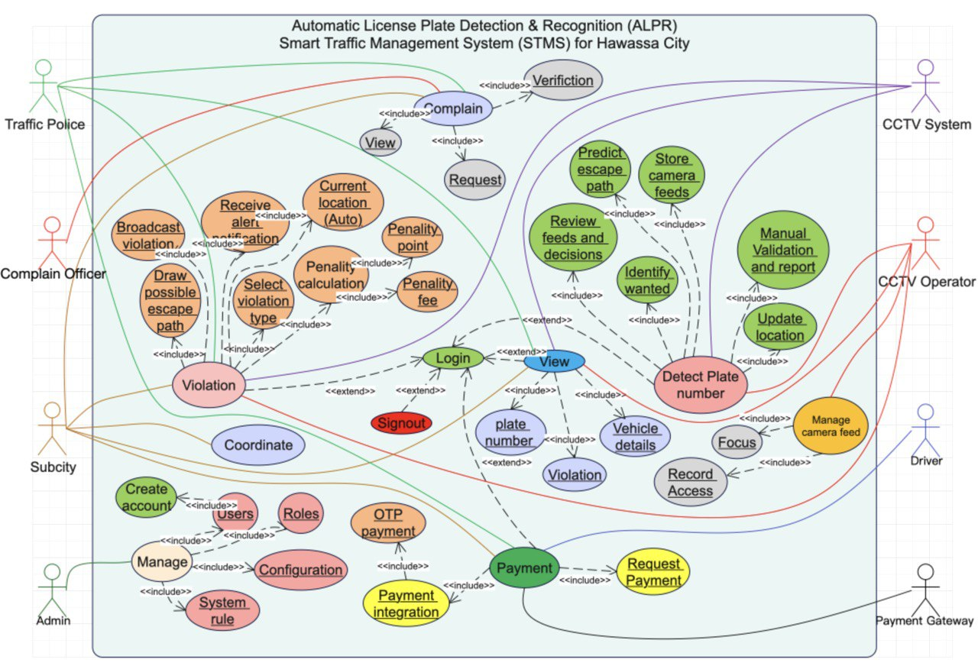
Fig 3.1 Use case UML Diagram of ALPR STMS, Hawassa

3.11 Use Case Documentation

UC-01: Login
Actors:
Traffic Police, Complain Officer, Subcity Officer, Admin, CCTV Operator
Description:
The primary security gateway for the system. It authenticates users based on their credentials and directs them to the appropriate dashboard based on their assigned role (defined in UC-03).
Preconditions:
User account must exist in the system.
Postconditions:
User is successfully authenticated and session is active.

UC-02: Signout
Actors:
All System Users
Description:
Allows any authenticated user to securely terminate their active session to prevent unauthorized access.
Relationships:
Extends: UC-01 Login
Postconditions:
Session is terminated; user is returned to the Login screen.

UC-03: Manage System (Administration)
Actors:
Admin
Description:
This is the administrative hub where the system environment is maintained. The Admin manages the human resources (users) and the logical rules that the system enforces.
Internal Scenarios (Included Behaviors):
- Users (Profile management); Includes Create Account: Registering new personnel into the database
- Roles (Permission assignment)
- Configuration: adjusting technical system settings
- System Rule (Defining penalty logic, speed limits, and enforcement thresholds)
Postconditions:
System configurations or User access rights are immediately updated.

UC-04: Detect Plate Number (Core Function)
Actors:
CCTV System (Primary/Auto), CCTV Operator (Secondary/Verification)
Description:
The core automated loop of the STMS. The system continuously processes video feeds to extract license plate data, cross-reference it with criminal databases, and track vehicle movement.
Internal Scenarios (Included Behaviors):
- Store Camera Feeds: Continuous archiving of video data for evidence.
- Predict Escape Path: Algorithmically determining potential routes for fleeing/wanted vehicles.
- Review Feeds and Decisions: Operator oversight of the automated detections.
- Identify Wanted: Real-time database check for stolen or flagged vehicles.
- Update Location: Logging the real-time GPS/Zone coordinates of the detected plate.
- Manual Validation and Report: Operator confirms the detection and finalizes the event report.
Preconditions:
Cameras are active and feeding data to the server.
Postconditions:
Vehicle presence is logged, location is updated, and alerts are ready for the violation module.

UC-05: Violation
Actors:
Traffic Police, Subcity Officer
Description:
This use case handles the enforcement workflow. Once a violation is detected, this module processes the specific offense, calculates the appropriate penalty, and alerts relevant units.
Internal Scenarios (Included Behaviors):
- Receive Alert Notification: Officer receives real-time data of an incident.
- Current Location (Auto): System automatically pulls location data from the detection module.
- Select Violation Type: Categorizing the offense (e.g., Speeding, Illegal Parking).
- Penalty Calculation: The logic engine that computes the fine; Includes: Penalty Point (Demerit points added to license), Penalty Fee (Financial amount calculated).
- Draw Possible Escape Path: Visualizing the predicted route on the officer’s map interface.
- Broadcast Violation: Sending alerts to nearby patrol units or sub-cities.
Relationships:
Extends: UC-01 Login (and interacts with View).
Postconditions:
Violation is officially recorded and penalty is assigned.

UC-06: View Data
Actors:
Traffic Police, Subcity Officer, CCTV Operator
Description:
A generalized use case allowing authorized roles to access read-only data for verification and monitoring.
Internal Scenarios (Included Behaviors):
- View Plate Number: Displaying the alphanumeric recognition result.
- View Vehicle Details: displaying ownership, model, and registration status.
- View Violation: Accessing the history of penalties associated with a plate.
Relationships:
Extends: UC-01 Login
Postconditions:
Requested data is displayed on the UI.

UC-07: Manage Camera Feed
Actors:
CCTV Operator
Description:
Allows the operator to manage the technical quality and retrieval of video data.
Internal Scenarios (Included Behaviors):
- Focus: Remote adjustment of camera lenses to improve recognition accuracy.
- Record Access: Retrieving specific historical video clips from storage.
Postconditions:
Camera feed is optimized or evidence is retrieved.

UC-08: Complain (Grievance Handling)
Actors:
Complain Officer
Description:
The workflow for handling disputes raised by citizens regarding penalties.
Internal Scenarios (Included Behaviors):
- Request: Logging a new complaint into the system.
- Verification: The process of validating the complaint against system evidence.
- View (Officer must view the violation record to verify).
Postconditions:
Complaint status is updated (Approved/Rejected).

UC-09: Coordinate
Actors:
Subcity Officer
Description:
Facilitates inter-departmental cooperation, allowing Subcity officers to manage traffic events that cross administrative boundaries.
Relationships:
Extends: UC-01 Login
Postconditions:
Coordination tasks are logged.

UC-10: Payment
Actors:
Traffic Police (Monitor), Subcity (Monitor), Driver (OTP Actor), Payment Gateway (External)
Description:
Handles the financial settlement of penalties. The system triggers a payment request which is processed via an external gateway.
Internal Scenarios (Included Behaviors):
- Request Payment: System initiates the transaction request.
- Payment Integration (Secure handshake with the banking API); Include OTP Payment: The validation step where the Driver receives a One-Time Password to authorize the fund transfer.
The Driver is an external actor whose only interaction with the system is receiving/inputting the OTP.
Postconditions:
Penalty status changes to "Paid" and free the active record.

3.12 Analysis-Level Class Diagram (Comprehensive Description and Rationale)

3.12.1 Purpose of the Analysis-Level Class Diagram
The Analysis-Level Class Diagram defines the static structural architecture of the ALPR-Based Smart Traffic Management System (ALPR-STMS) for Hawassa City.
It provides a technology-agnostic, business-focused model that identifies:
- Core domain entities
- Authorized human actors
- Supporting application services
- Evidence, intelligence, and enforcement components
- Relationships, multiplicity, and responsibility boundaries
The diagram serves as a foundational artifact for:
- Detailed design and implementation models
- Database schema derivation
- API and service contracts
- Role-Based Access Control (RBAC) enforcement
- Legal auditing and compliance verification

3.12.2 High-Level System Grouping and Structural Domains
To ensure clarity, maintainability, and legal defensibility, the system is divided into well-defined functional domains. Each domain encapsulates logically related responsibilities.
Primary Structural Domains
- Security & User Management
- Vehicle & Registration
- Violation & Enforcement (Core Domain)
- Surveillance & Evidence
- Intelligence & Coordination
- Complaint & Oversight
- Payment (External Interaction Only)
- Audit & Accountability
- Shared Value Objects
This grouping ensures clear separation of concerns, minimizes coupling, and enables independent evolution of subsystems.

3.12.3 Design Principles Applied

3.12.3.1 Single Responsibility Principle (SRP)
Each class has one clearly defined responsibility.
For example:
- Violation manages lifecycle state only
- Penalty manages punishment details only
- AuditLog manages traceability only

3.12.3.2 Separation of Concerns
The model separates:
- Actors → User hierarchy
- Business entities → Violation, Vehicle, Penalty
- Application services → ALPRProcessor, RoutePrediction
- Infrastructure → CCTVFeed, AuditLog
This prevents role confusion and legal ambiguity.

3.12.3.3 Role-Based Access Control (RBAC)
RBAC is implemented using:
- An abstract User superclass
- Controlled inheritance
- Explicit role responsibilities
Drivers are explicitly excluded from system login.

3.12.3.4 Auditability and Legal Validity
Every legally significant action is traceable via:
- AuditLog
- Explicit user attribution
- Timestamped records
This ensures:
- Court admissibility
- Internal investigations
- Anti-corruption compliance

3.12.3.5 Human-in-the-Loop Enforcement
Automated components support but never replace human authority.
No violation becomes enforceable without:
- Officer validation
- Evidence attachment
- Supervisor confirmation (where required)

3.12.4 Security & User Management Domain

3.12.4.1 Abstract Class: User
Purpose:
- Represents all authorized system personnel.
- It does not represent drivers or vehicle owners.
- Attributes
- userId : String – Unique system identifier
- fullName : String – Official identity
- phoneNumber : String – Communication and OTP reference
- email : String – Notifications and audit contact
- role : String – RBAC identifier
- Responsibilities
- Establish authenticated identity
- Enable controlled access to system functions
- Ensure accountability for every action

3.12.4.2 TrafficOfficer
Represents on-duty field traffic police.
Additional Attributes
- badgeNumber : String
- rank : String
- currentLocation : GeoCoordinate
Responsibilities
- Manually report violations
- Initiate violation records
- Draw estimated escape routes
- Receive and respond to alerts
Associations
- One TrafficOfficer → many Violations
- One TrafficOfficer → many Alerts

3.12.4.3 SubcityOfficer
Represents jurisdiction-level coordination authority.
Responsibilities
- Validate violations
- Coordinate inter-subcity enforcement
- Authorize escalation
- Supervise payment initiation

3.12.4.4 CCTVOperator
Responsible for surveillance validation.
Responsibilities
- Monitor live CCTV feeds
- Validate ALPR detections
- Attach video/image evidence
- Support complaint investigations

3.12.4.5 ComplaintOfficer
Ensures independent oversight.
Responsibilities
- Review complaints (office-based)
- Retrieve violation records
- Request additional evidence
- Decide confirmation or dismissal

3.12.4.6 SystemAdmin
System governance authority.
Responsibilities
- Manage users and roles
- Configure violation rules
- Maintain system parameters
- Oversee audit compliance

3.12.5 Vehicle & Registration Domain

3.12.5.1 Vehicle
Represents a registered vehicle (read-only for enforcement).
Attributes
- plateNumber (Primary Identifier)
- vehicleType
- model
- color
- ownerName
- registrationStatus
Relationship
- One Vehicle → many Violations

3.12.5.2 LicensePlate (Value Object)
Generated by ALPR processing.
Attributes
- plateNumber
- plateImage
- confidenceScore
Used to ensure AI results are reviewable and auditable.

3.12.6 Violation & Enforcement Domain (Core)

3.12.6.1 Violation
Central entity of the entire system.
Attributes
- violationId
- violationType
- description
- timestamp
- location
- status
Lifecycle States
- Pending
- Confirmed
- UnderComplaint
- Dismissed
- Paid
Responsibilities
- Maintain complete enforcement lifecycle
- Link vehicle, evidence, penalties, alerts, and complaints
- Serve as single source of truth

3.12.6.2 ViolationRule
Represents codified traffic laws.
Attributes
- ruleCode
- ruleName
- penaltyAmount
- penaltyPoints
- isOptional
Purpose
- Enables legal compliance
- Eliminates hard-coded penalties
- Supports policy updates

3.12.6.3 Penalty
Represents validated punishment.
Attributes
- penaltyId
- amount
- points
- status
Constraint
- Exists only if violation is confirmed
- One-to-one with Violation

3.12.7 Surveillance & Evidence Domain

3.12.7.1 Camera
Represents physical CCTV infrastructure.
Attributes
- cameraId
- cameraType
- location
- status

3.12.7.2 CCTVFeed
Represents captured footage.
Attributes
- feedId
- timestamp
- videoStream
Associations
- One Camera → many CCTVFeeds
- One Violation → zero or many CCTVFeeds

3.12.7.3 ALPRProcessor (Application Service)
Automated detection assistant.
Responsibilities
- Detect license plates
- Extract characters
- Assign confidence scores

3.12.8 Intelligence & Coordination Domain

3.12.8.1 Alert
Represents notifications to enforcement units.
Attributes
- alertId
- priority
- message
- timestamp
Filtered by
- Location
- Jurisdiction
- Predicted escape routes

3.12.8.2 RoutePrediction (Application Service)
Provides predictive intelligence.
Attributes
- predictedPaths
- confidenceLevel
Supports proactive interception and coordination.

3.12.9 Complaint & Oversight Domain

3.12.9.1 Complaint
Represents formal citizen challenges.
Attributes
- complaintId
- reason
- status
Ensures due process and trust.

3.12.9.2 AuditLog
Ensures transparency and legal traceability.
Attributes
- logId
- action
- timestamp
- performedBy
Coverage
- Violation creation
- Validation
- Complaint decisions
- Payment confirmation
- Rule configuration

3.12.10 Payment Domain (External Interaction Only)

3.12.10.1 Payment
Represents OTP-based financial settlement.
Attributes
- paymentId
- paymentMethod : OTP
- amount
- paymentDate
Critical Design Rules
- Driver never logs into system
- Payment initiated only after confirmation
- OTP handled externally

3.12.11 Shared Value Objects

3.12.11.1 GeoCoordinate / GeoLocation
Reusable location object.
Attributes
- latitude
- longitude
Used consistently across:
- Violations
- Cameras
- Officers
- Route prediction

3.12.12 Conclusion
The merged analysis-level class diagram and documentation provide a legally defensible, scalable, and human-centered structural foundation for the ALPR-Based Smart Traffic Management System.
The design:
- Preserves citizen rights
- Prevents autonomous enforcement abuse
- Enables smart-city intelligence
- Aligns with Ethiopian urban governance and public accountability standards
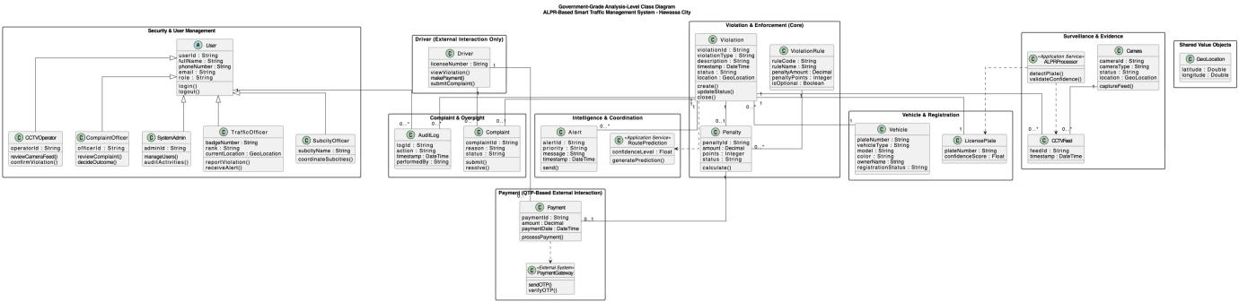Fig 3.2 Class UML Diagram ALPR STMS, Hawassa
Use Case | Supporting Classes
Violation | Violation, Vehicle, Alert, RoutePrediction
Detect Plate | Camera, CCTVFeed, ALPRProcessor, LicensePlate
Payment | Penalty, Payment
Complaint Handling | Complaint, Violation, CCTVFeed
Manage | User, ViolationRule, AuditLog
Coordinate | Alert, SubcityOfficer
Table 3.2 Alignment with Use Cases

3.13 SEQUENCE DIAGRAMS – DETAILED OPERATIONAL INTERACTION MODEL

3.13.1 Purpose and Government Context
Sequence diagrams in this system serve as official operational blueprints that describe how traffic enforcement decisions are formed, validated, coordinated, paid, disputed, and archived.
Unlike commercial systems, this design explicitly ensures:
- No automated punishment
- No direct driver-system interaction
- Human validation at every legal decision point
- Complete auditability
All diagrams comply with:
- Ethiopian traffic enforcement principles
- Evidence-based decision standards
- Government ICT accountability requirements

Notation | Meaning
alt | Legal decision branches
opt | Optional but permitted flows
return | Explicit system response
ref | Logical delegation
note | Legal/administrative clarification
Solid arrows | Mandatory operations
Dashed arrows | Responses / acknowledgements
Table 3.3 Legend and Modeling Conventions

3.13.2 Detailed Sequence Flow Descriptions

3.13.2.1 Security Login Sequence (All Officials – Excluding Driver)
Purpose
To ensure authenticated, role-based, and auditable access for all human system users, except drivers, who are explicitly excluded from system access.
Actors Involved
- Traffic Officer
- Subcity Officer
- CCTV Operator
- Complaint Officer
Detailed Sequence Flow

1, User Access Initiation
- An authorized official accesses the system through the secured Login UI.
- Access is only permitted from registered devices or secure networks.

2, Credential Submission
- Unique personnel ID
- Username
- Password
- Optional second factor (OTP / biometric) depending on role sensitivity

3, Authentication Request
- Login UI transmits encrypted credentials to the Authentication Service.
- No credentials are stored or cached at the UI layer.

4, Identity Verification
- Credential correctness
- Account status (active, suspended, revoked)
- Role authorization level

5, Audit Logging
- User ID
- Timestamp
- IP/device fingerprint
- Outcome

6, Access Grant / Denial
- If successful:
- Secure session token is issued
- Role-based access rights are loaded
- If failed:
- Access is denied
- System enforces retry limits and lockout policies

7, Legal & Security Notes
- Drivers never authenticate into the system.
- Login records are legally admissible audit evidence.
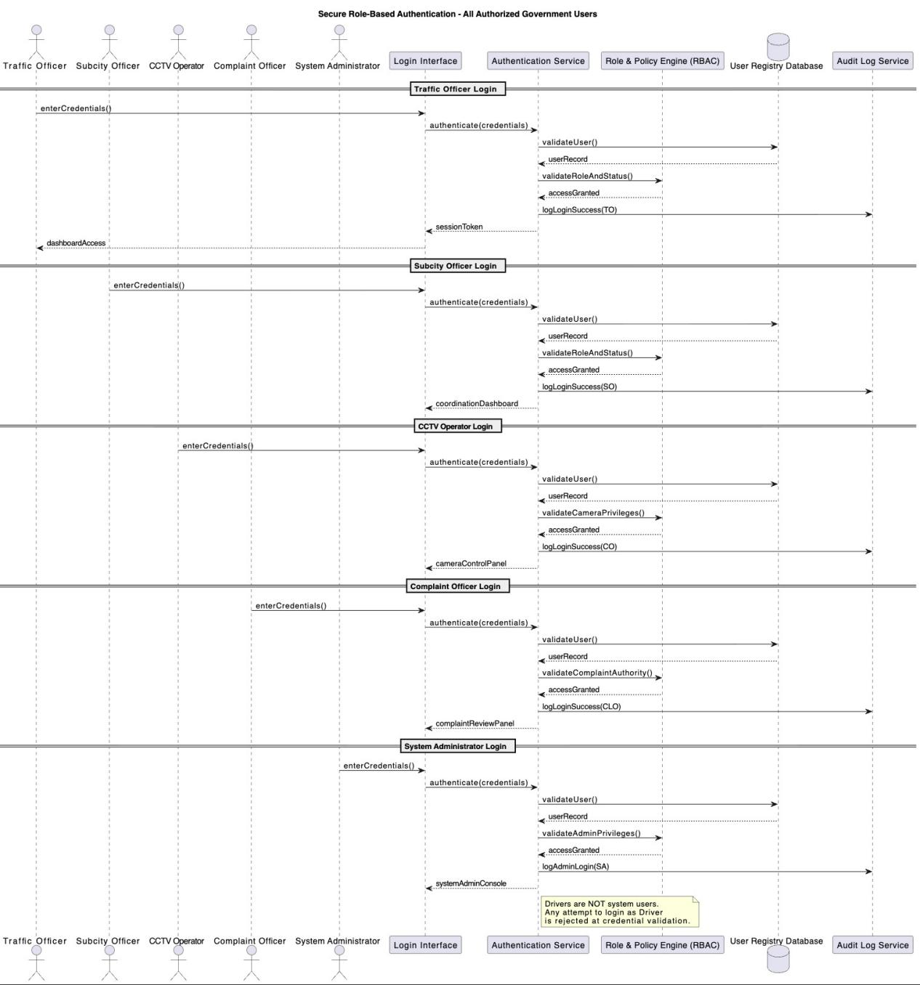Fig 3.3 Security Login Sequence UML Diagram ALPR STMS, Hawassa

3.13.2.2 Manual Violation Reporting (Traffic Officer)
Purpose
To allow on-site, legally accountable violation creation by traffic officers.
Detailed Sequence Flow
1, Violation Observation
- Traffic Officer identifies a violation physically on the road.
2, Violation Reporting Initiation
- Officer selects “Create Violation” from the system dashboard.
3, Automatic Context Capture [Automatic Location Update Service captures]
- GPS coordinates
- Time and date
- Officer identity
4, Violation Data Entry
- Violation type
- Vehicle description
- Plate number (manual or assisted)
5, Violation Record Creation
- PENDING_CONFIRMATION
6, Penalty Drafting
- Applicable fine
- Legal references
7, Audit Trail Creation
- Full violation creation process is logged.
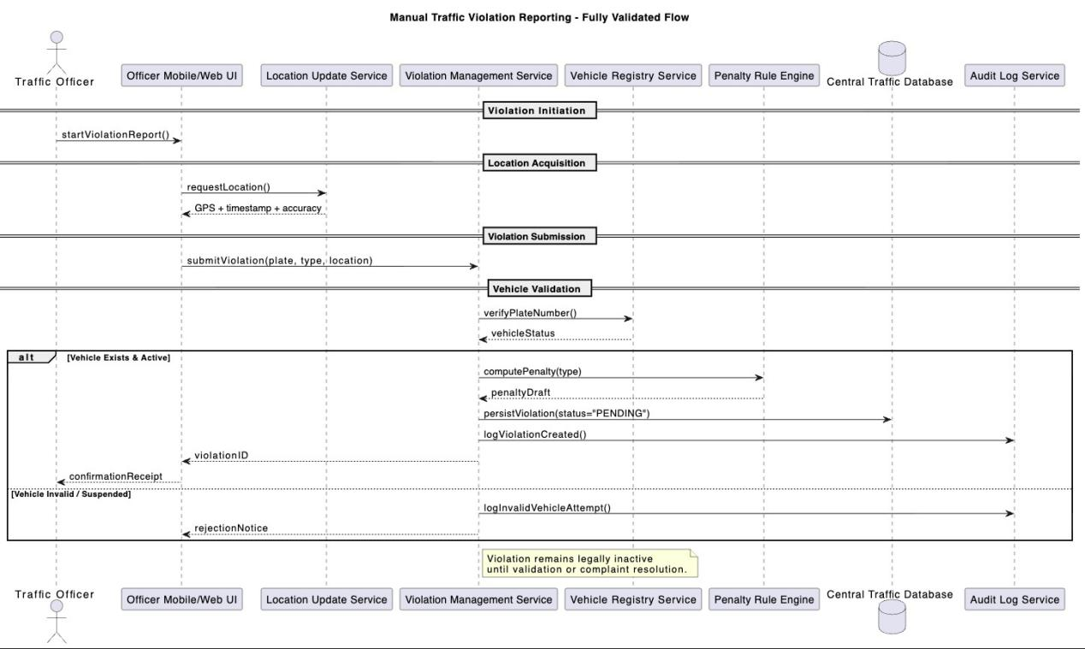Fig 3.4 Manual Violation Reporting Sequence UML Diagram ALPR STMS, Hawassa

3.13.2.3 CCTV-Assisted Automated Violation Detection (Advanced System-Initiated Detection)
Purpose
To detect violations without human presence, while ensuring human validation before enforcement.
Detailed Sequence Flow

1, Continuous Video Streaming
- CCTV cameras stream live footage to the CCTV Feed Manager.

2, Frame Analysis
- License plates
- Traffic violations

3, Confidence Scoring
- Each detection is assigned a confidence score.

4, Decision Gate
- If confidence < legal threshold:
- Detection is discarded
- Logged for transparency
- If confidence ≥ threshold:
- Proceed to candidate violation creation

5, Location Binding
- Camera ID
- Geo-coordinates
- Timestamp

6, Candidate Violation Creation
- Stored as UNCONFIRMED
- No penalty or notification yet

7, Mandatory Human Review
- CCTV Operator reviews footage and evidence.

8, Validation Outcome
- Confirm → Violation becomes active
- Reject → Violation permanently dismissed

3.13.2.4 Educational Route Prediction & Alerting
Purpose
To predict vehicle movement and assist officers in preventive and educational enforcement, not pursuit alone.
Detailed Sequence Flow

1, Violation Confirmation Trigger
- Confirmed violation triggers route prediction.

2, Path Analysis
- Road network
- Traffic patterns
- Historical movement data

3, Educational Alerts
- Subcity officers
- Nearby traffic officers
Focused on awareness, interception, or guidance

4, Audit Logging
- Predictions and alerts are logged for accountability.
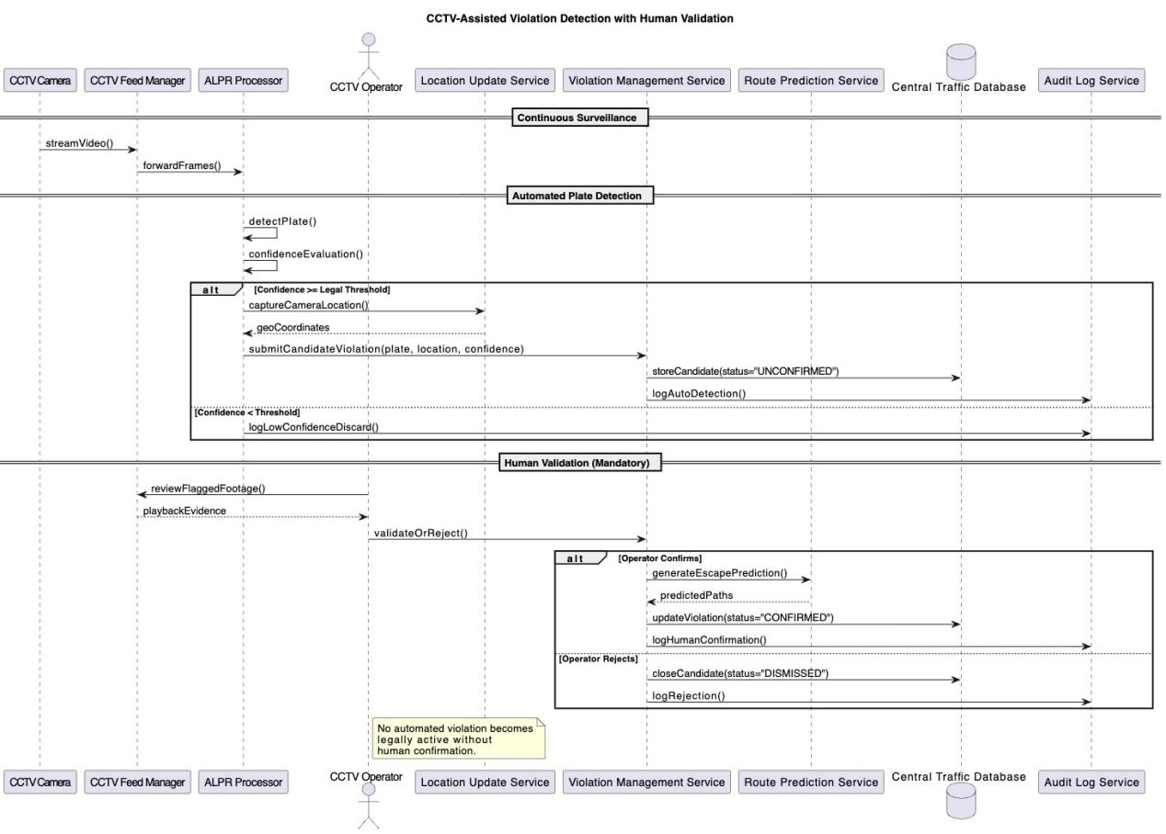Fig 3.5 CCTV-Assisted Violation Sequence UML Diagram ALPR STMS, Hawassa

3.13.2.5 Inter-Subcity Coordination
Purpose
To ensure cross-jurisdiction enforcement continuity.
Detailed Sequence Flow

1, Subcity Escalation
- Subcity Officer escalates violation when vehicle exits jurisdiction.

2, Central Coordination
- Alert Service routes information to neighboring subcities.

3, Shared Visibility
- All involved subcities can view violation status.

4, Audit Logging
- Escalation paths recorded.
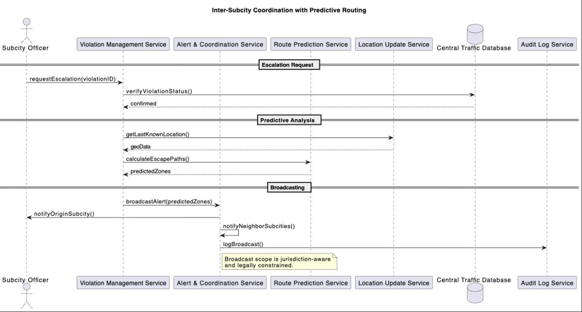Fig 3.6 Inter-Subcity Coordination Sequence UML Diagram ALPR STMS, Hawassa

3.13.2.6 Complaint Handling (Office-Only, No Driver System Access)
Purpose
To ensure fair review and legal correction of violations.
Detailed Sequence Flow

1, Driver Complaint Submission
- Driver receives violation ID from officer.
- Driver visits subcity office (no system access).

2, Complaint Retrieval
- Complaint Officer retrieves violation by ID.

3, Evidence Review
- CCTV footage requested if applicable.
- Reporting officer may be contacted.

4, Decision Making
- Confirm violation → proceed to payment
- Revoke violation → close permanently

5, Audit Recording
- Decision rationale recorded.
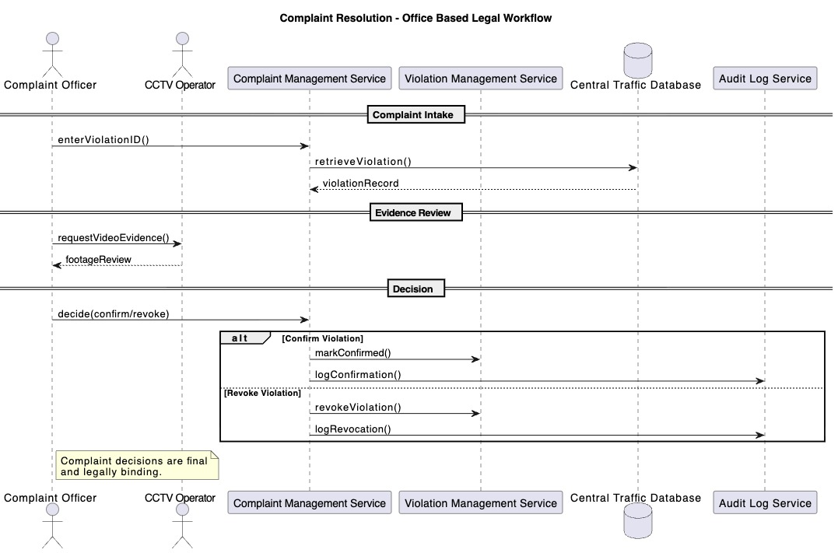Fig 3.7 Complain Resolution Sequence UML Diagram ALPR STMS, Hawassa

3.13.2.7 Payment Processing (OTP-Only Driver Interaction)
Purpose
To allow secure, limited, and controlled payment without system exposure.
Detailed Sequence Flow

1, Payment Initiation
- Traffic Officer OR
- Subcity Officer (post-complaint)

2, OTP Generation
- Payment Service requests OTP from Payment Gateway.

3, Driver Interaction
- Driver receives OTP.
- Submits OTP only.

4, Payment Confirmation
- Gateway confirms payment.

5, System Update
- Payment stored.
- Violation marked as PAID.

6, Audit Logging
- Financial trail fully logged.
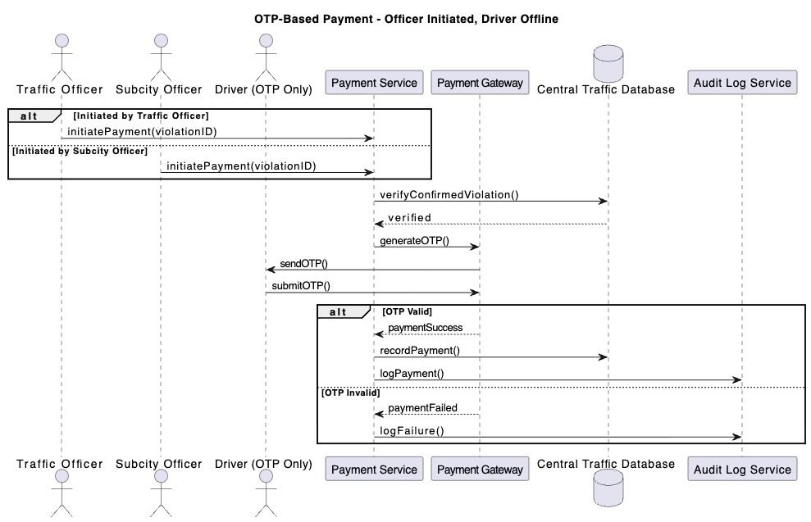Fig 3.8 OTP based Payment Sequence UML Diagram ALPR STMS, Hawassa

3.13.2.8 System Closure & Reporting
Purpose
To formally conclude enforcement and maintain institutional records.
Detailed Sequence Flow

1, Final Status Review
- Subcity Officer reviews violation lifecycle.

2, Reporting
- Legal review
- Statistical analysis
- Policy planning

3, Audit Preservation
- Records retained per government retention laws.
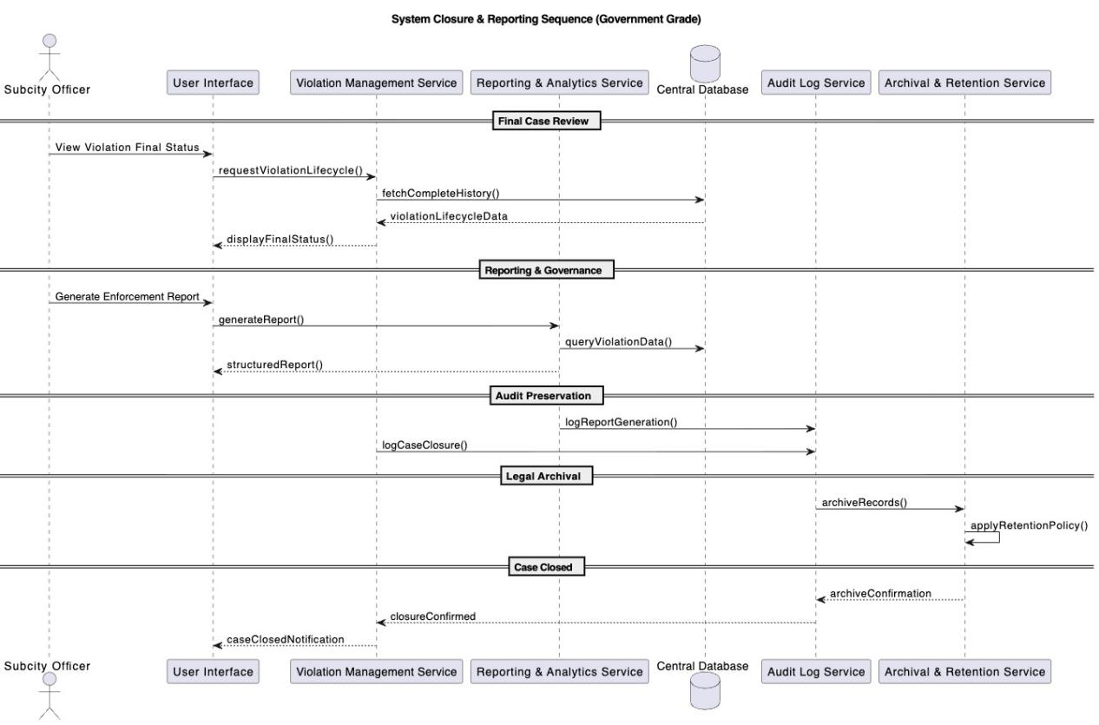Fig 3.9 System Closure Sequence UML Diagram ALPR STMS, Hawassa
Final Compliance Statement
- All officials authenticated
- Driver excluded from system
- Automation never enforces alone
- Human accountability preserved
- Court-defensible audit trails
- Government-grade operational rigor
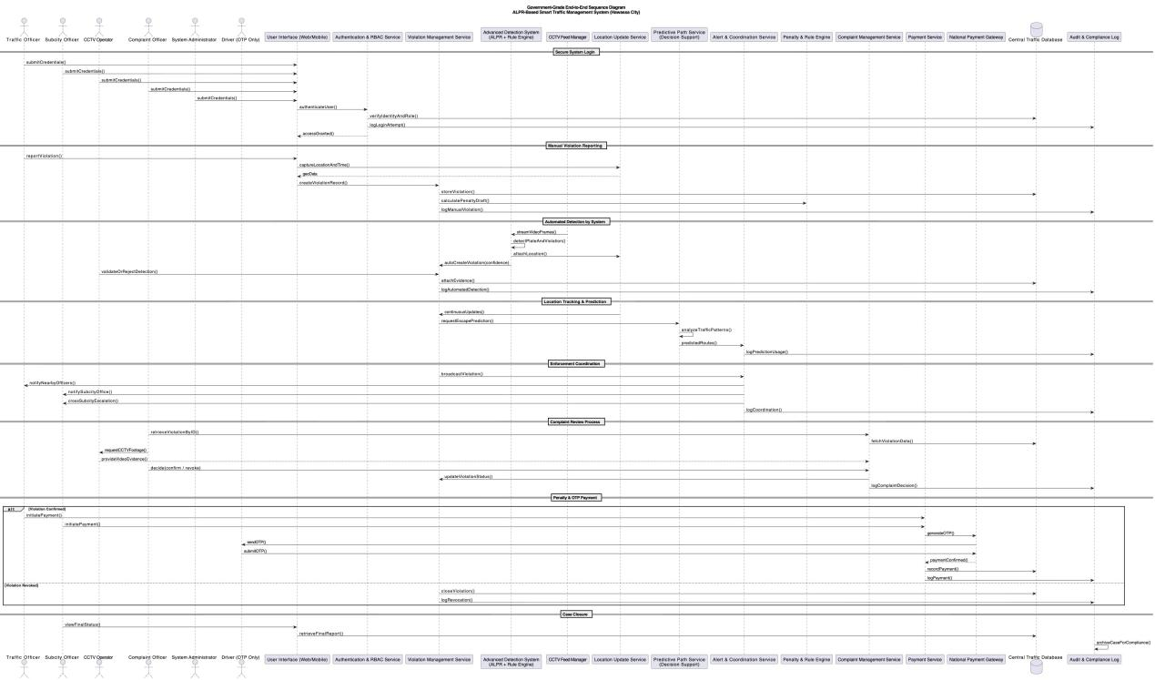
Fig 3.10 Full-System Sequence UML Diagram ALPR STMS, Hawassa

3.14 Activity Diagram – Detailed Functional Documentation

3.14.1 Introduction
The Activity Diagram represents the end-to-end operational workflow of the Automatic License Plate Detection and Recognition–Based Smart Traffic Management System (ALPR-STMS) deployed for Hawassa City Administration.
This diagram models the dynamic behavior of the system by illustrating:
- The sequence of actions
- The decision points
- The parallel activities
- The responsibilities of each actor
- The system’s internal processing
The objective is to ensure that every operational step is legally valid, traceable, role-controlled, and auditable, in compliance with government traffic enforcement standards.

3.14.2 Scope and Coverage
The Activity Diagram covers the complete traffic enforcement lifecycle, including:
- Secure system access
- Manual and automated violation detection
- Inter-officer coordination
- Vehicle interception
- Complaint handling
- OTP-based payment
- Case closure and reporting
The diagram explicitly excludes direct system interaction by drivers, except during OTP-based payment confirmation, in line with the system’s governance model.

3.14.3 Authentication and Role Assignment Phase
Purpose
To ensure that only authorized government personnel can access and operate the system.
Process Description
1, All system users (Traffic Officers, Subcity Officers, CCTV Operators, Complaint Officers, System Administrators) must enter valid credentials.
2, The Authentication Service validates credentials against the central authority database.
3, Upon successful authentication:
- A secure session is established.
- The user is assigned role-based permissions.
4, If authentication fails, access is denied and the process terminates.
Key Controls
- Mandatory authentication
- Role-based access control (RBAC)
- Audit logging of login events
Legal Significance
Ensures accountability and non-repudiation for every action taken within the system.

3.14.4 Violation Detection Phase (Parallel Activities)
Purpose
To detect traffic violations through both human observation and automated surveillance.
Parallel Execution Logic
This phase executes in parallel, ensuring maximum coverage and responsiveness.

3.14.4.1 Manual Detection by Traffic Officer
1, The Traffic Officer observes a traffic violation.
2, The officer records:
- Vehicle plate number
- Violation type
3, The violation is submitted to the system for processing.
This preserves the human authority and discretion required by law.

3.14.4.2 Automated Detection by ALPR & CCTV System
1, CCTV cameras continuously monitor traffic flow.
2, The ALPR subsystem:
- Detects plate numbers
- Analyzes behavior against violation rules
3, If a violation is detected:
- An automated violation report is generated.
4, If no violation is detected, the automated process ends silently.
Governance Principle
Automated detection supports enforcement but does not replace human validation.

3.14.5 Violation Registration and Evidence Capture
Purpose
To formally register violations with complete contextual data.
System Actions
- Capture GPS location and timestamp
- Store violation with status Pending
- Generate initial audit log entry
Outcome
A legally traceable violation record exists, ready for coordination and enforcement.

3.14.6 Alert Broadcasting and Coordination Phase
Purpose
To enable rapid, structured inter-unit coordination.
Process
- The Alert & Coordination Service broadcasts the violation.
- Notifications are sent to:
- Nearby Traffic Officers
- Relevant Subcity Officer
Benefits
- Faster interception
- Jurisdictional awareness
- Reduced escape probability

3.14.7 Vehicle Interception and Driver Interaction
Purpose
To safely stop the vehicle and determine the next enforcement path.
Traffic Officer Responsibilities
- Intercept the vehicle
- Stop the vehicle using lawful procedures
- Inform the driver of the violation
Decision Point
The process now diverges based on the driver’s response.

3.14.8 Immediate Admission Path (No Complaint)
Condition
Driver admits the violation.
Process
- Traffic Officer confirms the violation on-site.
- System finalizes the penalty.
- Payment authorization is issued.
Key Rule
This path allows rapid enforcement without administrative delay.

3.14.9 Complaint Handling Path (Office-Based Only)
Condition
Driver disputes the violation.
Process
- Traffic Officer issues a Violation Record ID.
- Driver is directed to the Subcity Traffic Office.

3.14.9.1 Complaint Officer Review
- Complaint Officer logs into the system.
- Retrieves the violation using the provided ID.
- Reviews:
- Officer report
- Violation details

3.14.9.2 CCTV Evidence Support
- CCTV Operator provides video evidence upon request.
- Evidence is reviewed for confirmation.

3.14.9.3 Decision Outcomes
Violation Confirmed
- Penalty is finalized.
- Payment authorization is issued.
Violation Revoked
- Violation status updated to Revoked.
- Decision is logged.
- Process terminates with no payment.

3.14.10 Payment Processing Phase (OTP-Based)
Purpose
To securely collect penalties without exposing drivers to the internal system.
Process
- Payment Service initiates OTP request.
- Payment Gateway sends OTP to the driver.
- Driver submits OTP.
- Payment is confirmed or marked pending.
Security Controls
- OTP validation
- Gateway integration
- Audit logging

3.14.11 Case Closure and Archival
Purpose
To formally conclude enforcement and preserve records.
Final Actions
- Subcity Officer reviews final case status.
- System:
- Closes the case
- Archives all records
- Preserves audit logs
- Generates analytical and legal reports
Compliance
Data retention follows government record-keeping laws.

3.14.12 Summary of Activity Diagram Strengths
The activity diagram ensures:
- Legal compliance
- Clear authority boundaries
- Human-in-the-loop enforcement
- Secure payment handling
- Full traceability
- Audit readiness
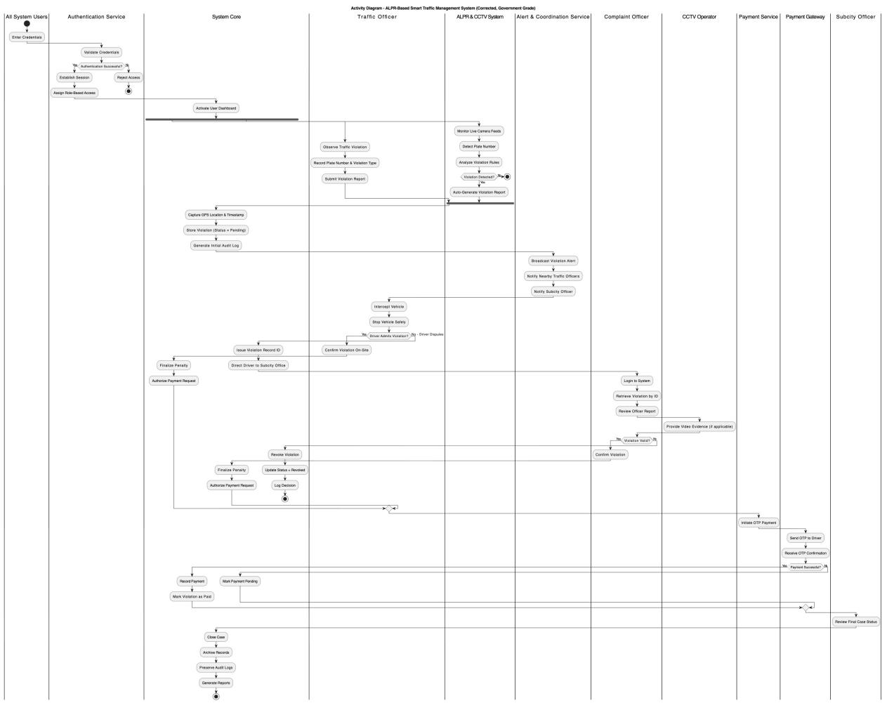Fig 3.11 Full-System Activity UML Diagram ALPR STMS, Hawassa

3.15 User Interface Prototyping

3.15.1 Introduction
User Interface (UI) Prototyping is a critical activity in system analysis that translates functional and non-functional requirements into visual, role-specific interaction models. The objective of UI prototyping in this project is not aesthetic design, but operational clarity, legal correctness, and usability under real traffic enforcement conditions.
For the ALPR-Based Smart Traffic Management System (ALPR-STMS), the user interfaces are designed to:
- Support fast, error-free enforcement actions
- Reflect institutional roles and authority
- Minimize cognitive load on officers in the field
- Ensure auditability and traceability
- Operate under low bandwidth and high-stress environments
All interfaces follow:
- Role-Based Access Control (RBAC)
- Government usability standards
- Minimal input, maximum automation
- Clear status visibility

3.15.2 User Interface Design Principles
The following principles govern all UI prototypes:
a) Role Separation
Each user role accesses only the screens relevant to their legal authority:
- Traffic Officer
- Subcity Officer
- CCTV Operator
- Complaint Officer
- System Administrator
Drivers are NOT system users and have no UI access.
b) Field-First Design
Interfaces for traffic officers are:
- Mobile-first
- Large buttons
- Minimal typing
- GPS-assisted
- Offline-tolerant
c) Evidence-Centric Enforcement
Every violation screen prioritizes:
- Plate number
- Time & location
- Evidence (image/video)
- Status lifecycle
d) Audit & Accountability
All screens visibly show:
- Logged-in officer identity
- Timestamp
- Action confirmation
- Immutable records

3.15.3 UI Prototypes by User Role

3.15.3.1 Login Interface (All Human Operators)
Applicable Users
- Traffic Officer
- Subcity Officer
- CCTV Operator
- Complaint Officer
- System Administrator
Purpose
- To authenticate human users and assign them to their authorized operational environment.
UI Elements
- Username / Badge Number
- Password
- Role auto-resolution (no manual role selection)
- Login button
- Error / lockout message
Behavior
- Credentials validated against central database
- Role determined automatically
- Session established with RBAC
- Login event logged in Audit Log
Security Notes
- No driver login
- No OTP here
- Multi-factor optional (future phase)

3.15.3.2 Traffic Officer Dashboard (Core Operational UI)
Purpose
- Primary enforcement workspace for field officers.
Main Components
- Current location (map view)
- “Report Violation” button
- Active alerts list
- Wanted vehicle notifications
- Shift status
Key Actions
- Create violation
- Draw escape path
- Receive broadcast alerts
- Initiate penalty request (when driver admits)

3.15.3.3 Violation Reporting Interface
Triggered From
- Traffic Officer Dashboard
UI Sections
- Vehicle Information
- Plate number (manual or ALPR)
- Vehicle type (optional)
- Violation Details
- Violation type (dropdown)
- Description (optional)
- Auto-captured timestamp
- Location
- Auto GPS
- Manual adjustment if needed
- Evidence
- Photo upload
- CCTV reference (if available)
- Prediction
- Map canvas to draw escape path
- Radius suggestion auto-generated
- Submit
- Confirmation dialog
- Violation ID generated

3.15.3.4 Alert & Coordination Interface
Used By
- Traffic Officers
- Subcity Officers
Features
- Real-time alert feed
- Priority color coding
- Predicted route overlay
- Inter-subcity escalation controls
Behavior
- Alerts filtered by proximity
- Officers acknowledge receipt
- All actions logged

3.15.3.5 CCTV Operator Interface
Purpose
- Support ALPR-assisted detection and validation.
UI Components
- Live camera list
- Video feed viewer
- Detected plate panel
- Confidence score display
- Approve / Reject detection buttons
Workflow
- System proposes detection
- Operator validates
- Evidence linked to violation
- Location update broadcasted

3.15.3.6 Complaint Handling Interface (Subcity Office Only)
Used By
- Complaint Officer
Purpose
- To ensure legal fairness and due process.
UI Components
- Violation ID search
- Violation timeline
- Evidence viewer
- CCTV request button
- Decision panel
Decisions
- Confirm violation → Payment authorized
- Revoke violation → Case closed
Driver presence is physical, not digital.

3.15.3.7 Payment Interface (Officer-Initiated Only)
Who Can Initiate
- Traffic Officer (if driver admits)
- Subcity Officer (after complaint resolution)
UI Elements
- Violation ID
- Amount & points
- “Request OTP Payment” button
- Payment status indicator
Driver Interaction
- Receives OTP on phone
- Enters OTP to payment gateway
- No system login

3.15.3.8 System Administration Interface
Used By
- System Administrator
Functions
- User management
- Role assignment
- Violation rule configuration
- Camera registry
- Audit review

3.15.4 UI Navigation Structure
Login
├── Traffic Officer Dashboard
│ ├── Report Violation
│ ├── Alerts
│ └── Payment Request
├── Subcity Officer Dashboard
│ ├── Coordination
│ ├── Complaints
│ └── Reporting
├── CCTV Operator
│ ├── Live Feeds
│ └── Detection Validation
└── Admin
├── Users
├── Rules
└── Audit Logs

3.15.5 Non-Functional UI Requirements
- Response time < 3 seconds
- Mobile-friendly (officers)
- Low bandwidth tolerant
- Amharic & English ready
- WCAG-aligned accessibility

3.15.6 User Experience (UX) Justification for Examiners
Purpose of UX Justification
The User Experience (UX) design of the ALPR-Based Smart Traffic Management System is intentionally engineered to support law enforcement accuracy, legal accountability, operational efficiency, and institutional adoption rather than consumer convenience.
This section justifies UX decisions based on government system standards, human factors engineering, and public-sector operational realities, ensuring the system is fit for production deployment within Hawassa City Administration.

3.15.6.1 UX Design Philosophy
The UX design follows a “Command-and-Control Public System Model”, not a commercial or citizen-centric application model.
Core Principles Applied
- Authority-Driven Interaction
- Error Prevention over Error Recovery
- Minimal Cognitive Load
- Legally Traceable Actions
- Role-Bound Visibility
These principles ensure that every action is intentional, auditable, and compliant with traffic law enforcement procedures.

3.15.6.2 Role-Based UX Segregation (Critical Design Decision)
Justification
Each user category operates under different legal mandates and responsibilities. Therefore, the UX strictly enforces role isolation.
Role | UX Design Rationale
Traffic Officer | Fast, field-ready interfaces prioritizing reporting & alerts
CCTV Operator | High-visibility monitoring, validation-focused screens
Subcity Officer | Coordination dashboards, escalation views
Complaint Officer | Evidence-centric, decision-support interfaces
System Admin | Configuration, governance, audit access
Driver | No system UI access (OTP only)
Table 3.4 Role and UX Design Rationale

3.15.6.3 Login UX Justification (All Human Operators)
Why All Human Operators Must Log In
- Establishes individual accountability
- Enables audit trail generation
- Supports role-based access control
- Prevents anonymous system actions
Why Drivers Do NOT Log In
- Drivers are external subjects, not system operators
- Legal procedures require office-based complaint handling
- Prevents digital disputes and identity fraud
- Aligns with current Ethiopian traffic enforcement practices
UX Outcome: Reduced system complexity, higher legal defensibility.

3.15.6.4 Minimalist Interface Design Justification
Why the UI Avoids Visual Complexity
- Users operate under stressful, time-critical conditions
- Many officers have varying levels of digital literacy
- Government systems prioritize clarity over aesthetics
UX Decisions
- Neutral colors
- Large actionable elements
- Explicit labels (no icons-only actions)
- No hidden or gesture-based controls
UX Outcome: Faster training, fewer operational errors, higher adoption.

3.15.6.5 Evidence-Centric UX Design
Justification
Traffic enforcement decisions must withstand:
- Legal scrutiny
- Complaints and appeals
- Administrative review
UX Implementation
- Evidence always visible, never hidden
- No deletion rights at operational levels
- Clear linkage between:
- Violation
- Evidence
- Decision
- Payment
UX Outcome: Strong chain of custody and institutional trust.

3.15.6.6 Alert & Broadcast UX Justification
Why Alerts Are Centralized and Prioritized
- Traffic enforcement is time-sensitive
- Missed alerts can result in:
- Escaped vehicles
- Public safety risks
- Administrative failure
UX Design Choices
- Priority-coded alerts
- Geographic relevance filtering
- Read-only alert messages (no alteration)
UX Outcome: Faster interception and coordinated response.

3.15.6.7 Complaint Handling UX Justification
Why Complaints Are Office-Based Only
- Ensures human judgment
- Prevents emotional or impulsive digital disputes
- Allows evidence verification with officers and CCTV operators
UX Characteristics
- Step-by-step review screens
- Mandatory decision logging
- Evidence request workflow embedded
UX Outcome: Fairness, transparency, and legal compliance.

3.15.6.8 Payment UX Justification (OTP-Only for Drivers)
Why OTP Payment Is the Only Driver Interaction
- Reduces system exposure to the public
- Eliminates need for driver accounts
- Aligns with national digital payment practices
Why Payment Can Be Initiated by:
- Traffic Officer (admitted violation)
- Subcity Officer (post-complaint)
UX Outcome: Secure, simple, and fraud-resistant payment flow.

3.15.6.9 Predictive Path & Location UX Justification
Why Map-Based Interaction Is Used
- Matches officers’ real-world mental models
- Improves situational awareness
- Supports coordination across subcities
UX Safeguards
- Prediction shown as assistive, not authoritative
- Human override always allowed
UX Outcome: Decision support without removing human authority.

3.15.6.10 Audit & Transparency UX Justification
Why Users See Audit Indicators
- Reinforces professional responsibility
- Discourages misuse
- Aligns with public-sector accountability culture
UX Implementation
- “All actions are logged” notices
- No silent system actions
UX Outcome: Ethical use and institutional trust.

3.16 Supplementary Specifications

3.16.1 Scope and Purpose
This section specifies supplementary system requirements that apply across the entire ALPR-Based Smart Traffic Management System (ALPR-STMS) and are not fully expressed through functional requirements or UML models.
These requirements address:
- Quality attributes
- Legal and regulatory constraints
- Operational constraints
- Security, reliability, and usability
- External system dependencies

3.16.2 Security Requirements
Authentication
The system shall require authentication for all human users, including:
- Traffic Officers
- Subcity Officers
- CCTV Operators
- Complaint Officers
- System Administrators
Drivers shall not authenticate into the system.
Authorization
- The system shall enforce role-based access control (RBAC).
- Users shall only access functions explicitly permitted by their assigned role.
Auditability
The system shall log all security-critical actions, including:
- Login and logout
- Violation creation and updates
- Payment initiation and confirmation
- Complaint decisions
Audit logs shall be tamper-resistant and retained according to government regulations.

3.16.3 Legal and Regulatory Constraints
- The system shall comply with:
- Road Transport Traffic Control Council of Ministers Regulation No. 557/2024
- National surveillance and data protection laws
CCTV footage shall only be accessed by authorized personnel and used solely for traffic enforcement.
Evidence records shall be retained according to legally mandated retention periods.

3.16.4 Performance Requirements
- The system shall process manual violation reports in near real-time.
- Alert broadcasts shall occur within operationally acceptable latency after violation confirmation.
- ALPR processing shall not degrade core enforcement operations during peak traffic hours.

3.16.5 Reliability and Availability
- The system shall support fault tolerance, ensuring manual enforcement remains operational if:
- CCTV feeds fail
- Network connectivity is disrupted
- Automated backups shall be performed regularly to prevent data loss.
- The system shall support graceful recovery after partial failures.

3.16.6 Data Integrity and Consistency
- All violations shall maintain a complete lifecycle history.
- Violation records shall not be physically deleted.
- Data consistency shall be enforced across:
- Violation records
- Penalties
- Payments
- Complaints
- State transitions shall be logged and auditable.

3.16.7 External Interface and Dependency Constraints
The system shall integrate with:
- Existing CCTV infrastructure
- Approved payment gateways (OTP-based)
- Government vehicle registration databases (read-only)
The system shall remain operational if any external interface is temporarily unavailable.

3.16.8 Usability and Human Factors
- User interfaces shall be simple, consistent, and task-focused.
- Mobile interfaces shall be optimized for field officers.
- System workflows shall align with existing enforcement procedures to minimize training requirements.

3.16.9 Maintainability and Scalability
- The system shall support incremental deployment across subcities.
- New CCTV cameras and users shall be added without architectural redesign.
- Business rules shall be configurable without source code modification.

3.16.10 Assumptions and Dependencies
Assumptions
- Traffic enforcement personnel will adopt digital reporting.
- Vehicle registration data is available digitally.
Dependencies
- Network connectivity
- CCTV feed availability
- Approved payment service providers

3.17 Change Management Process
This project follows a structured and controlled change management approach to ensure system stability, traceability, and compliance throughout the development lifecycle. Given the evolving operational and regulatory environment of traffic management, changes to system requirements or design may be necessary during analysis, design, or implementation phases.
Any proposed change to the requirements, system design, workflows, or technical architecture shall be formally documented and justified. Changes may arise due to operational feedback, regulatory updates (including traffic control regulations), or technical constraints identified during implementation.
All change requests shall undergo the following process:
- The change is documented, clearly stating the nature of the change and the justification.
- An impact analysis is conducted to assess effects on system functionality, design, schedule, and compliance.
- The proposed change is reviewed and approved by the designated supervisory or academic authority before implementation.
- Approved changes are incorporated into the relevant project artifacts, including the SRS, UML diagrams, and design documentation.
Unapproved changes shall not be implemented. This controlled approach ensures that the system remains consistent with its original objectives while allowing necessary and justified evolution during development.

CHAPTER FOUR

SYSTEM DESIGN

4.1 Introduction
This chapter presents the System Design of the ALPR-Based Smart Traffic Management System for Hawassa City. While Chapter Three focused on requirements analysis and behavioral modeling, this chapter translates those validated requirements into a structured, implementable, and maintainable system design suitable for government deployment and long-term operational use.
System design in this context serves as the technical blueprint that bridges stakeholder requirements with actual software construction. It defines how system components are organized, how responsibilities are distributed across architectural layers, how data flows through the system, and how the system ensures scalability, security, reliability, and legal compliance in a real-world public-sector environment.

4.1.1 Design Objectives
The primary objectives guiding the system design are:
Modularity and Maintainability
- To ensure that system components can be independently developed, tested, upgraded, and maintained without disrupting overall operations.
Government-Grade Reliability and Accountability
- To support auditable enforcement workflows, evidence preservation, and traceability of all actions performed by human operators and automated subsystems.
Security and Role-Based Control
- To enforce strict separation of responsibilities among traffic officers, subcity officers, CCTV operators, complaint officers, and system administrators, while explicitly excluding drivers from direct system access.
Incremental Automation Support
- To allow the system to evolve from manual violation reporting to advanced AI-assisted detection, prediction, and coordination without architectural redesign.
Integration with Existing Infrastructure
- To seamlessly integrate with existing CCTV networks, payment gateways, and government data repositories while respecting institutional boundaries and data governance rules.

4.1.2 Design Scope
The System Design phase defines how the ALPR-STMS will be constructed, structured, and deployed, without altering the validated requirements.
The design scope includes:
- High-level system architecture
- Subsystem decomposition
- Component responsibilities and interfaces
- Data flow and control flow structures
- Security and access control architecture
- Integration with external systems (CCTV, payment gateways)
- Deployment and scalability considerations
Important Design Constraint
The design strictly preserves:
- Human authority over enforcement decisions
- Subcity-based administrative hierarchy
- Auditability and traceability of all actions

4.1.3 Architectural Philosophy
The system design follows public-sector software engineering principles, including:
a) Authority-Centric Design
Human officers remain the final decision-makers at every enforcement stage.
b) Layered Responsibility
Clear separation between:
- Presentation layer (UI)
- Application services
- Domain logic
- Infrastructure services
c) Phased Capability Enablement
Design supports gradual activation of:
- Manual reporting
- CCTV-assisted detection
- Predictive path analysis
- Automated detection (future phase)
d) Audit-First Architecture
Every critical operation generates immutable audit records.

4.1.4 Compliance and Standards Alignment
The system design aligns with:
- ISO/IEC 25010 – Software quality models (security, reliability, maintainability)
- ISO 9241 – Human-centered system interaction (UI considerations)
- Government IT governance principles – Auditability, traceability, and data protection
- Public safety system best practices – Human-in-the-loop decision enforcement
These standards guide both architectural decisions and detailed design choices presented in the subsequent sections.
Analysis Artifact | Design Outcome
Use Case Diagrams | Service boundaries and APIs
Sequence Diagrams | Component interaction design
Activity Diagrams | Control flow and state transitions
Class Diagram | Domain model and persistence design
UX Prototypes | Presentation layer structure
Non-Functional Requirements | Architecture constraints
Table 4.1 Relationship Between Analysis Artifacts and Design Artifacts

4.1.5 Design Readiness Statement
Based on the completed analysis and validation activities:
- Functional requirements are stable
- Non-functional requirements are measurable
- Legal and institutional constraints are respected
- UX is compliant with ISO 9241
- Operational workflows are verified
The project is therefore fully prepared to proceed into the System Design phase.

4.1.6 Chapter Organization
This chapter is structured as follows:
- Section 4.2 introduces the Class-Type Architectural Layers, defining responsibilities across the user interface, controller, business, persistence, and system layers.
- Section 4.3 presents detailed Class Modeling, translating domain concepts into structured software entities.
- Section 4.4 – 4.9 elaborate on behavioral, collaborative, component, deployment, persistence, and user interface designs, forming a complete production-ready system design specification.

4.1.7 System Architecture Design

4.1.7.1 Introduction to System Architecture
System Architecture defines the structural blueprint of the Automatic License Plate Detection and Recognition–Based Smart Traffic Management System (ALPR-STMS). It specifies how system components are organized, how they interact, and how responsibilities are distributed across layers to ensure scalability, security, reliability, and legal compliance.
This architecture is designed specifically for municipal government deployment, taking into account:
- Existing CCTV infrastructure
- Subcity-based administrative governance
- Human-centered enforcement authority
- Incremental technological adoption
The architecture translates previously defined requirements, workflows, and UML models into a deployable technical structure.

4.1.7.2 Architectural Style Selection
Selected Architecture Style: Layered Service-Oriented Architecture (LSOA)
The ALPR-STMS adopts a Layered Service-Oriented Architecture (LSOA) combining:
- Layered Architecture for clarity and control
- Service-Oriented Principles for modularity and scalability
This hybrid approach is preferred for government systems because it:
- Enforces separation of concerns
- Simplifies auditing and maintenance
- Supports phased expansion without redesign

4.2 Class Type Architecture

4.2.1 Overview
The ALPR-Based Smart Traffic Management System adopts a layered class-type architecture to ensure separation of concerns, security enforcement, scalability, and maintainability. This architecture is intentionally aligned with enterprise and government IT system design standards, where each layer has clearly defined responsibilities, controlled interaction paths, and auditable boundaries.
The architecture is structured into the following logical layers:
- User Interface Layer
- Controller / Process Layer
- Business (Domain) Layer
- Persistence Layer
- System / Integration Layer
Each layer is implemented using well-defined classes, and no layer bypasses another. This design prevents unauthorized access, reduces coupling, and enables controlled system evolution.
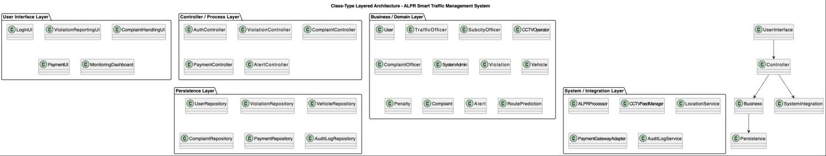Fig 4.1: Class-type layered architectural Diagram UML Diagram ALPR STMS, Hawassa

4.2.2 Presentation Layer (User Interaction Layer)
Purpose:
The User Interface (UI) Layer provides role-specific interaction points for all authorized human operators. It does not contain business logic and never communicates directly with the database.
Users Served:
- Traffic Officer
- Subcity Officer
- CCTV Operator
- Complaint Officer
- System Administrator
Driver is intentionally excluded from this layer as it’s only integrated only on OTP payment.
Components:
- Web-based dashboard (administrative users)
- Mobile interface (traffic officers)
- Secure login and session management
- Role-based UI rendering
Representative Classes
- LoginUI
- ViolationReportingUI
- ComplaintHandlingUI
- MonitoringDashboard
- PaymentUI (used by officers during OTP-based payment facilitation)
Key Characteristics:
- Role-aware interfaces (Traffic Officer, Subcity Officer, CCTV Operator, Complaint Officer, Admin)
- Secure login for all human actors except drivers
- Read-only or restricted interfaces where enforcement authority is not required
- Supports desktop and secured workstation environments
- ISO 9241 compliant
- Government accessibility standards
- Minimal cognitive load

4.2.3 Controller / Process Layer
Purpose:
The Controller Layer acts as the orchestration and coordination layer, handling all requests from the UI and enforcing workflow sequencing. Implements business processes and enforces workflow rules.
Core Services:
- Violation Management Service
- Alert & Coordination Service
- Complaint Management Service
- Payment Service
- User & Role Management Service
- Audit Logging Service
Responsibilities:
- Enforce process order
- Validate actions against rules
- Coordinate between subsystems
- Prevent unauthorized operations
- Role authorization enforcement
- Routing requests to appropriate business services
- Handling success/failure flows
Representative Classes
- AuthController
- ViolationController
- ComplaintController
- PaymentController
- AlertController
Key Design Rule
- No UI component is allowed to access business logic directly.
- All requests must pass through a controller.
This ensures auditability, traceability, and security enforcement.

4.2.4 Domain & Intelligence (Business/Domain) Layer
Purpose:
This layer represents the core intelligence and rules of the traffic enforcement domain. It models real-world concepts and enforces legal and procedural constraints, independent of UI or infrastructure.
Core Domain Entities
- User (abstract)
- TrafficOfficer
- SubcityOfficer
- CCTVOperator
- ComplaintOfficer
- SystemAdmin
- Violation
- Vehicle
- Penalty
- Complaint
- Alert
- RoutePrediction
Responsibilities
- Violation lifecycle management
- Penalty calculation rules
- Complaint decision logic (confirm / revoke)
- Enforcement status transitions
- Route prediction logic (decision support only)
Key Modules:
- Violation Rule Engine
- Penalty Calculation Engine
- ALPR Processing Engine
- Route Prediction & Path Estimation Module
- Evidence Validation Logic
Special Note:
Even when automated detection is enabled:
- Final violation confirmation remains human-controlled
- AI outputs are advisory, not authoritative

4.2.5 Data Management (Persistence) Layer
Purpose:
The Persistence Layer abstracts all data storage operations and enforces data integrity, consistency, auditability, and security.
Responsibilities
- CRUD operations
- Transaction management
- Historical data retention
- Legal evidence preservation
Primary Data Stores:
- Central Violation Database
- Vehicle & Plate Registry
- CCTV Evidence Repository
- Payment Records
- Complaint Records
- Audit Logs
Data Governance Rules:
- Immutable audit records
- Role-restricted access
- Retention per government policy
- Legal traceability of every action
Representative Classes
- UserRepository
- ViolationRepository
- VehicleRepository
- ComplaintRepository
- PaymentRepository
- AuditLogRepository

4.2.6 Infrastructure & Integration (System) Layer
Purpose:
This layer handles external systems and advanced service integrations, isolating them from core business logic.
Integrated Services
- ALPRProcessor – AI-based plate recognition
- CCTVFeedManager – video stream handling
- LocationService – GPS and geo-context services
- PaymentGatewayAdapter – OTP payment integration
- AuditLogService – centralized audit recording
Design Justification
- Prevents vendor lock-in
- Enables replacement or upgrade of AI models
- Protects core logic from external system failures
Deployment Model:
- On-premise government servers
- Secure VPN access
- Failover and redundancy support
Actor | Presentation | Services | Domain | Data
Traffic Officer |  |  |  | Limited
Subcity Officer |  |  |  | Limited
CCTV Operator |  |  |  | Evidence Only
Complaint Officer |  |  |  | Complaint Scope
System Admin |  |  |  | Full
Driver | X | OTP Only | X | Payment Only
Table 4.2 Actor to Layer Mapping

4.2.7 Architectural Security Principles
The architecture embeds security by design:
- Role-Based Access Control (RBAC)
- Encrypted communication (TLS)
- Multi-factor authentication (officials)
- OTP-based payment authentication (driver)
- Full auditability of all actions
Phase | Capability
Phase 1 | Manual reporting + alerts
Phase 2 | CCTV-assisted detection
Phase 3 | Predictive route analysis
Phase 4 | Automated detection (human-validated)
Table 4.3 Architectural Support for Phased Deployment
The architecture allows progressive activation without structural changes.

4.2.8 Architectural Quality Attributes
The system architecture explicitly satisfies:
- Scalability: Add cameras, users, subcities
- Reliability: Redundant services and backups
- Maintainability: Modular service design
- Auditability: Immutable logs
- Legal Compliance: Human authority preserved

4.2.9 Architecture Validation Statement
- Fully aligns with system requirements
- Supports government operational models
- Preserves legal enforcement authority
- Enables smart city expansion
- Is suitable for real-world deployment
Aspect | Benefit
Security | Strict role boundaries and access control
Maintainability | Layer isolation reduces change impact
Scalability | Services can scale independently
Auditability | Centralized logging and traceability
Legal Compliance | Human-in-the-loop enforcement preserved
Table 4.4 Architectural Benefits Summary

4.3 Class Modeling

4.3.1 Purpose of Class Modeling
Class modeling defines the static structural blueprint of the system by identifying the key classes, their attributes, operations, and relationships. In the ALPR-Based Smart Traffic Management System, class modeling ensures that:
- Real-world traffic enforcement entities are accurately represented
- Responsibilities are clearly assigned
- Dependencies are controlled and traceable
- The design supports extensibility, auditability, and legal compliance
This model serves as the foundation for implementation, testing, and future system evolution.

4.3.2 Class Modeling Scope
The class model focuses on:
- Core domain entities (e.g., Violation, Vehicle, Penalty)
- User hierarchy representing authorized human actors
- Supporting service classes required for enforcement, prediction, and auditing
- Clear separation between data entities and service/process classes
Drivers are explicitly excluded as system users, consistent with legal and operational requirements.

4.3.3 User Class Hierarchy
User (Abstract Class)
The User class defines common identity and accountability attributes shared by all authorized personnel.
Key Attributes
- User identifier
- Personal identification details
- Assigned role
Design Rationale
- Enforces role-based access control
- Avoids redundancy
- Supports centralized authentication and auditing
Class | Responsibility
TrafficOfficer | Report violations, initiate roadside penalties
SubcityOfficer | Coordinate enforcement and review cases
CCTVOperator | Validate ALPR detections and evidence
ComplaintOfficer | Adjudicate disputes and complaints
SystemAdmin | Manage system configuration and users
Table 4.5 Specialized User Classes

4.3.4 Core Domain Classes
Vehicle
Represents a registered vehicle identified by its license plate.
- Serves as a reference entity
- Can be linked to multiple violations over time
- Immutable historical linkage ensures legal traceability
Violation (Central Domain Class)
The Violation class is the core entity around which the entire system operates.
Responsibilities
- Track the lifecycle of a traffic offense
- Link evidence, penalties, alerts, and complaints
- Maintain legally auditable status transitions
Typical States
- Reported
- Under Review
- Confirmed
- Complained
- Revoked
- Paid
Penalty
Represents the enforcement outcome when a violation is confirmed.
- Created only after validation
- May result in OTP-based payment
- Status-controlled to prevent duplicate or unauthorized payments
Complaint
Encapsulates a formal dispute raised by a driver through an office process.
- Linked to exactly one violation
- Reviewed exclusively by Complaint Officers
- Decision outcomes directly affect violation and penalty status
Alert
Represents system-generated or officer-triggered notifications.
- Distributed based on geography and priority
Supports inter-subcity coordination
- Enhances response efficiency
Route Prediction
A decision-support class that provides predicted movement paths for a suspected vehicle.
- Uses historical and real-time data
- Assists officers but does not enforce actions
- Designed as advisory intelligence only

4.3.5 Relationship Design Principles
- Aggregation over inheritance is used where legal independence is required (e.g., Violation–Penalty)
- One-to-many relationships preserve historical enforcement data
- Optional associations reflect real-world uncertainty (e.g., not all violations lead to complaints)
These principles ensure accuracy, flexibility, and legal defensibility.

4.3.6 Compliance and Design Quality Considerations
- Supports forensic auditing and evidence preservation
- Prevents unauthorized state transitions
- Aligns with public-sector software accountability requirements
- Enables future expansion (e.g., additional sensors or analytics)

4.4 State Chart Modeling

4.4.1 Introduction
State chart modeling describes the dynamic behavior of critical system entities by illustrating how they transition from one state to another in response to events, conditions, and decisions.
For the ALPR-Based Smart Traffic Management System, state charts are essential to ensure:
- Legal correctness of enforcement workflows
- Controlled decision-making authority
- Auditability and traceability
- Prevention of invalid or unauthorized transitions
This section focuses on state-critical domain entities, primarily the Violation, which governs the lifecycle of traffic enforcement actions.

4.4.2 Scope of State Modeling
State chart modeling is applied to entities that:
- Have a clear lifecycle
- Undergo formal decision points
- Require legal and administrative control
Modeled Entities
- Violation (primary and mandatory)
- Complaint (secondary, embedded within violation lifecycle)
- Penalty (state-dependent outcome)
Among these, the Violation State Chart is the authoritative control model for the entire system.

4.4.3 Violation State Chart – Conceptual Overview
A Violation progresses through a strictly controlled lifecycle beginning at detection/reporting and ending with either payment completion or revocation.
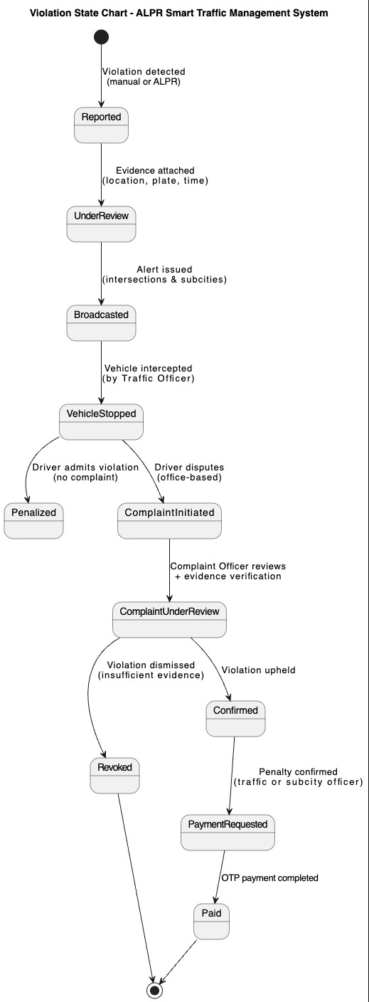
Key design principles: Fig 4.2: Violation State Chart Diagram
- No state skipping allowed
- All transitions are event-driven
- Decisions are role-restricted
- Every transition is audit-logged

4.4.3.1 Detailed State Descriptions
1. Reported
Entry Condition
- Violation detected manually by Traffic Officer
- OR automatically detected by ALPR system
Characteristics
- Initial immutable record created
- Contains timestamp and provisional location
2. UnderReview
Trigger
- Evidence attachment (image/video/location)
Actors
- Traffic Officer
- CCTV Operator (if ALPR-based)
Purpose
- Validate legitimacy before city-wide escalation
3. Broadcasted
Trigger
- Confirmation of violation validity
System Actions
- Alert dissemination to:
- Nearby officers
- Subcity control rooms
- Border checkpoints (if applicable)
4. VehicleStopped
Trigger
- Physical interception of the vehicle
Importance
- No penalty or complaint can proceed without interception
- Ensures procedural fairness
5. Penalized
Condition
- Driver admits violation
- No complaint requested
Action
- Penalty prepared immediately
- Payment request initiated by Traffic Officer or Subcity Officer
6. ComplaintInitiated
Condition
- Driver disputes violation
- Complaint registered only at office level
Important Rule
- Driver never interacts digitally with enforcement system
7. ComplaintUnderReview
Actors
- Complaint Officer
- CCTV Operator (if evidence requested)
Decision Inputs
- Stored violation data
- CCTV footage
- Officer report
8. Revoked
Outcome
- Violation dismissed
- Penalty canceled
- Case closed permanently
Legal Significance
- Prevents further enforcement or payment attempts
9. Confirmed
Outcome
- Complaint rejected
- Violation upheld
Next Step
- Mandatory payment initiation
10. PaymentRequested
Actors
- Traffic Officer (roadside)
- OR Subcity Officer (post-complaint)
System Behavior
- OTP payment generated
- Payment gateway engaged
11. Paid
Final State
- Payment successfully completed
- Violation closed
- Records archived per government retention policy

4.4.4 Complaint State Behavior (Embedded)
Although not modeled separately, complaints operate as a controlled sub-state within the violation lifecycle.
Key guarantees:
- One complaint per violation
- No payment allowed during complaint review
- Decision authority limited to Complaint Officer

4.4.5 Design & Compliance Considerations
- Prevents illegal enforcement
- Supports judicial review
- Ensures evidence-based decisions
- Fully auditable for government oversight
The state chart ensures that technology enforces policy, not the other way around.

4.5 Collaboration Modeling

4.5.1 Introduction
Collaboration Modeling describes how system actors and software components work together to accomplish business objectives.
Unlike class diagrams (static) or state charts (behavioral per entity), collaboration modeling focuses on:
- Responsibility distribution
- Interaction correctness
- Operational authority
- Information flow integrity
In the ALPR-Based Smart Traffic Management System, collaboration modeling is critical because the system operates in a multi-agency, legally sensitive environment, involving:
- Traffic enforcement officers
- Subcity administrative units
- CCTV operations
- Complaint handling authorities
- Payment infrastructure
This section ensures that no actor exceeds authority, no process bypasses legal control, and all interactions are traceable and auditable.

4.5.2 Collaboration Modeling Scope
Collaboration is modeled across five primary operational domains:
- Violation Detection & Reporting
- Alert Broadcasting & Coordination
- CCTV-Assisted Evidence Collaboration
- Complaint Handling & Decision Making
- Penalty Payment & Closure
Each collaboration group is described using:
- Participating actors
- Collaborating system components
- Responsibility boundaries
- Interaction rules

4.5.3 Key Collaboration Participants
Human Actors
- Traffic Officer
- Subcity Officer
- CCTV Operator
- Complaint Officer
- Driver (OTP payment only; no system access)
System Components
- Authentication Service
- Violation Management Service
- ALPR Processor
- CCTV Feed Manager
- Alert & Coordination Service
- Penalty Engine
- Complaint Management Service
- Payment Service
- Central Database
- Audit Log Service

4.5.4 Collaboration Scenario 1: Violation Detection & Reporting
Objective
To collaboratively detect, validate, and formally register a traffic violation.
Participants
- Traffic Officer
- ALPR Processor
- Violation Management Service
- Location Service
- Central Database
- Audit Log Service
Collaboration Flow
- Traffic Officer reports a violation manually OR
- ALPR Processor detects a violation automatically
- Location Service provides GPS and timestamp
- Violation Management Service consolidates all inputs
- Central Database persists the violation
- Audit Log records the action
Key Collaboration Rule

- Detection authority is shared, but registration authority is centralized.

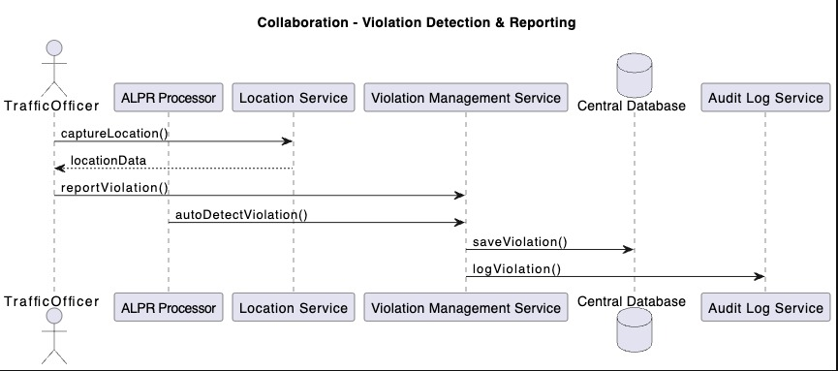
Fig 4.3: Collaboration Diagram – Violation Detection and Reporting

4.5.5 Collaboration Scenario 2: Alert Broadcasting & Inter-Subcity Coordination
Objective
To ensure rapid and geographically targeted enforcement response.
Participants
- Violation Management Service
- Alert & Coordination Service
- Traffic Officers
- Subcity Officers
- Route Prediction Service
Collaboration Flow
- Violation Management Service triggers alert
- Alert Service requests predicted escape routes
- Alerts broadcast based on proximity and jurisdiction
- Subcity Officers coordinate escalation
Key Collaboration Rule

- Only Subcity Officers may authorize inter-subcity escalation.
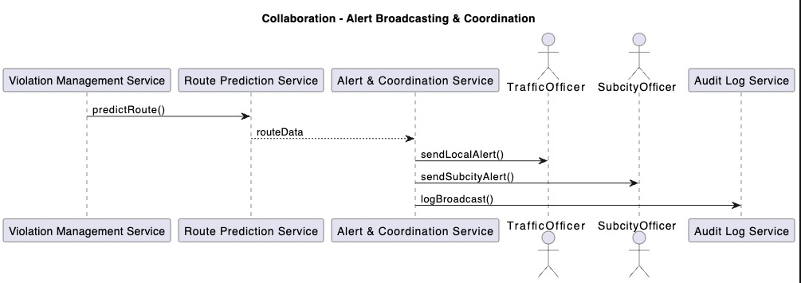
Fig 4.4: Collaboration Diagram Alert & Coordination

4.5.6 Collaboration Scenario 3: CCTV-Assisted Evidence Validation
Objective
To validate violations using video evidence without automated enforcement authority.
Participants
- CCTV Operator
- CCTV Feed Manager
- ALPR Processor
- Violation Management Service
Collaboration Flow
- CCTV feeds are monitored continuously
- ALPR detects candidate plates
- CCTV Operator validates or rejects detection
- Evidence attached to violation record
Key Collaboration Rule

- Human validation is mandatory before legal enforcement.
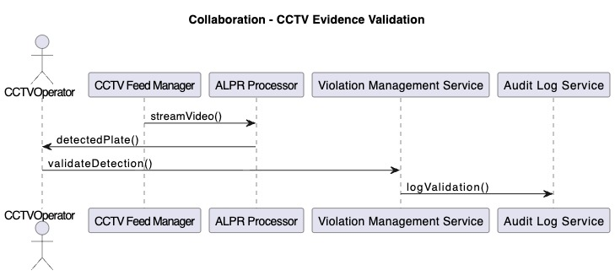
Fig 4.5: Collaboration Diagram – CCTV Validation

4.5.7 Collaboration Scenario 4: Complaint Handling & Legal Decision
Objective
To ensure fair adjudication of disputed violations.
Participants
- Complaint Officer
- Complaint Management Service
- Violation Management Service
- CCTV Operator
- Central Database
Collaboration Flow
- Driver submits violation ID at office
- Complaint Officer retrieves case
- Evidence reviewed and optionally requested
- Decision recorded (Confirm / Revoke)
Key Collaboration Rule

- Complaint decisions override all automated outcomes.
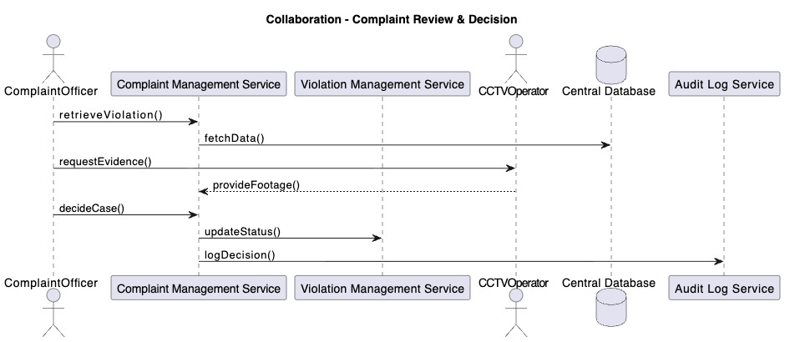
Fig 4.6: Collaboration Diagram – Complaint Handling

4.5.8 Collaboration Scenario 5: Penalty Payment & Case Closure
Objective
To complete enforcement legally and financially.
Participants
- Traffic Officer / Subcity Officer
- Payment Service
- Payment Gateway
- Driver (OTP only)
- Audit Log Service
Collaboration Flow
- Authorized officer initiates payment
- Payment Service requests OTP
- Driver receives and submits OTP
- Payment confirmed and logged
- Violation closed
Key Collaboration Rule

- Drivers interact only with payment gateway, never with enforcement system.
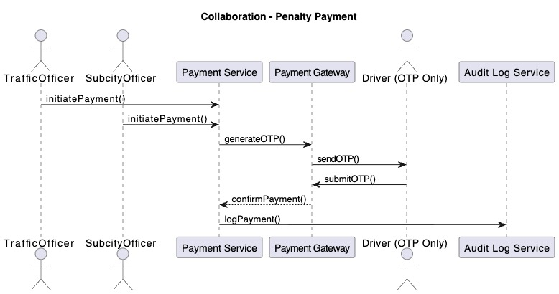
Fig 4.7: Collaboration Diagram – Payment

4.5.9 Collaboration Integrity & Governance Controls
- All collaborations are role-restricted
- No direct driver-system interaction
- All decisions are evidence-based
- Every collaboration produces audit logs
- Inter-subcity actions require authorization

4.6 Component Modeling

4.6.1 Introduction
Component Modeling defines the logical and physical decomposition of the system into deployable, replaceable, and maintainable components.
While collaboration modeling focused on who interacts with whom, component modeling focuses on:
- What software units implement those interactions
- How responsibilities are isolated
- How government-grade reliability, security, and auditability are achieved
For the ALPR-Based Smart Traffic Management System (ALPR-STMS), component modeling is especially critical because the system must operate across law enforcement, administrative governance, surveillance infrastructure, and financial systems, each with different legal and operational constraints.

4.6.2 Component Modeling Objectives
The component model is designed to achieve the following objectives:
Separation of Concerns
- Each component has a single, well-defined responsibility.
Role-Based Enforcement
- Components enforce authority boundaries defined in the SRS.
Auditability and Legal Traceability
- Every critical action passes through auditable components.
Scalability and Future Expansion
- AI-based automation and smart city integration can be added without redesign.
Fault Isolation
- Failures in one component (e.g., payment gateway) do not compromise core enforcement operations.

4.6.3 High-Level Component Architecture
The system is composed of five major component groups:
- Presentation Components
- Control & Orchestration Components
- Core Domain Components
- Infrastructure & Integration Components
- Governance & Audit Components
Each group is described in detail below.

4.6.4 Presentation Components
Purpose
To provide secure, role-based access to system functionalities without exposing internal business logic.
Components
- Web User Interface
- Mobile Officer Interface
- CCTV Control Dashboard
Responsibilities
- Credential input and session initiation
- Data visualization (violations, alerts, status)
- Controlled action triggering (no direct data manipulation)
Governance Rule

- Presentation components never perform enforcement logic.

4.6.5 Control & Orchestration Components
Purpose
To coordinate workflows, validate permissions, and route requests to appropriate domain components.
Components
- Authentication Service
- Authorization & Role Manager
- Workflow Controller
Responsibilities
- Login and session validation (all human actors except drivers)
- Role-based access enforcement
- Workflow sequencing (e.g., violation → alert → penalty)
Governance Rule

- All user actions must pass through orchestration components.

4.6.6 Core Domain Components
Purpose
To implement the legal and operational logic of traffic enforcement.
Components
- Violation Management Service
- Penalty Engine
- Complaint Management Service
- Route Prediction Service
Responsibilities
- Violation lifecycle management
- Penalty calculation based on legal rules
- Complaint adjudication support
- Predictive path analysis (decision support only)
Legal Constraint

- No component may autonomously enforce penalties without human authorization.

4.6.7 Surveillance & Intelligence Components
Purpose
To support evidence-based enforcement using CCTV and AI-assisted detection.
Components
- CCTV Feed Manager
- ALPR Processor
- Evidence Repository
Responsibilities
- Video ingestion and stream management
- Plate detection and confidence scoring
- Evidence attachment to violations
Governance Rule

- AI detection assists decision-making but does not replace human judgment.

4.6.8 Financial & External Integration Components
Purpose
To manage legally compliant payment processing and external system communication.
Components
- Payment Service
- Payment Gateway Adapter
- Notification Service (OTP, SMS)
Responsibilities
- Payment initiation by authorized officers
- OTP-based driver interaction
- Secure confirmation handling
Critical Constraint

- Drivers have no system access beyond OTP interaction.

4.6.9 Governance & Audit Components
Purpose
To ensure accountability, compliance, and traceability.
Components
- Audit Log Service
- Reporting & Analytics Service
Responsibilities
- Immutable logging of actions
- Government reporting support
- Legal evidence preservation
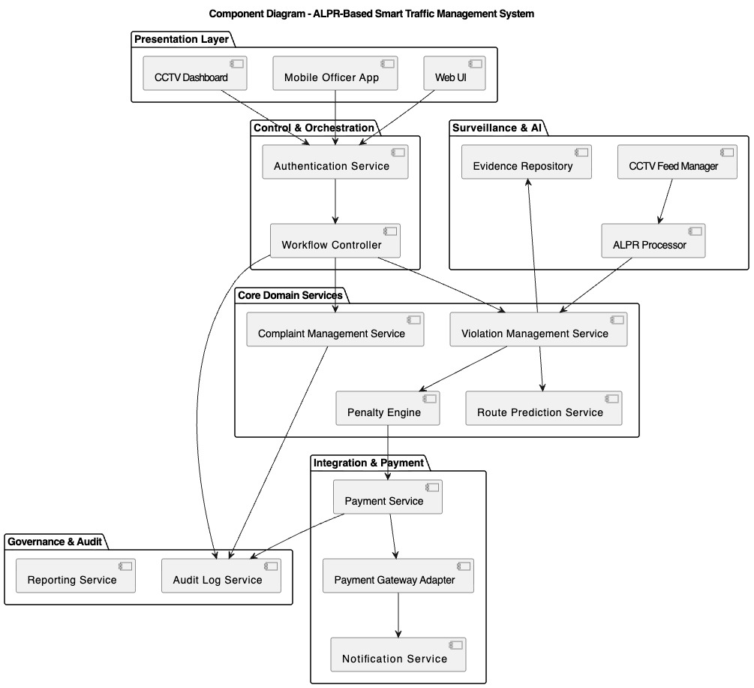
Fig 4.8: Component Interaction Diagram

4.6.10 Component Dependency Rules
- Presentation components depend only on orchestration services
- Domain components never depend on UI components
- Surveillance components never trigger penalties directly
- Payment components operate only after legal confirmation
- Audit logging is mandatory for all state-changing operations

4.6.11 Government-Grade Design Assurance
This component architecture ensures:
- Legal accountability
- Operational transparency
- Controlled automation
- Future AI extensibility
- Compliance with public-sector IT governance standards

4.6.12 Transition to Next Section
With system components clearly defined, the next section:

4.7 Deployment Modeling

4.7.1 Introduction
Deployment modeling describes the physical realization of the system architecture, specifying:
- Hardware nodes
- Network boundaries
- Execution environments
- Component-to-node mappings
For the ALPR-Based Smart Traffic Management System (ALPR-STMS), deployment modeling is critical because the system operates in a government environment involving:
- Law enforcement field operations
- Central administrative control
- Surveillance infrastructure
- Financial systems
- Legal audit requirements
The deployment architecture is designed to ensure:
- High availability
- Security isolation
- Legal compliance
- Future scalability

4.7.2 Deployment Design Principles
The deployment architecture follows these government IT principles:
Centralized Governance, Distributed Operations
- Core logic centralized
- Enforcement actions distributed
Network Segmentation
- Public access strictly limited
- Surveillance and enforcement isolated
Fail-Safe Operation
- Manual enforcement continues during outages
Audit-First Architecture
- Logs stored centrally and immutably
Phased Infrastructure Adoption
- Supports gradual expansion of CCTV and AI

4.7.3 Deployment Environments
The system is deployed across four primary environments:
1. Field Environment
- Traffic officers
- Subcity officers
- Mobile enforcement units
2. Surveillance Environment
- CCTV cameras
- CCTV operator workstations
3. Central Data Center
- Core system services
- Databases
- Audit and reporting
4. External Integration Environment
- Payment gateway
- SMS/OTP services

4.7.4 Physical Deployment Nodes

4.7.4.1 Officer Mobile Devices
Description
- Smartphones or tablets used by traffic police officers
Deployed Components
- Mobile Officer Application (UI only)
Responsibilities
- Violation reporting
- Alert reception
- Payment initiation (on-site admission cases)
Constraints
- No local data persistence
- Requires authenticated session
- Works in online/offline hybrid mode

4.7.4.2 Subcity Traffic Office Workstations
Description
- Desktop systems located at subcity traffic offices
Deployed Components
- Web UI
- Complaint handling interface
- Reporting dashboard
Responsibilities
- Complaint adjudication
- Payment authorization after complaint resolution
- Inter-subcity coordination

4.7.4.3 CCTV Control Center
Description
- Secured facility managed by city police surveillance unit
Deployed Components
- CCTV Dashboard
- CCTV Feed Manager (local)
- ALPR preprocessing module (optional edge processing)
Responsibilities
- Video monitoring
- Manual validation of ALPR detections
- Evidence provision upon request
Security Note
- CCTV operators cannot initiate penalties or payments.

4.7.4.4 Central Application Servers
Description
- Located at Hawassa City Administration Data Center
Deployed Components
- Authentication Service
- Workflow Controller
- Violation Management Service
- Penalty Engine
- Complaint Management Service
- Route Prediction Service
- Audit Log Service
- Reporting Service
Responsibilities
- Core system logic
- Legal enforcement processing
- Central coordination

4.7.4.5 Central Database Servers
Description
- Secure government-hosted database servers
Stored Data
- User accounts (excluding drivers)
- Violations
- Evidence metadata
- Complaints
- Payments
- Audit logs
Security Measures
- Encryption at rest
- Role-based access
- Backup and disaster recovery

4.7.4.6 External Payment & Notification Services
Description
- Third-party or government-approved services
Components
- Payment Gateway
- SMS/OTP Provider
Interaction Rule
- Drivers interact only with OTP messages — never directly with system interfaces.
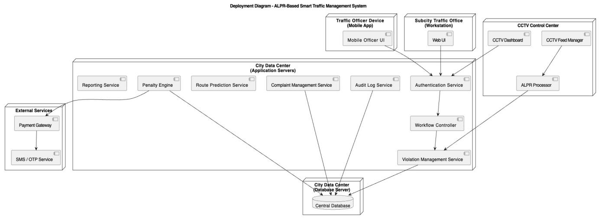
Fig 4.9: Deployment Diagram

Zone | Access Level
Officer Devices | Restricted, authenticated
Subcity Offices | Government intranet
CCTV Center | Highly restricted
Data Center | Fully secured
External Services | One-way integration
Table 4.6 Network & Security Boundaries

4.7.5 Scalability & Future Deployment Considerations
The deployment architecture supports:
- Adding more CCTV cameras without downtime
- Migrating ALPR processing to edge devices
- Integrating national traffic databases
- Expanding to other cities
- Cloud or hybrid deployment (future phase)

4.7.6 Government Compliance Assurance
This deployment model ensures:
- Data sovereignty
- Legal traceability
- Operational continuity
- Security-by-design
- Compliance with public-sector IT standards

4.8 Persistence Modeling

4.8.1 Introduction
Persistence modeling defines how system data is stored, managed, protected, retained, and retrieved throughout the operational lifecycle of the ALPR-Based Smart Traffic Management System (ALPR-STMS).
Given that the system supports:
- Legal enforcement
- Financial penalties
- Surveillance evidence
- Audit and accountability
the persistence layer is treated as a mission-critical government asset, not merely a technical storage mechanism.
This section describes:
- Data categories
- Storage architecture
- Data lifecycle
- Security controls
- Legal retention policies

4.8.2 Persistence Design Objectives
The persistence model is designed to achieve the following objectives:
Legal Admissibility
- Evidence and records must be legally defensible
Data Integrity
- No unauthorized modification
- Full traceability of changes
Controlled Access
- Role-based data visibility
Operational Performance
- Fast retrieval for enforcement and coordination
Long-Term Retention
- Compliance with government record-keeping laws

4.8.3 Data Categories and Classification
All system data is classified into the following categories:

4.8.3.1 Master Data
Relatively stable reference data.
Examples:
- User accounts (officers, operators, admins)
- Vehicle registry records
- Violation rules and penalty definitions
- Camera metadata
- Subcity configurations
Persistence Characteristics:
- Updated infrequently
- Strict administrative control
- Version-controlled

4.8.3.2 Transactional Data
Generated during daily operations.
Examples:
- Violations
- Alerts
- Penalties
- Payments
- Complaints
- Route predictions
Persistence Characteristics:
- High volume
- Time-sensitive
- Strong consistency required

4.8.3.3 Evidence Data
Legally sensitive multimedia and metadata.
Examples:
- CCTV snapshots
- Video frame references
- ALPR detection results
- Confidence scores
Persistence Characteristics:
- Immutable once attached
- Stored with cryptographic hashes
- Referenced, not duplicated

4.8.3.4 Audit and Log Data
System accountability records.
Examples:
- Login/logout events
- Data access logs
- Decision logs
- Payment confirmations
- Complaint outcomes
Persistence Characteristics:
- Append-only
- Tamper-resistant
- Long-term retention

4.8.4 Database Architecture

4.8.4.1 Centralized Relational Database
The core persistence layer uses a centralized relational database hosted in the city data center.
Primary Characteristics:
- ACID compliance
- Strong referential integrity
- Structured schema enforcement
Used For:
- Violations
- Users
- Complaints
- Penalties
- Payments
- Audit logs (metadata)

4.8.4.2 Evidence Storage (Hybrid Model)
- Evidence data is handled using a hybrid persistence approach:
- Large video files stored in Secure file storage or object storage
- Metadata stored in Central database
This avoids database overload while maintaining traceability.

4.8.5 Core Persistent Entities

4.8.5.1 User Persistence
Stores all system users except drivers.
Key Fields:
- User ID
- Role
- Subcity assignment
- Status (active/suspended)
- Authentication credentials (hashed)
Drivers are not persisted as system users.

4.8.5.2 Violation Persistence
The Violation entity is the central persistence anchor.
Stored Attributes:
- Violation ID
- Plate number
- Violation type
- Timestamp
- Location
- Reporting source (manual / CCTV)
- Current status
Each violation links to:
- Evidence
- Penalty
- Alerts
- Complaints
- Payments

4.8.5.3 Evidence Persistence
Evidence is persisted as:
- Reference ID
- Source camera
- Capture timestamp
- Confidence score
- Hash value (integrity verification)
Evidence cannot be deleted manually.

4.8.5.4 Penalty and Payment Persistence
Penalty Data:
- Amount
- Points (if applicable)
- Status
Payment Data:
- OTP reference
- Payment gateway transaction ID
- Timestamp
- Confirmation status
Payments are immutable once confirmed.

4.8.5.5 Complaint Persistence
Complaint records include:
- Complaint ID
- Violation reference
- Decision officer
- Decision outcome
- Decision justification
Each decision is logged and irreversible.

4.8.6 Data Lifecycle Management
Violation Lifecycle
- Created
- Pending confirmation
- Confirmed or revoked
- Paid or closed
Evidence Lifecycle
- Captured → Linked → Archived → Retained
Audit Lifecycle
- Generated → Stored → Archived → Retained indefinitely

4.8.7 Data Security Controls
Security measures applied at persistence level:
- Encryption at rest
- Role-based access enforcement
- Read/write separation
- Immutable audit tables
- Hash-based evidence verification

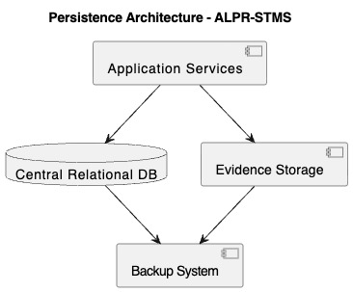
4.8.8 Backup and Disaster Recovery Fig 4.10: Persistence Architecture Diagram
Backup Strategy:
- Daily incremental backups
- Weekly full backups
- Off-site secure storage
Recovery Objectives:
- RPO: ≤ 24 hours
- RTO: ≤ 4 hours

Data Type | Retention
Violations | ≥ 5 years
Payments | ≥ 7 years
Complaints | ≥ 7 years
Audit Logs | Permanent
Evidence | As per legal requirement
Table 4.7 Retention and Archival Policy

4.8.9 Compliance and Governance Assurance
The persistence model ensures:
- Legal defensibility
- Operational continuity
- Government audit readiness
- Privacy protection
- Long-term institutional memory

4.9 User Interface design

4.9.1 Introduction
The User Interface (UI) of the ALPR-Based Smart Traffic Management System (ALPR-STMS) is designed as a mission-critical government interface, prioritizing:
- Accuracy over aesthetics
- Clarity over complexity
- Accountability over convenience
The UI serves as the primary interaction point between authorized government personnel and the system, directly supporting enforcement, coordination, complaint resolution, and administrative governance.
The design strictly adheres to:
- Government IT usability standards
- ISO 9241 human-centered design principles
- Role-based operational separation
- Legal evidentiary requirements

4.9.2 UI Design Objectives
The UI design aims to achieve the following objectives:
Operational Efficiency
- Minimize steps for critical actions
- Reduce cognitive load during field operations
Role-Based Clarity
- Each user sees only relevant functions
- No feature overlap between unrelated roles
Legal Defensibility
- Clear timestamps
- Explicit confirmations
- Immutable records
Error Prevention
- Validation at every critical input
- Mandatory confirmation dialogs
Scalability
- Supports future automation phases
- Easily extendable interfaces
Role | UI Access
Traffic Officer | Violation reporting, alerts, route drawing
Subcity Officer | Coordination dashboard, escalation
CCTV Operator | Camera feeds, ALPR validation
Complaint Officer | Complaint review, decision panels
System Admin | Configuration, user management
Driver | No system UI access (OTP payment only)
Table 4.8 User Roles and UI Access Scope

4.9.3 UI Architectural Pattern
The UI follows a Modular Role-Based Dashboard Architecture:
- Common authentication interface
- Separate dashboards per role
- Shared visual language
- Centralized notification framework
This prevents unauthorized access and supports auditability.

4.9.4 Common UI Components

4.9.4.1 Authentication Interface
- Username and password login
- Role verification
- Session timeout enforcement
- Multi-factor support (future-ready)
Drivers are explicitly excluded from login.

4.9.4.2 Notification & Alert Panel
- High-visibility alerts
- Priority indicators (color-coded)
- Timestamped messages
- Geographic relevance indicators
Alerts cannot be dismissed without acknowledgment.

4.9.4.3 Map & Location Interface
- Real-time GIS integration
- Officer location tracking
- Route drawing canvas
- CCTV camera overlay
Used for:
- Escape path prediction
- Alert prioritization
- Interception planning

4.9.5 Role-Specific UI Designs

4.9.5.1 Traffic Officer Interface
Purpose:
- Field enforcement and reporting
Key Screens:
- Violation reporting form
- Plate number input
- Automatic GPS capture
- Escape route drawing map
- Alert inbox
Design Characteristics:
- Large buttons
- Minimal text
- Mobile-first layout
- Offline fallback indicators

4.9.5.2 Subcity Officer Dashboard
Purpose:
- Coordination and escalation
Key Screens:
- Active violations overview
- Inter-subcity alerts
- Escalation controls
- Status tracking
Design Characteristics:
- Tabular summaries
- Filters by priority
- Region-based visualization

4.9.5.3 CCTV Operator Interface
Purpose:
- Surveillance and validation
Key Screens:
- Live camera feeds
- ALPR detection review panel
- Confidence score display
- Manual confirmation controls
Design Characteristics:
- Multi-feed layouts
- Zoom and playback tools
- Evidence tagging controls

4.9.5.4 Complaint Officer Interface
Purpose:
- Legal review and decision-making
Key Screens:
- Violation search by ID
- Evidence review
- Officer statements
- Decision submission form
Design Characteristics:
- Read-only evidence
- Mandatory justification fields
- Decision locking after submission

4.9.5.5 System Administrator Interface
Purpose:
- Governance and configuration
Key Screens:
- User management
- Role assignment
- Rule configuration
- Audit log viewer
Design Characteristics:
- Restricted access
- Confirmation dialogs
- Change history panels

4.9.6 UI Validation and Error Handling
- Mandatory fields enforced
- Inline validation messages
- Explicit error explanations
- Prevention of duplicate submissions
All critical actions require confirmation.

4.9.7 Accessibility and Government Standards Compliance
The UI complies with:
- ISO 9241 (ergonomics of human-system interaction)
- Government accessibility requirements
- Color contrast standards
- Keyboard navigation support
- Clear iconography with text labels

4.9.8 UI Security Considerations
- Session timeout enforcement
- Role-based UI rendering
- No client-side role logic
- Sensitive data masking
- Screenshot and export restrictions (where applicable)

4.9.9 UI Evolution and Future Readiness
The UI is designed to support:
- Full ALPR automation
- AI-assisted decision hints
- National system integration
- Smart city dashboards

4.9.10 UI Design Summary
The ALPR-STMS UI:
- Supports real-world enforcement workflows
- Ensures legal and administrative compliance
- Minimizes operational risk
- Enhances coordination and accountability
- Reflects government-grade professionalism

4.10 System Transition and Deployment Strategy

4.10.1 Introduction
System transition is the structured process through which the proposed Automatic License Plate Detection and Recognition–Based Smart Traffic Management System (ALPR-STMS) moves from a designed solution into an operational, institutionalized, and legally compliant production system within Hawassa City Administration.
This section defines the technical, operational, organizational, and procedural activities required to introduce the system into real traffic enforcement operations while ensuring continuity of service, legal validity, data integrity, and institutional acceptance. The transition strategy is intentionally incremental to accommodate existing manual practices, infrastructure constraints, and human resource readiness.

4.10.2 Transition Objectives
The primary objectives of the system transition are to:
- Ensure seamless migration from manual and semi-manual traffic enforcement to a digital system without service disruption.
- Preserve legal authority and human decision-making throughout all phases.
- Enable progressive adoption of ALPR and predictive intelligence based on infrastructure readiness.
- Maintain operational continuity during system rollout.
- Guarantee data security, auditability, and regulatory compliance.
- Achieve organizational acceptance across traffic police, subcity offices, and administrative bodies.

4.10.3 Transition Scope
The transition covers the following domains:
Technical Scope
- System deployment and configuration
- Integration with existing CCTV infrastructure
- Database initialization and data validation
- Network and security setup
Operational Scope
- Traffic violation reporting workflows
- Inter-subcity coordination
- Complaint handling and resolution
- OTP-based payment processing
Organizational Scope
- Role assignment and access control
- Training and capacity building
- Change management and policy alignment

4.10.4 Phased Transition Strategy
To reduce risk and ensure adoption, the ALPR-STMS follows a four-phase transition model.
Phase 1: Manual Digital Enforcement (Baseline Deployment)
Description
This phase introduces digital reporting while preserving all existing enforcement practices.
Key Characteristics
- Traffic officers log in and manually report violations
- Location and timestamp captured automatically
- Alerts broadcast digitally instead of via walkie-talkie
- No automated detection
Outcome
- Immediate improvement in documentation, coordination, and traceability
- Zero disruption to legal and operational workflows
The implementation timeline for Phase One is aligned with the detailed project schedule presented in Appendix D.
Phase 2: CCTV-Assisted Detection (Human-Validated)
Description
CCTV feeds are integrated, but all decisions remain human-validated.
Key Characteristics
- ALPR suggests candidate plate numbers
- CCTV operators validate or dismiss detections
- Evidence stored digitally
- No automated penalty issuance
Outcome
- Improved detection accuracy
- Strengthened evidentiary support
- Increased enforcement efficiency
Phase 3: Predictive Tracking and Smart Alerts
Description
The system introduces predictive intelligence while maintaining officer authority.
Key Characteristics
- Route prediction based on last known locations
- Priority alerts for officers along predicted paths
- Enhanced inter-subcity coordination
Outcome
- Higher interception success rate
- Reduced escape incidents
- Smarter resource allocation
Phase 4: Semi-Automated Enforcement (Future-Ready)
Description
Advanced automation is introduced under strict governance controls.
Key Characteristics
- Automated violation detection (subject to validation)
- Automated penalty calculation
- Full digital lifecycle management
Outcome
- Maximum efficiency
- Policy-driven automation
- Scalable smart-city readiness
4.10.5 User Transition and Role Enablement
Authorized System Users
Only government-authorized personnel interact with the system:
- Traffic Officers
- Subcity Officers
- CCTV Operators
- Complaint Officers
- System Administrators
Drivers are NOT system users.
Their interaction is limited strictly to:
- OTP-based payment via external payment gateway
- Physical complaint submission at subcity offices
This ensures:
- Legal clarity
- Reduced system abuse
- Strong institutional control

4.10.6 Training and Capacity Building
A structured training program is mandatory prior to each phase transition.
Training Coverage
- Role-specific system usage
- Legal implications of digital evidence
- Complaint handling procedures
- Data privacy and security responsibilities
Training Approach
- Classroom sessions
- Practical simulations
- Supervised live operations
- Continuous refresher programs

4.10.7 Data Migration and Initialization
Data Sources
- Vehicle registration records
- Traffic rule and penalty definitions
- User accounts and roles
Data Controls
- Validation against authoritative government sources
- Controlled access during migration
- Audit logging of all data initialization activities
No historical paper records are altered or deleted; digital records supplement existing archives.
Risk | Mitigation Strategy
Network failure | Offline capture & delayed synchronization
CCTV malfunction | Manual reporting fallback
User resistance | Incremental rollout & training
Legal disputes | Human-validated decisions & audit trails
Data breach | Encryption, RBAC, audit logging
Table 4.9 Risk Management and Mitigation

4.10.8 Compliance, Governance, and Audit Readiness
The system transition ensures:
- Full compliance with Road Transport Traffic Control COM Regulation 557-2024
- Role-based access control (RBAC)
- Immutable audit logs for all critical actions
- Traceability for every violation, decision, and payment
All records are retained in accordance with government data retention and evidence laws.

4.10.9 Transition Completion Criteria
The transition is considered successful when:
- All authorized users operate independently.
- Violations are processed end-to-end digitally.
- Alerts and coordination occur in real time.
- Complaints are resolved using digital evidence.
- Payment processing functions reliably.

Audit logs demonstrate accountability and traceability.

Conclusion
This project has presented a comprehensive analysis, specification, and system design of an Automatic License Plate Recognition (ALPR) Based Smart Traffic Management System tailored for urban environments such as Hawassa City. Beginning from Unit 1, the documentation has systematically progressed from problem identification and requirement analysis through architectural design, modeling, and interface considerations, culminating in a fully integrated, government-grade system specification.
The study initially identified critical challenges in existing traffic management practices, including heavy reliance on manual enforcement, limited inter-subcity coordination, absence of real-time intelligence, and lack of reliable digital records. These limitations were shown to negatively impact enforcement efficiency, legal accountability, and strategic traffic planning. In response, this project proposed a structured, scalable, and legally defensible system that incrementally transitions from manual reporting to advanced automated enforcement supported by computer vision and predictive analytics.
Through Unit 2 (System Requirement Specifications), the system’s functional and non-functional requirements were defined with precision, ensuring alignment with real-world operational constraints, government procedures, and institutional responsibilities. Clear use case definitions, sequence diagrams, activity diagrams, and conceptual class models were developed to reflect authentic workflows involving traffic officers, subcity officers, CCTV operators, complaint officers, and system administrators—while deliberately excluding drivers from system access except through OTP-based payment mechanisms. This strict role separation enhances security, accountability, and compliance with public-sector IT governance principles.
In Unit 3 (Analysis and Modeling), the system behavior was explored in depth using production-ready UML artifacts. Detailed sequence diagrams illustrated end-to-end workflows, including login authentication for all human operators, manual and automated violation detection, CCTV-assisted validation, predictive path analysis, complaint resolution, penalty decision-making, and secure payment processing. Activity diagrams further clarified the logical flow of enforcement actions, decision points, and exception handling, ensuring that every possible operational scenario is addressed with clarity and precision.
Unit 4 (System Design) translated these analytical models into a robust architectural framework. The class-type architecture defined clear separation between presentation, controller, business, persistence, and system layers, ensuring maintainability and scalability. Additional modeling—covering state charts, collaboration, components, deployment, persistence, and user interface design—demonstrated how the system can be implemented in a real government IT environment while maintaining performance, security, and legal traceability. Special emphasis was placed on audit logging, data retention, and compliance with standards such as ISO 9241 and public-sector usability and accessibility requirements.
The proposed system is not merely a theoretical construct but a deployment-ready blueprint that respects existing institutional structures, integrates with current CCTV infrastructure, and supports phased adoption. Its modular design allows gradual enhancement—from manual reporting and coordination to fully automated ALPR detection and predictive traffic intelligence—without disrupting ongoing operations. Furthermore, the system provides long-term value by generating structured data that can support legal review, policy formulation, urban planning, and smart city initiatives.
In conclusion, this project successfully delivers a holistic, accurate, and government-aligned smart traffic management solution. It demonstrates how modern software engineering practices, when applied with contextual awareness and institutional discipline, can significantly improve traffic enforcement efficiency, transparency, and accountability. The documentation produced serves both as an academic achievement and as a practical foundation for real-world implementation, positioning the system as a viable contribution to the modernization of urban traffic governance.

RECOMMENDATIONS
Based on the analysis, design, and proposed implementation of the ALPR-Based Smart Traffic Management System for Hawassa City, the following recommendations are made to ensure effective deployment, sustainability, and institutional acceptance:

Phased Implementation Strategy
It is recommended that the system be deployed incrementally, beginning with:
- Manual digital violation reporting
- Centralized violation and vehicle database
- OTP-based payment processing
- Advanced features such as automated CCTV-based detection and predictive route tracking should be introduced after sufficient infrastructure readiness and staff training.

Legal and Policy Alignment
Continuous alignment with national and regional traffic regulations, particularly Road Transport Traffic Control Council of Ministers Regulation No. 557/2024, is essential. Any updates to traffic laws should be reflected promptly in the system’s violation rules and penalty engine.

Capacity Building and Training
Comprehensive training programs should be provided for:
- Traffic police officers
- Subcity officers
- CCTV operators
- Complaint and administrative officers
This will ensure correct system usage, reduce resistance to change, and improve enforcement accuracy.

Infrastructure Enhancement
Gradual expansion of CCTV coverage, secure network connectivity, and reliable data center infrastructure is recommended to support advanced ALPR processing and real-time coordination.

Data Governance and Security
Strong data protection policies, role-based access control, audit logging, and compliance with government data retention laws should be enforced to maintain public trust and legal defensibility.

Future Integration
The system should be prepared for future integration with:
- National vehicle registration databases
- Smart city platforms
- Inter-city and federal traffic enforcement systems

APPENDIX

Appendix A: Actors Summary
- Traffic Officer
- Subcity Officer
- CCTV Operator
- Complaint Officer
- System Administrator
- Driver (OTP payment participant only)

Appendix B: Legal Basis
The system is legally grounded in Ethiopian traffic enforcement frameworks, with specific reference to:
- Federal and regional traffic laws
- Official authority of traffic police
- Recognized penalty and violation classifications
- Driver complaint and appeal rights

Appendix C: Assumptions and Limitations
- Initial CCTV coverage is limited
- Network availability may vary across subcities
- Drivers do not directly interact with the system except for OTP payment
- Complaint handling is strictly office-based and officer-mediated

Appendix D: Detailed Project Task and Schedule

D.1 Purpose of This Appendix
This appendix provides the detailed, task-level project schedule for the ALPR-Based Smart Traffic Management System for Hawassa City. It expands upon the high-level schedule overview presented in Chapter 1 and documents the chronological execution plan, task dependencies, academic constraints, and milestone alignment for the project.
The schedule presented herein:
- Covers end-to-end project activities (all phases)
- Emphasizes Phase One (Manual Digital Traffic Reporting System) during design, implementation, and testing stages
- Accounts for academic holidays, final examinations, and institutional delays
- Supports schedule feasibility analysis and project governance review

D.2 Scheduling Assumptions and Constraints
The detailed schedule is prepared based on the following assumptions:
- The project follows an incremental and phased development approach.
- Early activities (planning, authorization, documentation) support all system phases.
- Design, implementation, and testing activities after the academic break are primarily focused on Phase One.
- National holidays, academic breaks, and examination periods are treated as non-development intervals.
- Task durations are estimated conservatively to ensure realistic delivery under academic and institutional conditions.
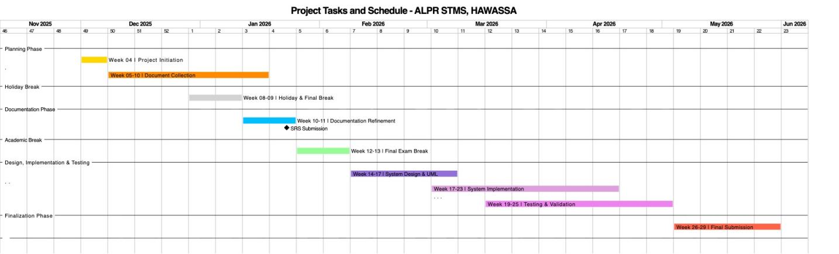Figure A.1: Detailed Project Tasks and Schedule – ALPR STMS, Hawassa

D.3 Detailed Task Description and Timeline Mapping

D.3.1 Planning Phase
Duration: Week 04 (December 1–7, 2025)
Key Activities:
- Project initiation
- Stakeholder coordination
- Scope confirmation
- Preliminary feasibility alignment
This phase establishes the administrative and organizational foundation for the entire project lifecycle.

D.3.2 Authorization and Document Collection Phase
Duration: Weeks 05–10 (December 8, 2025 – January 18, 2026)
Key Activities:
- Collection of traffic regulations and legal documents
- Authorization requests from relevant government bodies
- Institutional approvals and permissions
- Data access agreements
This phase is critical for ensuring legal compliance, data legitimacy, and governmental alignment.

D.3.3 Holiday and Final Examination Break
Duration: Weeks 08–09 (December 29, 2025 – January 11, 2026)
This period reflects non-productive time due to academic and national holidays. No development or documentation activities are scheduled.

D.3.4 Documentation Refinement Phase
Duration: Weeks 10–11 (January 12–25, 2026)
Key Activities:
- Finalization of SRS
- UML refinement
- Requirements validation
- Consistency checks and academic formatting
D.3.5 Requirements Specification Milestone
Milestone: SRS Submission
Date: January 21, 2026
This milestone represents the formal completion and submission of the System Requirements Specification document.

D.3.6 Academic Break
Duration: Weeks 12–13 (January 26 – February 8, 2026)
This scheduled break accommodates final examinations and institutional downtime.

D.3.7 System Design Phase (Phase One Focus)
Duration: Weeks 14–17 (February 9 – March 8, 2026)
Key Activities:
- Architectural design
- UML modeling (class, sequence, activity, deployment)
- Design validation against SRS
- Phase One scope alignment
This phase translates requirements into formal system design artifacts.

D.3.8 System Implementation Phase (Phase One)
Duration: Weeks 17–23 (March 2 – April 20, 2026)
Key Activities:
- Core system development
- Manual traffic reporting workflows
- User role management
- Payment initiation logic (non-driver interaction)
Implementation overlaps partially with testing to support incremental validation.

D.3.9 Testing and Validation Phase
Duration: Weeks 19–25 (March 16 – May 4, 2026)
Key Activities:
- Functional testing
- Integration testing
- Validation against traffic enforcement workflows
- Error correction and performance tuning

D.3.10 Finalization and Submission Phase
Duration: Weeks 26–29 (May 4 – May 31, 2026)

Key Activities:
- Final documentation consolidation
- Corrections based on review feedback
- Formal submission
- Archival preparation
Phase | Activity | Start Date | End Date | Duration | Phase Coverage
Planning | Project initiation | Dec 1, 2025 | Dec 7, 2025 | 1 week | All phases
Authorization | Document collection | Dec 8, 2025 | Jan 18, 2026 | 6 weeks | All phases
Documentation | Refinement & SRS | Jan 12, 2026 | Jan 25, 2026 | 2 weeks | All phases
Milestone | SRS submission | Jan 23, 2026 | Jan 23, 2026 | Milestone | All phases
Design | System design | Feb 9, 2026 | Mar 8, 2026 | 4 weeks | Phase One
Implementation | Development | Mar 2, 2026 | Apr 20, 2026 | 7 weeks | Phase One
Testing | Validation | Mar 16, 2026 | May 4, 2026 | 7 weeks | Phase One
Finalization | Submission | May 4, 2026 | May 31, 2026 | 4 weeks | Phase One
Table A.1: Summary of Project Tasks, Duration, and Focus

REFERENCES
Sommerville, I. (2016). Software engineering (10th ed.). Pearson Education Limited.
Pressman, R. S., & Maxim, B. R. (2020). Software engineering: A practitioner’s approach (9th ed.). McGraw-Hill Education.
International Organization for Standardization. (2018). ISO/IEC/IEEE 29148:2018 – Systems and software engineering — Life cycle processes — Requirements engineering. ISO.
International Organization for Standardization. (2019). ISO 9241-210:2019 – Ergonomics of human-system interaction — Human-centred design for interactive systems. ISO.
Object Management Group. (2017). Unified Modeling Language (UML) specification version 2.5. https://www.omg.org/spec/UML/2.5
Redmon, J., & Farhadi, A. (2018). YOLOv3: An incremental improvement. arXiv Preprint arXiv:1804.02767. https://arxiv.org/abs/1804.02767
OpenALPR Inc. (2020). Automatic license plate recognition best practices. https://www.openalpr.com
Federal Democratic Republic of Ethiopia. (2024). Road Transport Traffic Control Council of Ministers Regulation No. 557/2024. Federal Negarit Gazette, Addis Ababa, Ethiopia.
Sidama National Regional State Transport and Road Development Bureau. (2023). Urban traffic management operational guidelines. Hawassa, Ethiopia.

